SUBCOURSE EDITION
OD 0460 A

M1 ABRAMS TANK AUTOMOTIVE TEST EQUIPMENT



M1 ABRAMS TANK AUTOMOTIVE TEST EQUIPMENT

SUBCOURSE OD 0460
Edition A

United States Army Combined Arms Support Command
Fort Lee, VA 23801-1809

7 Credit Hours

GENERAL

The purpose of this subcourse is to introduce the automotive test equipment used on the M1 Abrams tank.

The scope of the subcourse covers the procedures for the self-test and functional use of the special test equipment STE-M1/FVS; the inspection, hook-up, and use of the TS--352 B/U multimeter; and the procedures used to hook-up and use the breakout box and multimeter.

Seven credit hours are awarded for successful completion of this subcourse. It consists of three lessons divided into tasks as Follows:

Lesson l: THE SELF-TEST AND FUNCTIONAL USE OF STE-M1/FVS

TASK 1: Describe the proper procedures for performing a self--test.

TASK 2: Describe the proper procedures for the functional use of the test set on the vehicle.

Lesson 2: THE HOOK-UP AND USE OF THE MULTIMETER

TASK 1: Describe the proper procedures for the inspection, hook-up, and use of the TS-352 B/U multimeter.

i

M1 TANK AUTOMOTIVE TEST EQUIP - OD 0460

Lesson 3: THE HOOK-UP OF THE BREAKOUT BOX AND MULTIMETER

TASK 1: Describe the proper procedures for setting up the breakout box.

TASK 2: Describe the proper procedures for the functional use of the breakout box and multimeter.

ii

M1 TANK AUTOMOTIVE TEST EQUIP - OD 0460

TABLE OF CONTENTS

Section Page

TITLE i

TABLE OF CONTENTS iii

Lesson 1: THE SELF-TEST AND FUNCTIONAL
USE OF STE-M1/FVS 1

Task 1: Describe the proper procedures
for performing a self-test 1

Task 2: Describe the proper procedures
For the functional use of the test set
on the vehicle 28

Practical Exercise 1 43

Answers to Practical Exercise 1 45

Lesson 2: THE HOOK-UP AND USE OF THE
MULTIMETER 46

Task 1: Describe the proper procedures
for inspection, hook-up and use of
the TS-352 B/U multimeter 46

Practical Exercise 2 55

Answers to Practical Exercise 2 57

iii

M1 TANK AUTOMOTIVE TEST EQUIP - OD 0460

Lesson 3: THE HOOK-UP OF THE BREAKOUT BOX
AND MULTIMETER 58

Task 1: Describe the proper procedures
for setting up the breakout box 58

Task 2: Describe the proper procedures
for the functional use of the breakout
box and multimeter 64

Practical Exercise 3 70

Answers to Practical Exercise 3 71

REFERENCES 72

iv

M1 TANK AUTOMOTIVE TEST EQUIP - OD 0460 - LESSON 1/TASK 1

LESSON 1

THE SELF-TEST AND FUNCTIONAL USE OF STE-M1/FVS

TASK 1. Describe the proper procedures for performing a self-test.

CONDITIONS

Within a self-study environment and given the subcourse text, without assistance.

STANDARDS

Within two hours

REFERENCES

No supplementary references are needed for this task.

1. Introduction

It is important for an noncommissioned officer to understand how to set up and use the test equipment that will be used in the maintenance of ordnance equipment. When dealing with a vehicle as complex as the M1 Abrams tank, this becomes particularly important. Knowledge of the set-up and use of the multimeter, breakout box, and simplified test equipment (STE-M1/FVS) is essential for proper
maintenance of the M1 tank.

This lesson describes the procedures for performing the self-test on the STE-M1/FVS test set and provides an example of how the test set is used on the vehicle. Task 1 introduces the STE-M1/FVS test set and describes the procedures for performing the self-test.

2. General Description of the STE-M1/FVS Test Set

The STE-M1/FVS test set combines common and peculiar hardware. The common hardware items are used for testing all the vehicles that the test set supports. This hardware is used in conjunction with the peculiar items necessary to meet the

1

M1 TANK AUTOMOTIVE TEST EQUIP - OD 0460 - LESSON 1/TASK 1

requirements of the vehicle being tested. In this case, the peculiar hardware described will be from the M1 peculiar group, since the common hardware group and the M1 peculiar group are used together to checkout and troubleshoot the M1 tank subsystems.

The power for the operation of the test set is supplied by the vehicle. Figure 1 shows a block diagram of the STE-M1/FVS test set.

FIGURE 1. STE-M1/FVS TEST SET BLOCK DIAGRAM.
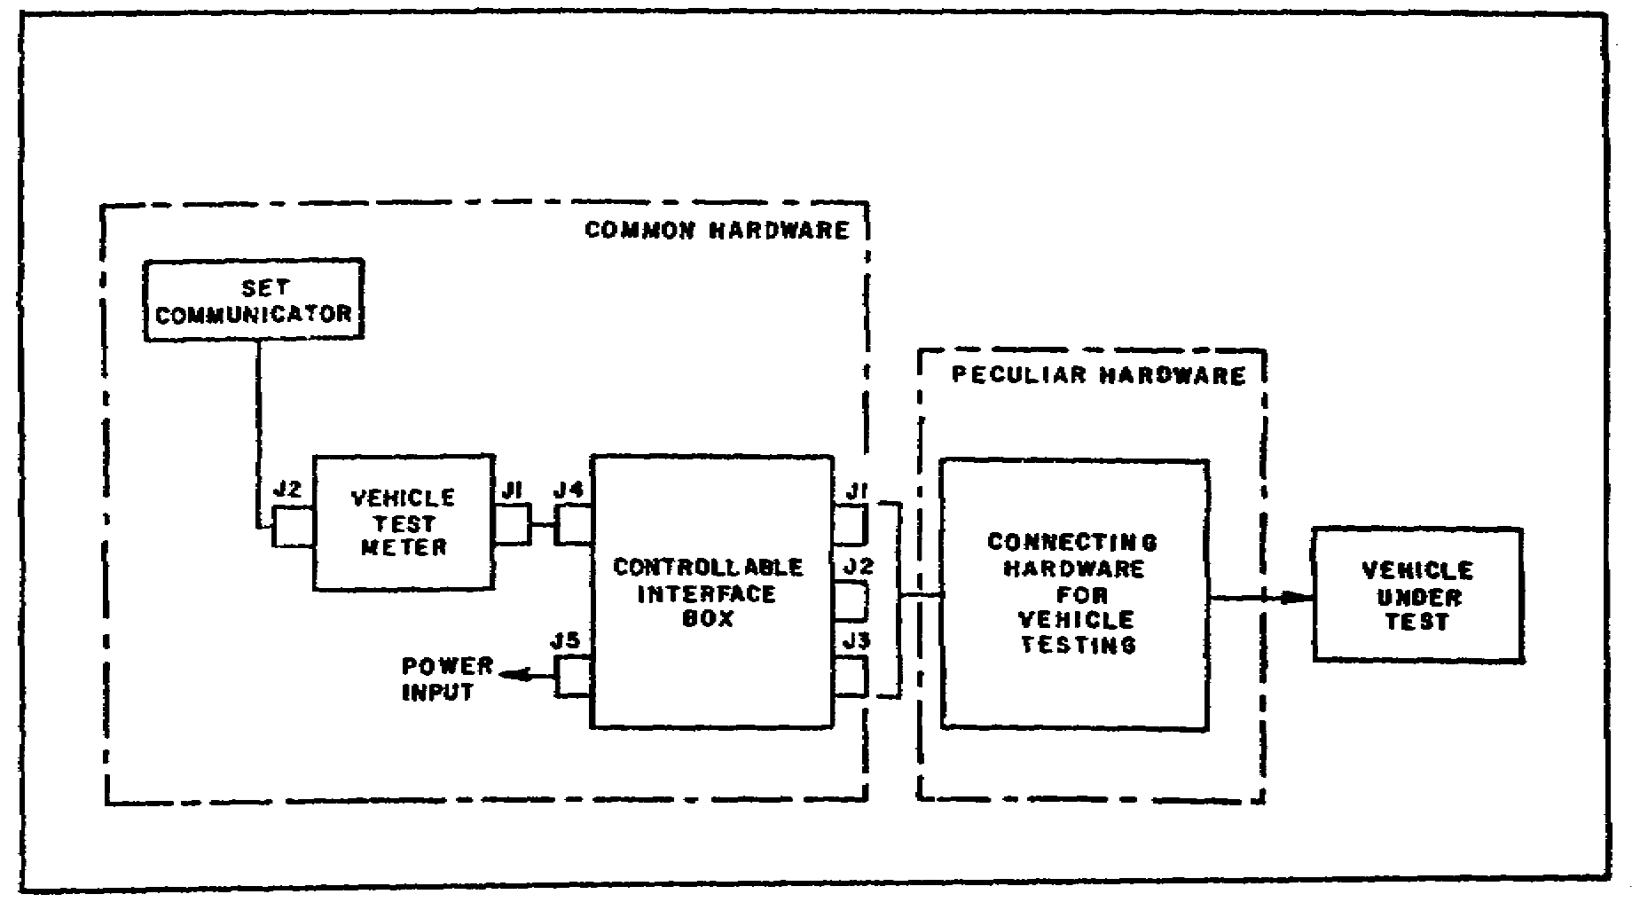

a. Common Hardware. The common hardware items consist of a vehicle test meter (VTM), a controllable interface box (CIB), a set communicator, and associated adapters and cable assemblies.

(1) Vehicle Test Meter. The vehicle test meter (VTM) is the basic unit, to which the controllable interface box (CIB) and the set communicator are connected. A microprocessor within the VTM controls its internal operation and the data inputs and outputs. The VTM receives input power from the CIB. In the stand-alone mode, the VTM is able to measure voltage, resistance, current, and frequency. The VTM is a part of the VTM/Transducer Kit/Set Communicator Assembly (figure 2 on the following page).

2

M1 TANK AUTOMOTIVE TEST EQUIP - OD 0460 - LESSON 1/TASK 1

FIGURE 2. VTM/TRANSDUCER KIT/SET
COMMUNICATOR ASSEMBLY.
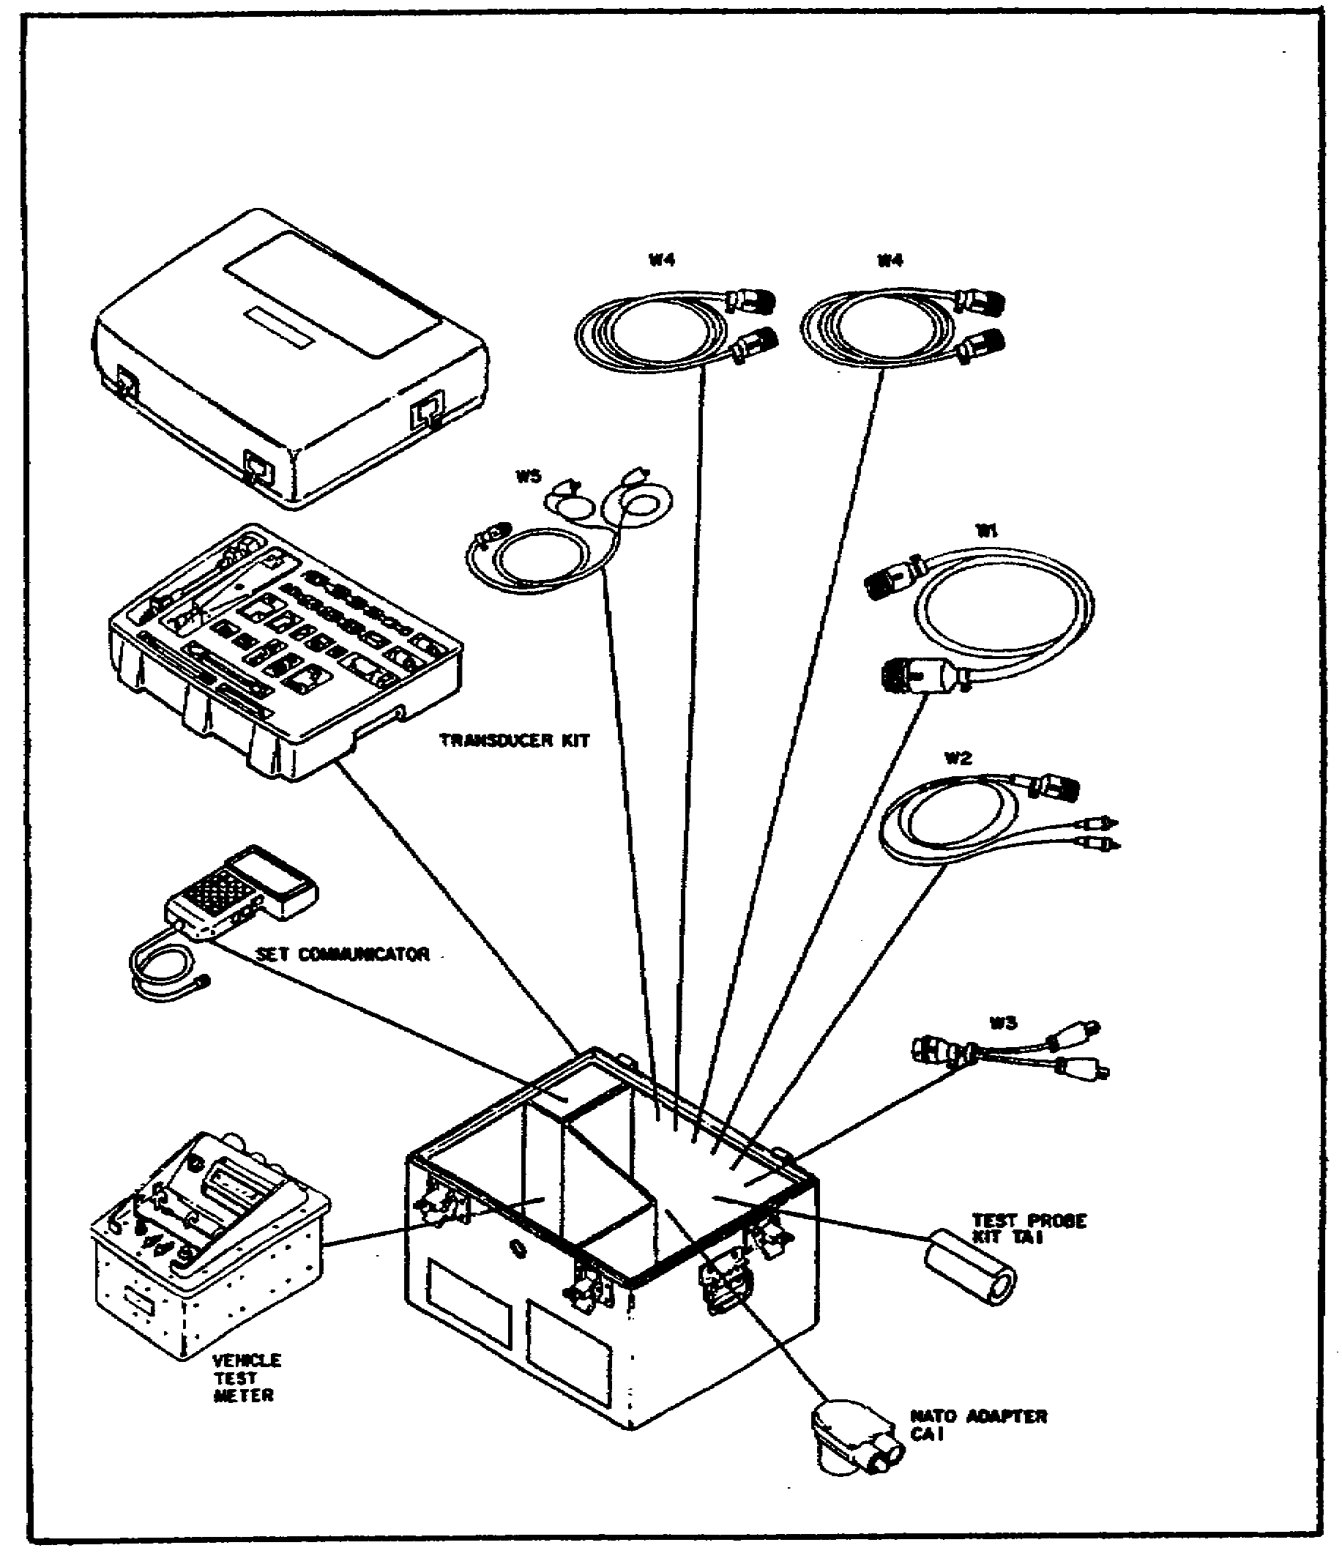

(2) Controllable Interface Box. The controllable interface box (CIB) is connected by cables to both the VTM and to the vehicle being tested. The CIB has two identical 128-pin connectors. When these connectors are used with the test cables and peculiar hardware items, they connect to the vehicle test connectors and active junctions. The CIB also contains a microprocessor

3

M1 TANK AUTOMOTIVE TEST EQUIP - OD 0460 - LESSON 1/TASK 1

for multiplexing, communication, and power control. The CIB is a part of the controllable interface assembly which also contains an adapter (figure 3).

FIGURE 3. CONTROLLABLE INTERFACE ASSEMBLY.
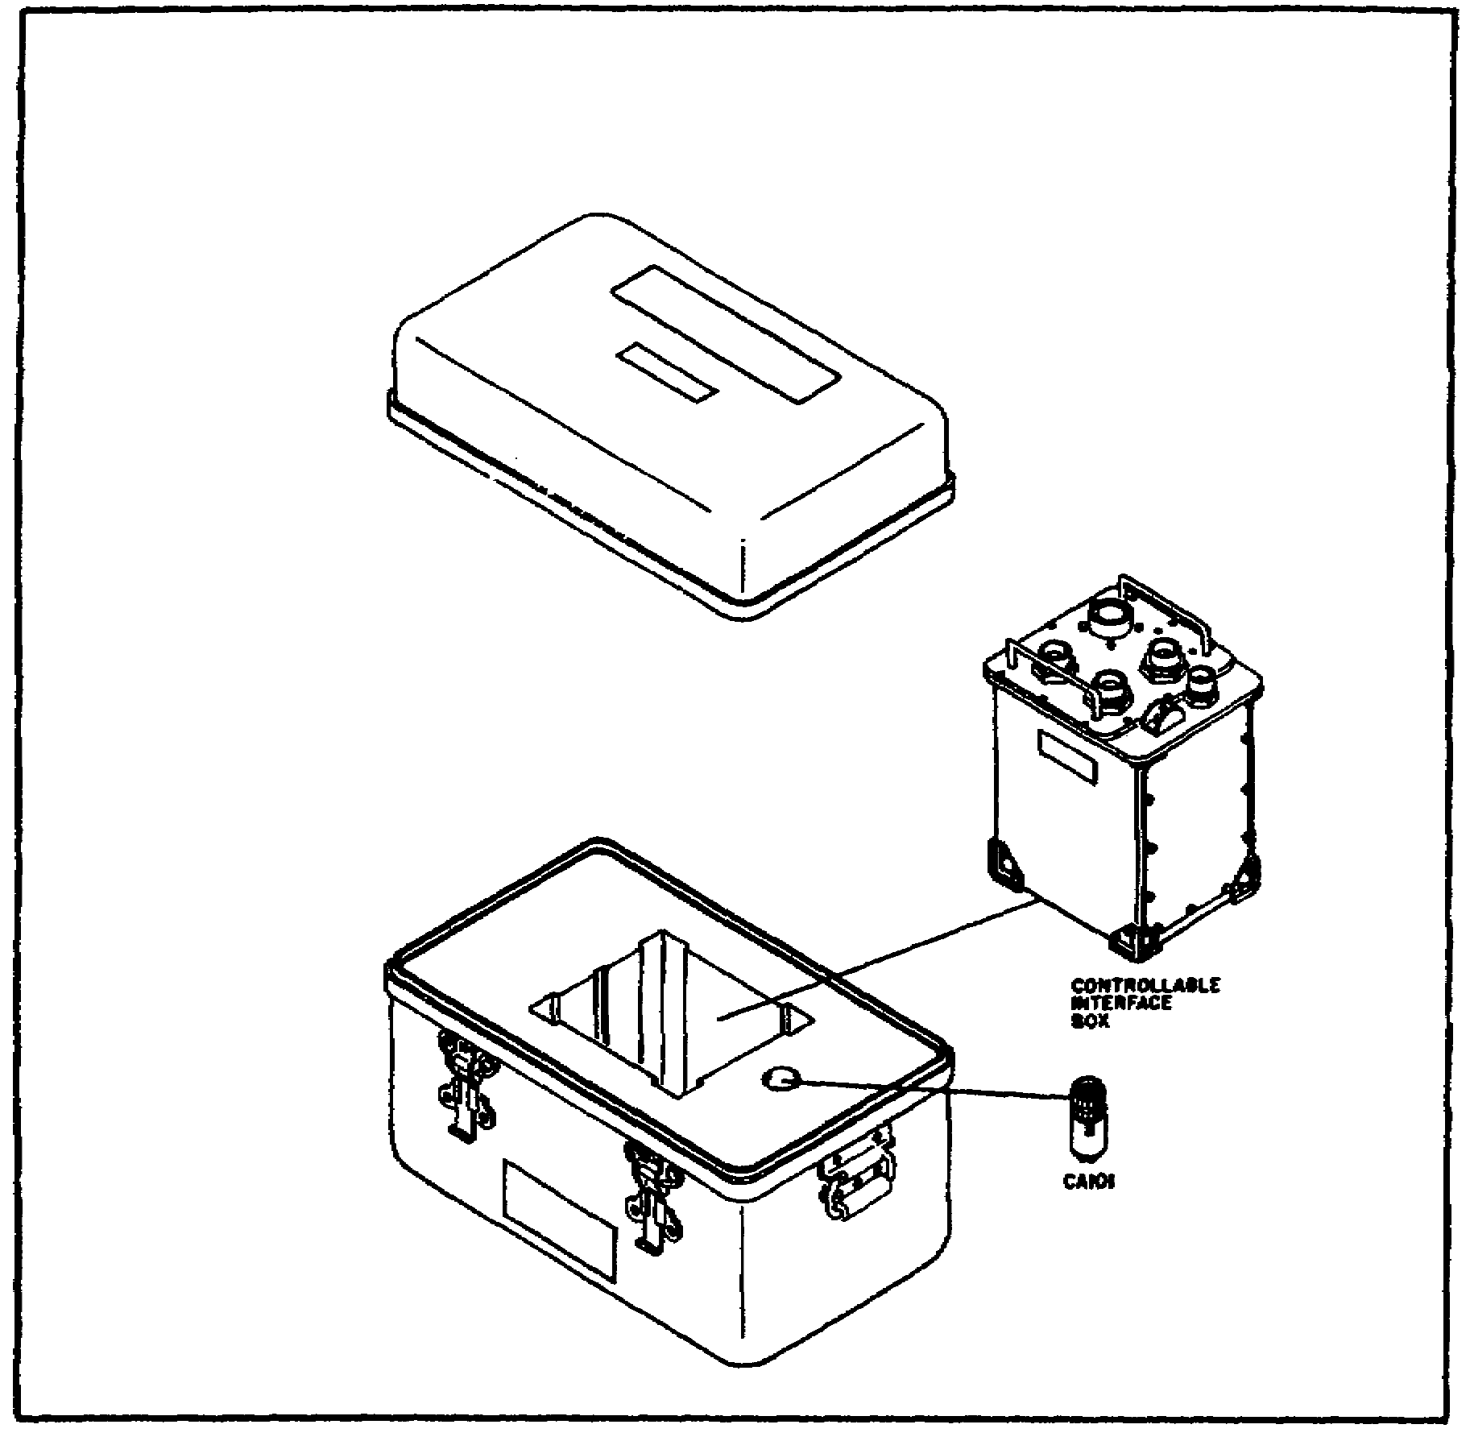

(3) Set Communicator. The set communicator is the means by which the test set communicates information to the operator. A keyboard allows the operator to communicate with the test set. These communications include the input of test data, test numbers, responses to observations, and commands to control the test progress. Thirty nine characters of an alphanumeric (alphabet plus numbers) display are used by the operator to give instructions and request information. The set communicator is a

4
M1 TANK AUTOMOTIVE TEST EQUIP - OD 0460 - LESSON 1/TASK 1

part of the VTM/Transducer Kit/Set Communicator Assembly (refer to figure 1 on page 2).

(4) Test Cables and Adapters. The test cables and adapters assembly (figure 4) consists of a shorting plug, cable assemblies, and an adapter for vehicle testing.

FIGURE 4. TEST CABLES AND ADAPTERS ASSEMBLY.
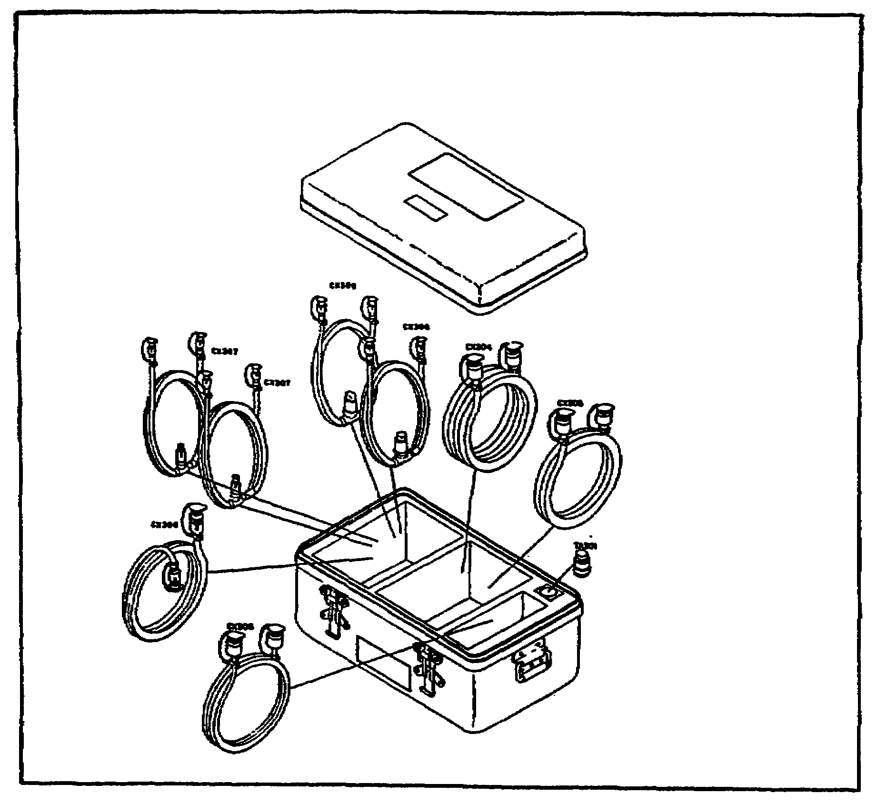

b. M1 Peculiar Hardware. Some of the hardware to be used with the STE-M1/FVS test set was designed especially to be used with the M1 Abrams tank. The M1 peculiar hardware consists of four assemblies, each in its own transit case.

(1) Stabilization/Turret Accessories. The stabilization/turret accessories assembly contains

5
M1 TANK AUTOMOTIVE TEST EQUIP - OD 0460 - LESSON 1/TASK 1

electrical diagnostic breakout assemblies (DBA), branched cables, plugs, electrical adapters, and a transducer.

(2) Engine/Transmission/Fire Extinguisher/Hull Accessories. The engine/transmission/fire extinguisher/hull accessories assembly consists of test fittings and adapters, transducers, and cables. An infrared simulator, used in testing the fire extinguisher system, is also included in this case.

(3) Hull Test Accessories. The hull test accessories assembly contains test adapters to run the hull system tests.

(4) Turret Test Accessories. The turret test accessories assembly contains adapters to do turret systems tests.

3. The STE-M1/FVS Self-test

The STE-M1/FVS has a built-in self-testing capability that is used to determine that the test set is ready for use. The self-test is also used to identify fault symptoms within the test set and to confirm that maintenance action have corrected any previous problem in the test set. The self-test should always be performed before using the test set on the vehicle.

a. Preparing the STE for Operation. Before performing the self-test, it is necessary to prepare the simplified test equipment (STE) for operation. For the self-test to succeed, the test set must be operated in a temperature environment between +20 and +125 degrees Fahrenheit. An internal temperature sensing device stops the operation of the test set outside these temperature limits. Any component that cannot be repaired by straightening bent pins, or by cleaning, should be turned in for replacement.

(1) Checking the Vehicle Test Meter (VTM) for Serviceability. The first step in setting up the test set for operation is to check the VTM for serviceability (figure 5 on the following page).

- Look at J1, J2, J3, and J4 on the VTM. Check for bent or broken pins, dented or cracked shells, and dirt.

6

M1 TANK AUTOMOTIVE TEST EQUIP - OD 0460 - LESSON 1/TASK 1

- Check the display window for cracks.

- Make sure that the circuit breaker, TEST SELECT, and TEST switches on the VTM operate freely.

- Pull the circuit breaker switch to the OFF position.

FIGURE 5. INSPECTING THE VTM.
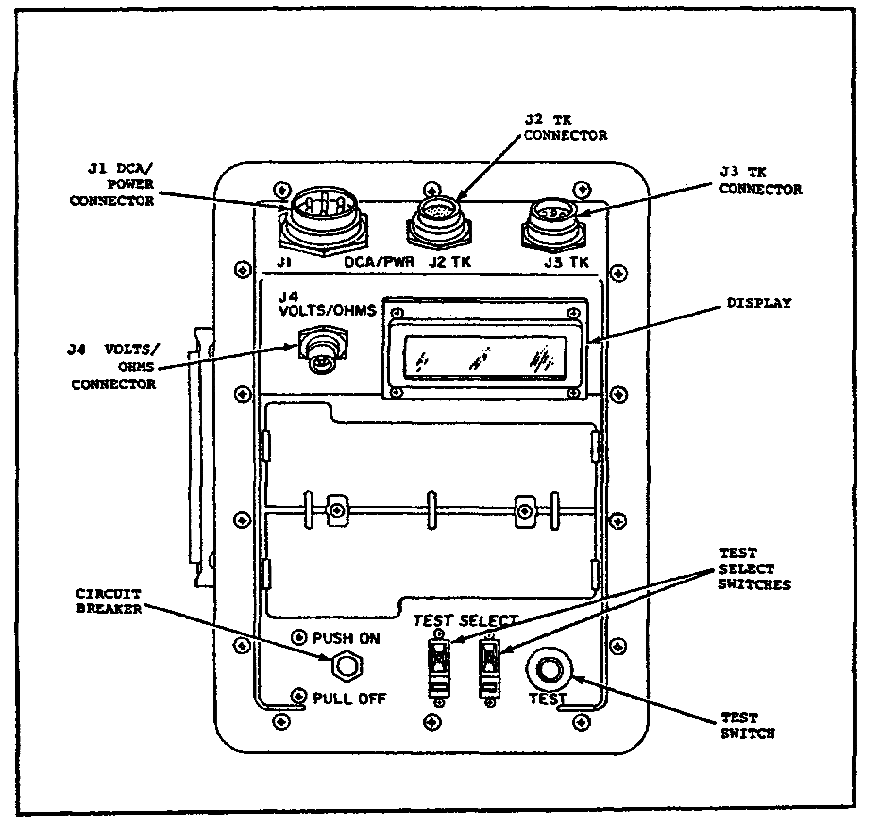

(2) Checking the Set Communicator (SETCOM) for Serviceability. The next step in preparing the test set for operation is to check the set communicator (SETCOM) for serviceability (figure 6 on the following page).

7

M1 TANK AUTOMOTIVE TEST EQUIP - OD 0460 - LESSON 1/TASK 1

- Check the display window on the SETCOM for cracks.

- Look at the keys. Check for cracks or missing keys.

FIGURE 6. INSPECTING THE SETCOM.
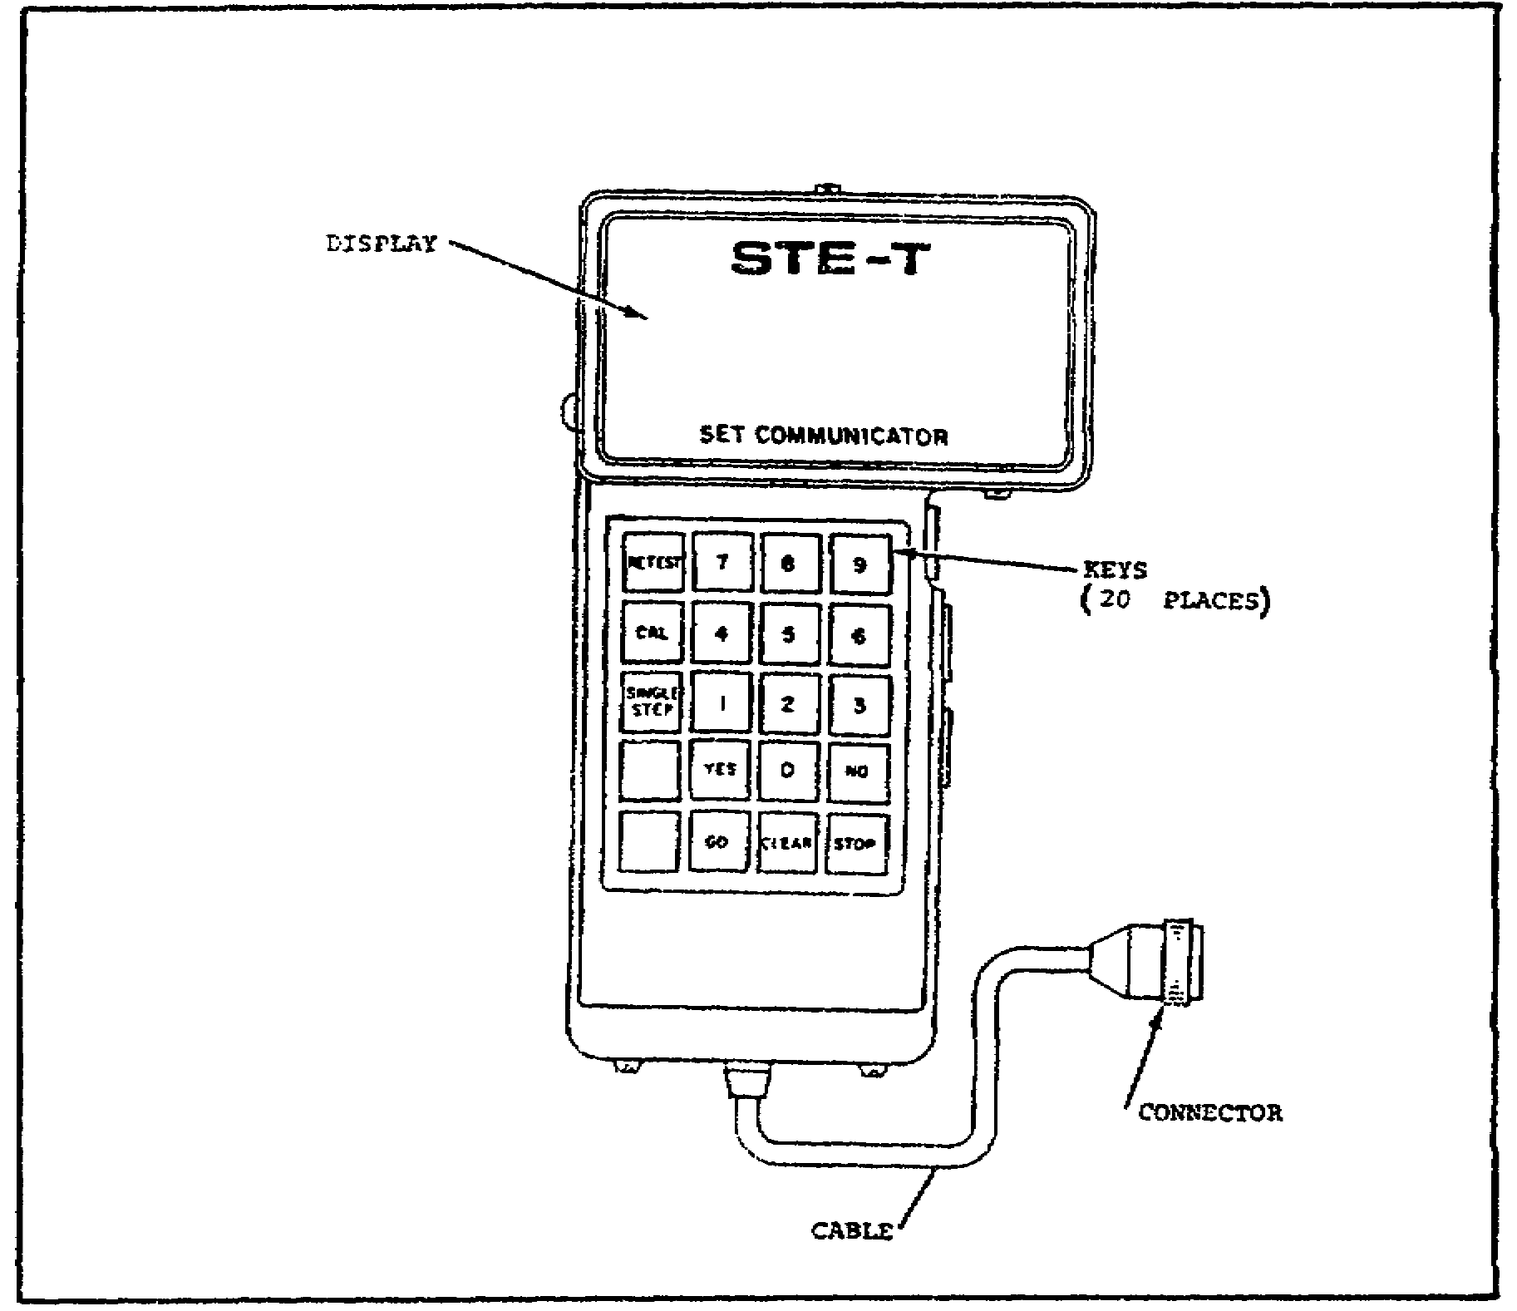

- Make sure the cable is not cut or frayed.

- Check the connector for bent or broken pins, a dented or cracked shell, and for dirt.

(3) Checking the Controllable Interface Box for Serviceability. Next, the controllable interface box (CIB) is checked for serviceability (figure 7 on the following page).

8

M1 TANK AUTOMOTIVE TEST EQUIP - OD 0460 - LESSON 1/TASK 1

- Look at connectors J1, J2, J3, J4, and J5 on the CIB. Check for bent or broken pins, dented or cracked shells, and dirt.

- Make sure the power (PWR) switch operates freely.

- Set the power (PWR) switch to OFF.

FIGURE 7. INSPECTING THE CIB.
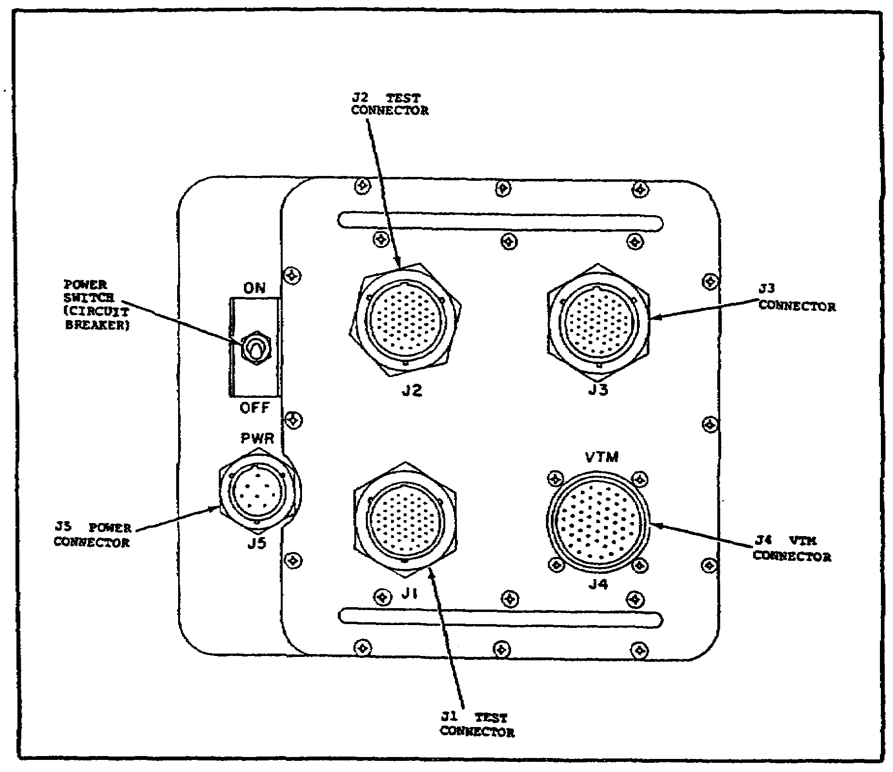

(4) Checking the rest Cables and the NATO Adapter for Serviceability. The following checks should be made to determine the serviceability of the test cables and NATO adapter:

- Make sure that-cables CX309, WI, and CX306 are not cut or badly frayed.

9

M1 TANK AUTOMOTIVE TEST EQUIP - OD 0460 - LESSON 1/TASK 1

- Check cables CX309, W1, CX306, and the NATO adapter for bent or broken connector pins, cracked or dented connector shells, and dirt.

(5) Checking the CIB Cables and Shorting Plug for Serviceability. Next, make the following serviceability checks:

- Make sure cable CX304, cable CX305, and shorting plug TA301 are not cut or frayed.

- Check cable CX304, cable CX305, and shorting plug TA301 for bent or broken connector pins, cracked or dented connector shells, and for dirt.

(6) Making the Standard Cable Hookup for a Hull Test. Once the test set components have been thoroughly inspected for damage, the set can be hooked up. To perform the self-test, the test set (figure 8 on the following page) should be hooked up as for a hull test.

- Place the CIB, the VTM, the SETCOM, and cables CX309, W1, and CX306 on the tank hull by the driver's hatch.

- Connect W1-P1 to connector J1 on the VTM.

- Connect Wl-P2 to connector J4 on the CIB.

- Connect the SETCOM to the VTM. This can be done in one of two ways. The SETCOM can be connected directly to connector J2 on the VTM. Or, when greater maneuverability is required, the 25 foot extension cable CX309 may be used to make the connection. When CX309 is used, connect CX309-Pl to connector J2 on the VTM and then connect CX309-P2 to the SETCOM cable.

- Connect CX306-P2 to connector J35 on the CIB.

- Connect the NATO adapter CA1 to cable CX306-P1.

NOTE

It is not recommended that a battery charger be connected to the tank during STE testing. However, if a battery charger must be used, make sure that no heavy duty machinery or motors are operated during testing since they may affect the operation of the test set.

10

M1 TANK AUTOMOTIVE TEST EQUIP - OD 0460 - LESSON 1/TASK 1

FIGURE 8. HOOKING UP THE TEST SET.
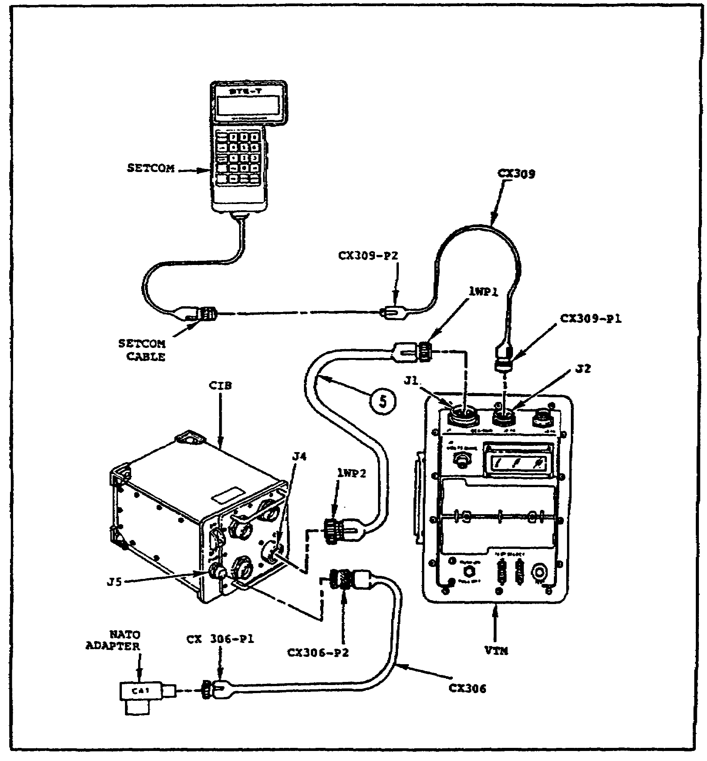

- Check all battery condition indicators, as outlined in TM 9-2350-255-10. All battery condition indicators should be green. If all battery condition indicators are not green, the batteries must be charged, in accordance with TM 9-2350-255-10.

- If all battery condition indicators are green, plug the NATO adapter CA1 into the slave receptacle on the power distribution box (figure 9 on the following page).

11

M1 TANK AUTOMOTIVE TEST EQUIP - OD 0460 - LESSON 1/TASK 1

FIGURE 9. CONNECTING THE TEST SET TO
THE POWER DISTRIBUTION BOX.
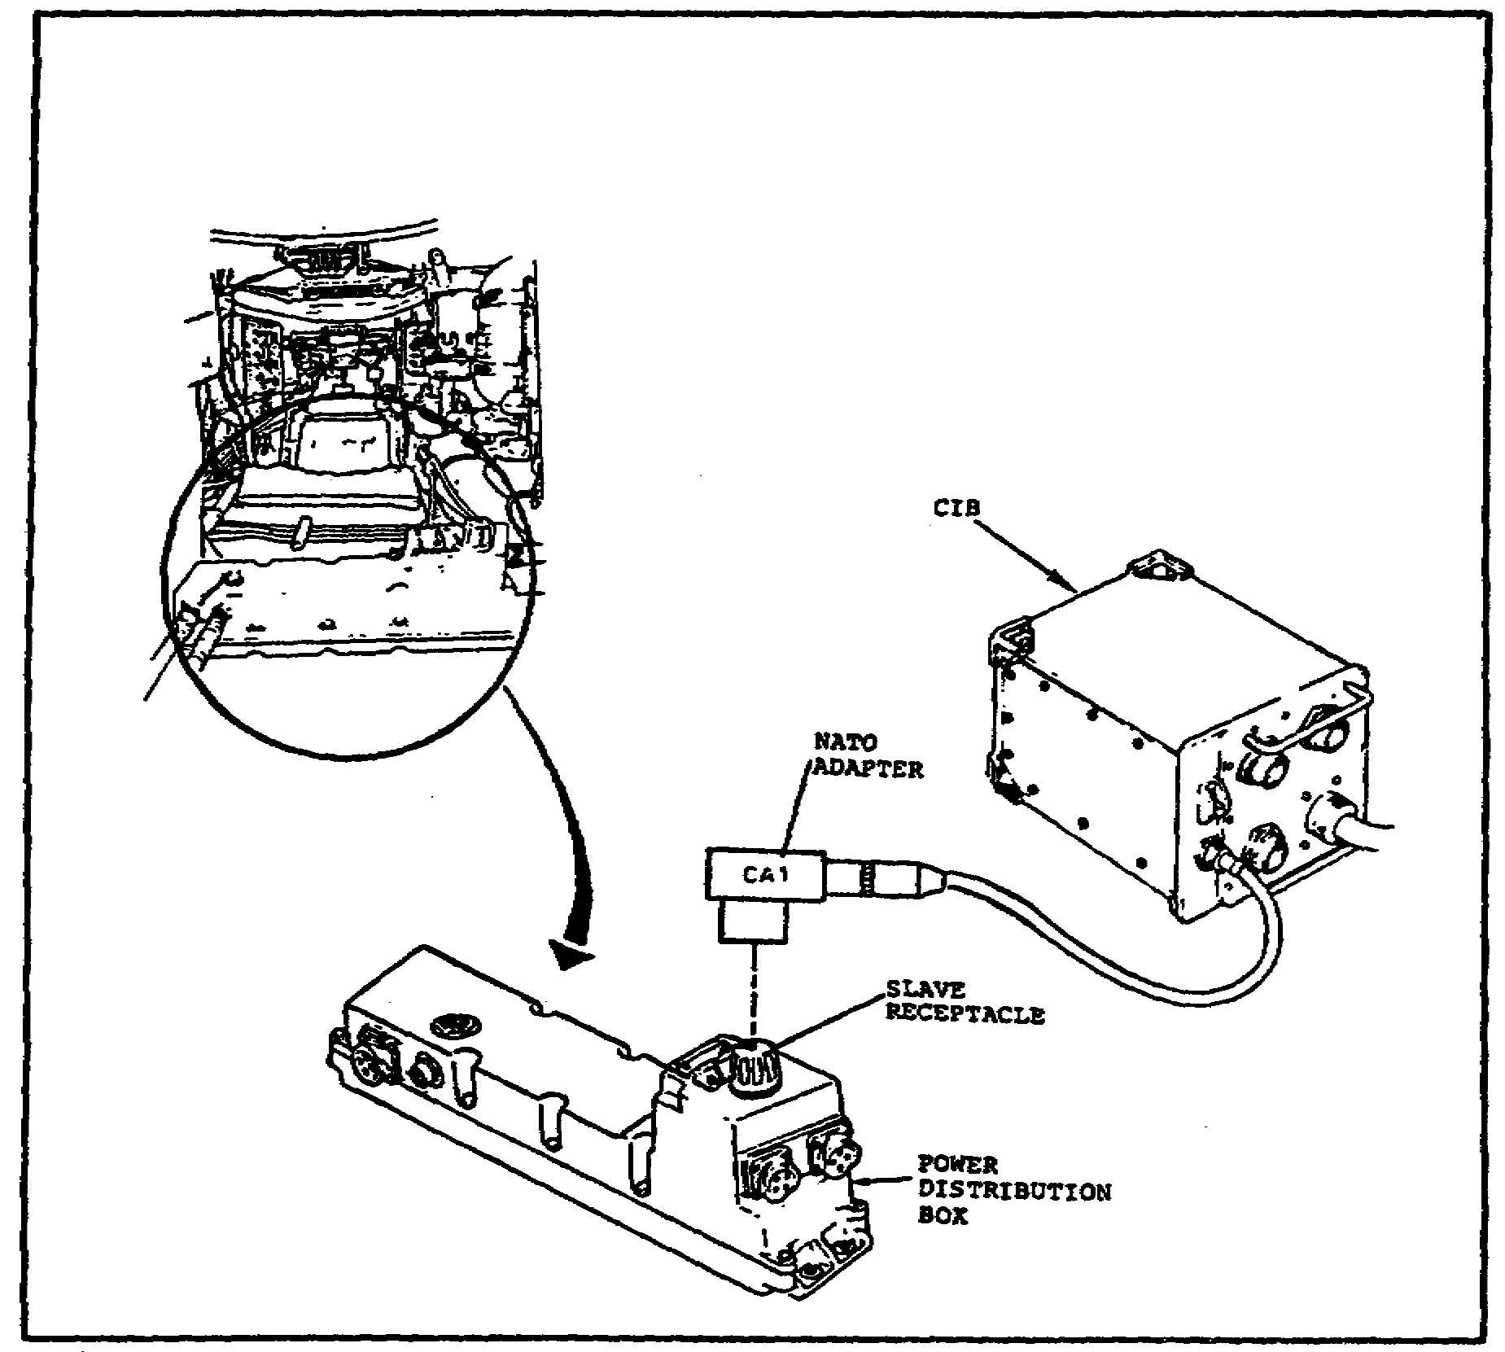

- Set the power (PWR) switch on the CIB to the ON position.

- Push the circuit breaker switch on the VTM to ON.

- The display on the VTM should show .8.8.8.8 for about two seconds and then change to _ _ _ _. If this sequence is NOT displayed, the STE test set is faulty, and the following actions should be taken:

  - If nothing appears on the display, check all cable connectors for tightness; then, if nothing appears on the display, troubleshoot the STE test set for the symptom NO VTM DISPLAY ON POWER UP, in accordance with TM 9-4910-751-14-1, chapter 5.

12
M1 TANK AUTOMOTIVE TEST EQUIP - OD 0460 - LESSON 1/TASK 1

- If any one dot, number eight, or dash does not appear on the display, replace the faulty display module, in accordance with TM 9-4910-751-14-1, chapter 5.

- If the VTM display shows blank, then shows .8.8.8.8, then is blank again, troubleshoot the STE test set for the symptom VTM DISPLAYS BLANK, THEN .8.8.8.8, THEN BLANK, as outlined in TM 9-4910-751-14-1, chapter 5.

b. Performing the Self-test. The STE self-test consists of making various entries into the VTM or SETCOM unit and receiving appropriate responses on the displays of those two units. If, at any time during the self-test, the proper response is NOT displayed by the test equipment, then the test set or a component of the test set is faulty.

(1) VTM Confidence Tests. Two VTM confidence tests must be performed as the first steps in the self-test (figure 10 on the following page).

(a) VTM Confidence Test 66. To perform the first VTM confidence test, follow these steps:

- Set the TEST SELECT switches on the VTM to 66.

- Press the TEST button on the VTM.

- The display on the VTM should show 0066. If it does not show 0066, troubleshoot the test set for the symptom VTM DOES NOT DISPLAY 0066, in accordance with the instructions contained in TM 9-4910-751-14-1, chapter 5.

(b) VTM Confidence Test 99. To perform the second VTM confidence test, follow these steps:

- Set the TEST SELECT switches on the VTM to 99.

- Press the TEST button on the VTM.

- The VTM display should flash some numbers and then show PASS. If the display does not show PASS, troubleshoot the test set for the symptom VTM DISPLAYS AN ERROR CODE, in accordance with TM 9-4910-751-14-1, chapter 5.

13

M1 TANK AUTOMOTIVE TEST EQUIP - OD 0460 - LESSON 1/TASK 1

FIGURE 10. VTM CONFIDENCE TESTS.
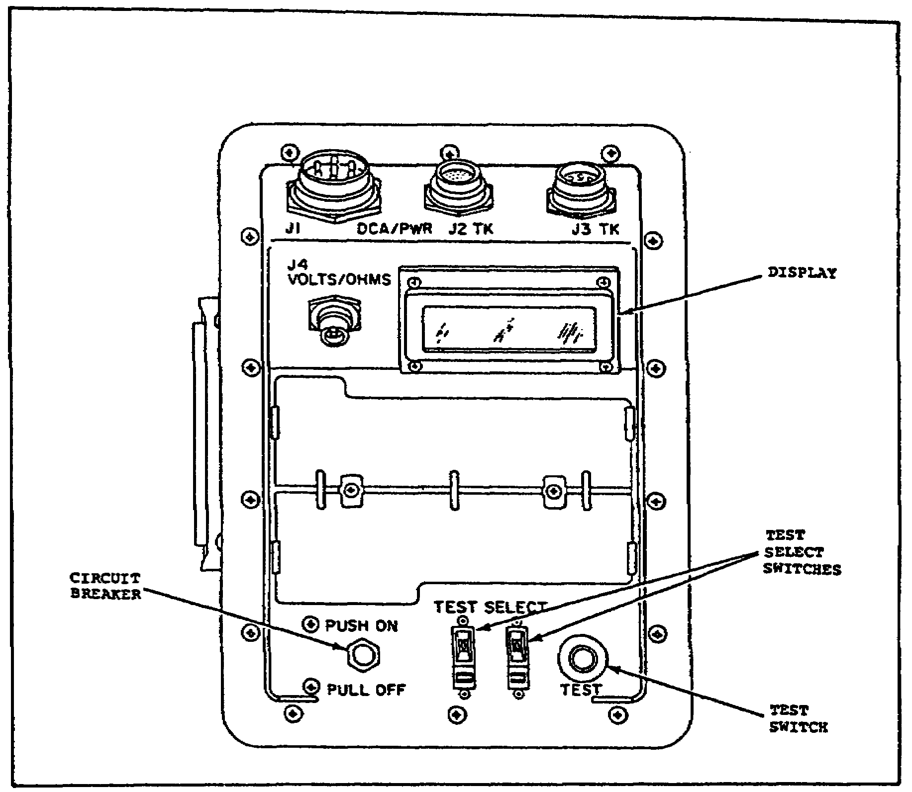

(c) Clearing the Unit. To clear the unit, follow these steps:

- Set the TEST SELECT switches on the VTM to 00.

- Press the TEST button on the VTM.

- Check the display on the SETCOM. The SETCOM display should show STE/M1 FVS CLEAR UNIT. If it does not, troubleshoot the test set for the symptom SET COMMUNICATOR DOES NOT DISPLAY STE-M1/FVS CLEAR UNIT, as outlined in TM 9-4910-751-14-1, chapter 5.

(2) Running Self-test 666. From this point on, all testing is done using the SETCOM unit (figure 11 on the following page). Continue the self-test by doing the steps listed below, in sequence.

14

M1 TANK AUTOMOTIVE TEST EQUIP - OD 0460 - LESSON 1/TASK 1

FIGURE 11. THE SETCOM UNIT.
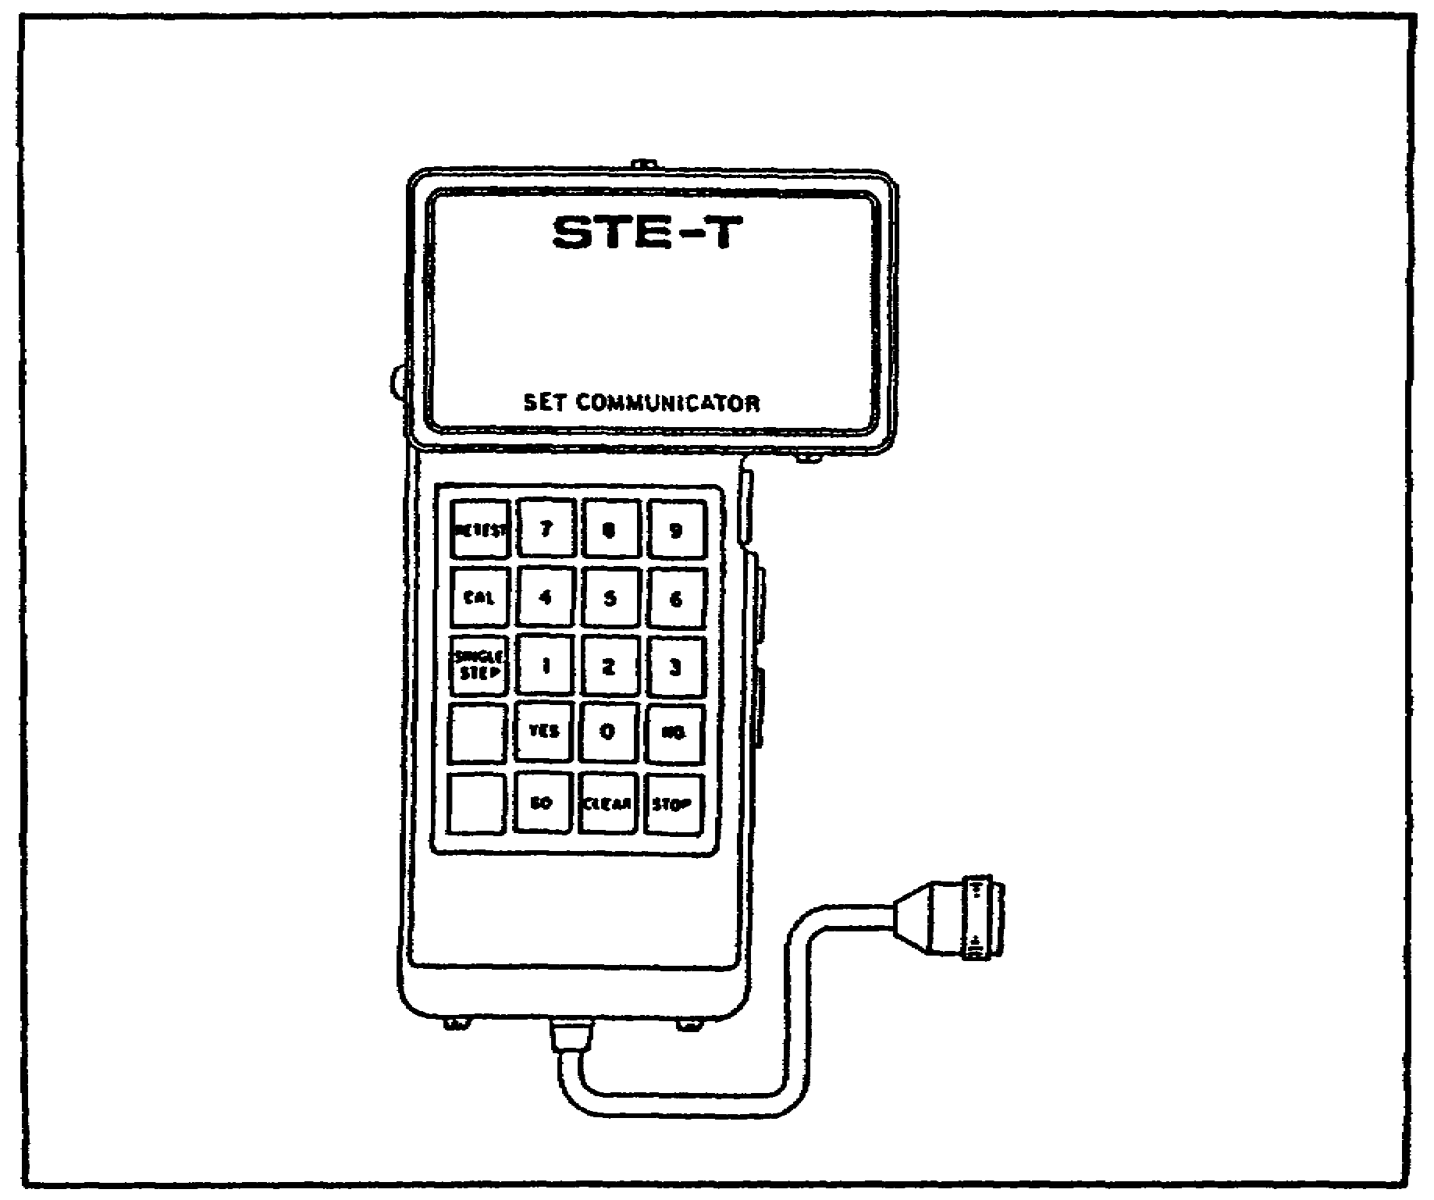

NOTE

The sections of the self-test outlined below have been titled to assist in identifying the main component being tested. In some cases, components other than the main component identified in the section title are being simultaneously tested.

(a) Beginning Self-test 666. To begin self-test 666, follow these steps:

- Press the CLEAR key on the SETCOM. The display should read: ENTER TEST NUMBER. If the display cannot be cleared (does not read ENTER TEST NUMBER), replace the VTM, in accordance with the procedures outlined in TM 9-4910-751-14-1. The

15

M1 TANK AUTOMOTIVE TEST EQUIP - OD 0460 - LESSON 1/TASK 1

faulty VTM must undergo intermediate direct support maintenance level troubleshooting procedures for symptom 25 as outlined in TM 9-4910-751-14-2, chapter 6.

- Press the 6 key three times. The display should read: ENTER TEST NUMBER: 666. Note that the CLEAR key can also be used to clear the display if a wrong number is entered.

- Press the GO key. The display should read: TEST 666 SELF-TEST. If the display does not read this, troubleshoot the test set for the symptom SET COMMUNICATOR DOES NOT DISPLAY TEST 666 SELF-TEST, outlined in TM 9-4910-751-14-1, chapter 5.

- Press the GO key again. The display should show the words: REVISION DATE, followed by a number indicating the date when the program was updated.

(b) Testing for a Faulty VTM. The self-test continues by checking for a faulty VTM.

- Press the GO key. The SETCOM display should say: REMOVE CABLES FROM CIB J1, J2, AND J3. Check to make sure that no cables are connected to the CIB connectors J1, J2, and J3.

- Press the GO key again. The display should read: TEST IN PROGRESS PLEASE WAIT. Wait for the display to change. If the message on the display reads: BUTTON TEST: PRESS RETEST, the VTM is operational. When this is the case, proceed to test for a faulty SETCOM unit, as described in paragraph 3b(2)(c) on the following page. If the message on the display shows the words FAULTY VTM, followed by a set of numbers, perform these steps:

  - Record the message and number.

  - Press the GO key. The display will read: TEST FINISHED PUSH STOP AND CLEAR.

  - Press the STOP key.

  - Press the CLEAR key.

  - Replace the VTM in accordance with the procedures outlined in TM 9-4910-751-14-1.

  - Repeat the self-test.

16
M1 TANK AUTOMOTIVE TEST EQUIP - OD 0460 - LESSON 1/TASK 1

(c) Testing for a Faulty SETCOM. If the VTM is not faulty, the self-test continues by testing for a faulty SETCOM unit. If any characters are missing, or if the display is not as indicated in the following tests, replace the set communicator (SETCOM), in accordance with the procedures outlined in TM 9-4910-751-14-1, and repeat the self-test to this point.

- The display should read: BUTTON TEST: PRESS RETEST.

- Press the RETEST key to get the message: BUTTON TEST: PRESS 7.

- Press the 7 key. The message should read: BUTTON TEST: PRESS 8.

- Press the 8 key. The display should read: BUTTON TEST: PRESS 9.

- Press the 9 key. The display will read: BUTTON TEST: PRESS CAL.

- Press the CAL key. The display will show: BUTTON TEST: PRESS 4.

- Press the 4 key. BUTTON TEST: PRESS 5 will appear on the display.

- Press the 5 key. BUTTON TEST: PRESS 6 will appear on the display.

- Press the 6 key. The words BUTTON TEST: PRESS SINGLE STEP will appear.

- Press the SINGLE STEP key. The message should read: BUTTON TEST: PRESS 1.

- Press the 1 key. BUTTON TEST: PRESS 2 will appear on the display.

- Press the 2 key. BUTTON TEST: PRESS 3 will be displayed.

- Press the 3 key. BUTTON TEST: PRESS YES will appear on the display.

- Press the YES key. The words BUTTON TEST PRESS 0 will appear.

17

M1 TANK AUTOMOTIVE TEST EQUIP - OD 0460 - LESSON 1/TASK 1

- Press the 0 key. The display will read: BUTTON TEST: PRESS NO.

- Pressing the NO key will obtain the message: BUTTON TEST: PRESS CLEAR.

- Press the CLEAR key to obtain the display BUTTON TEST: PRESS GO.

- Press the GO key. The display should show DISPLAY TEST: 0123456789.

- Press the GO key again. The display will read ABCDEFGHIJKLM on the first line and NOPQRSTUVWXYZ on the second line.

- Press the GO key again. The display will show abcdefghijklm on the first line and nopqrstuvwxyz on the second line.

- Press the GO key. The display should show 19 dots on the first line and 19 dots on the second line.

- Press the GO key again. The display will show 19 dashes on the first line and 19 dashes on the second line.

(d) Checking for a Fault Message. These steps of the self-test involve several of the components of the test set. Continue the self-test by performing these steps:

- Press the GO key. The message displayed should read: INSPECT CIB CONNECTORS J1 AND J2.

- Press the GO key again. The message will be: ARE PINS BENT OR BROKEN? Look at the connectors J1 and J2 on the CIB. Check for bent or broken pins. If no pins are bent or broken, continue the test. If any pins on the CIB connectors J1 and J2 are bent or broken, proceed as follows:

  - Press the YES key. The display reads: FAULTY CONNECTOR 66610 (the number on the display is not used).

  - Press the STOP key.

  - Press the CLEAR key.

18

M1 TANK AUTOMOTIVE TEST EQUIP - OD 0460 - LESSON 1/TASK 1

- Replace the CIB, in accordance with TM 9-4910-751-14-1, chapter 5.

- Repeat the self-test to this point.

  - If no pins on connectors J1 or J2 of the CIB are bent or broken, press the NO key. The display will read: TEST IN PROGRESS PLEASE WAIT.

  - Wait for the display to change. If the display has no fault message, it will read CONNECT CX304 TO CIB J1. When no fault message appears, the self-test should continue with the CIB cable CX304 test, described in paragraph 3b(2)(e) on page 21. If a fault message appears on the display, it will be necessary to take the appropriate corrective action. Table 1 shows the faults that may appear on the display at this point.

TABLE 1. FAULT MESSAGE - STOP TEST.
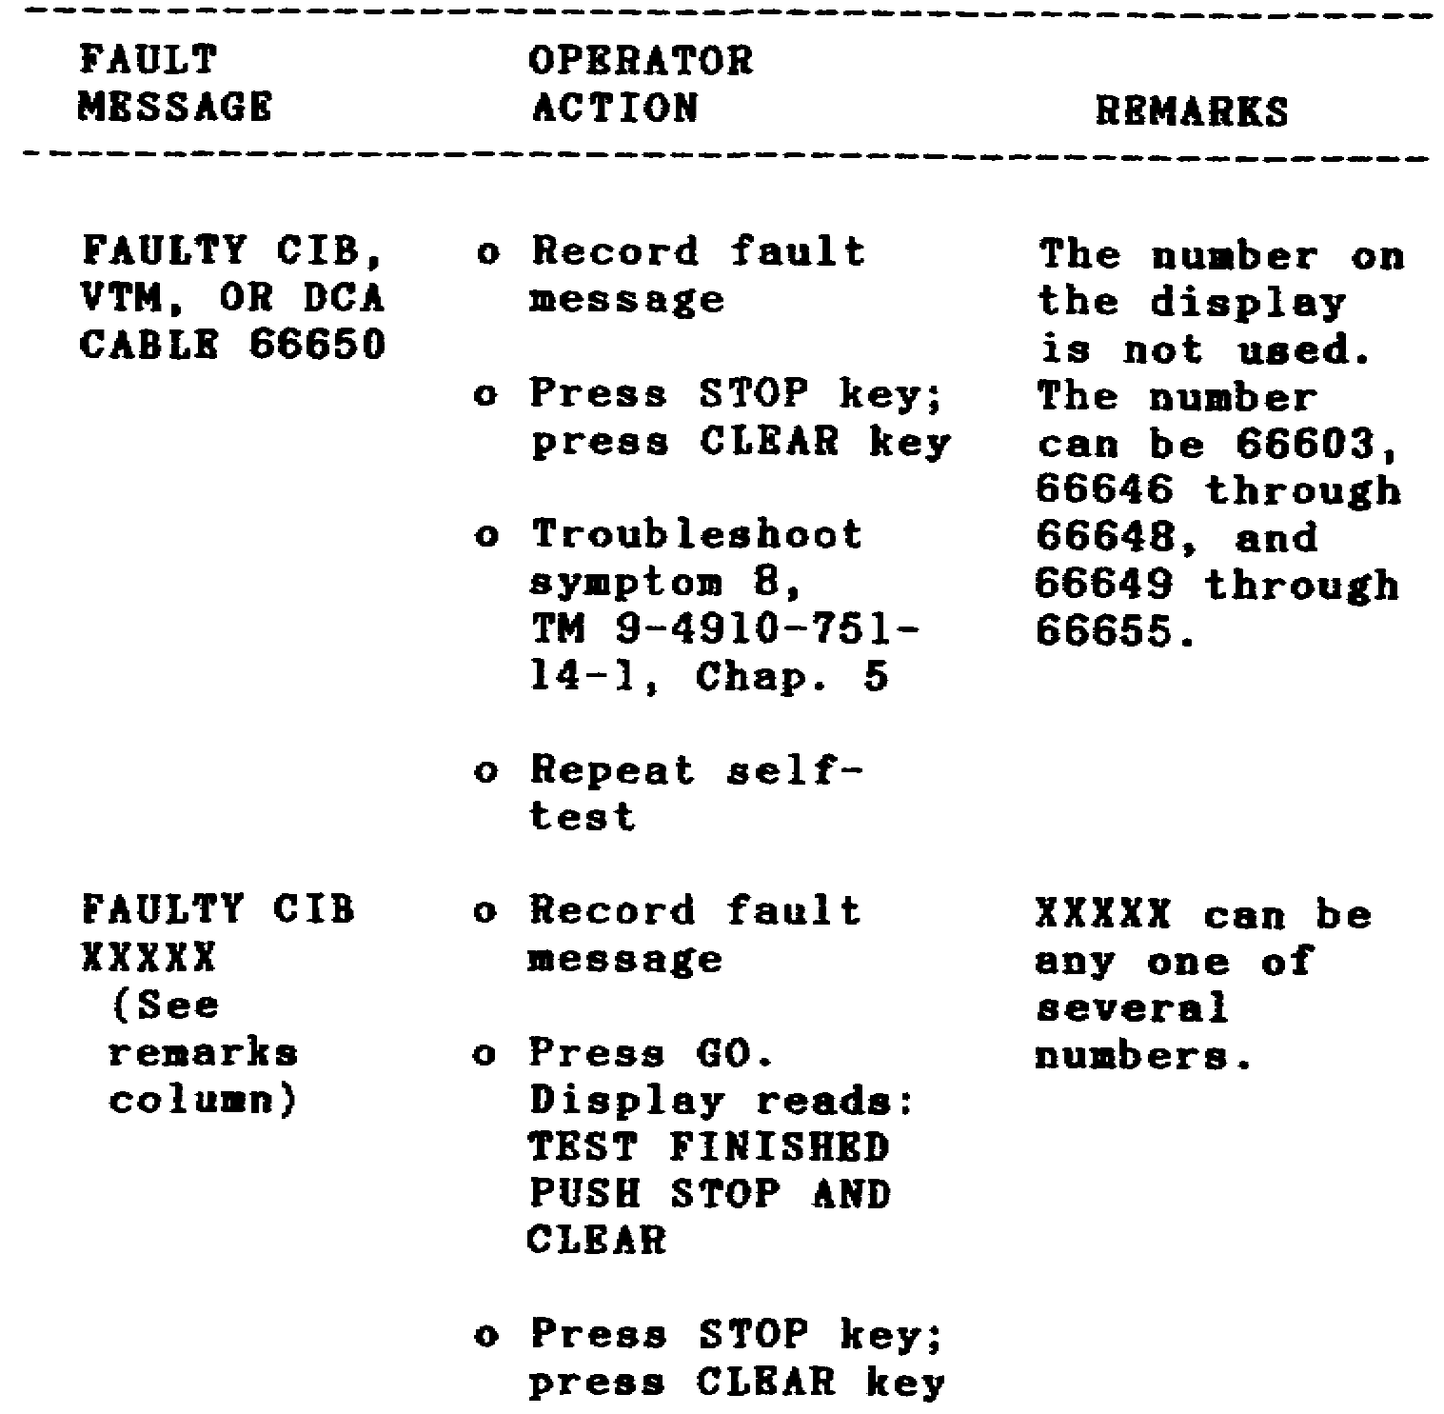

19

M1 TANK AUTOMOTIVE TEST EQUIP - OD 0460 - LESSON 1/TASK 1

TABLE 1. FAULT MESSAGE - STOP TEST.
(CONTINUED)
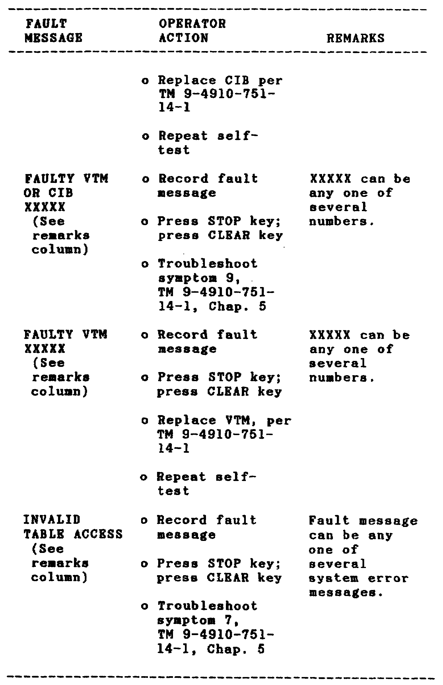

20

M1 TANK AUTOMOTIVE TEST EQUIP - OD 0460 - LESSON 1/TASK 1

(e) Checking CIB Cable CX304. If no fault message appeared on the SETCOM display, the self-test can continue with a check for a defective CIB cable. The first CIB cable to be checked is cable CX304 (figure 12 on the following page).

CAUTION

Be careful when connecting cable CX304 to the CIB. The connector pins can easily be bent or broken.

- The SETCOM display should read CONNECT CX304 TO CIB J1. Plug in connector CX304-P2 to the J1 connector on the CIB.

CAUTION

Be careful when connecting plug TA301 to cable CX304. The connector pins can easily be bent or broken.

- Press the GO key. The display will show: CONNECT PLUG TA301 TO CX304. Plug the TA301 plug into the CX304-Pl connector.

- Press the GO key. The words TEST IN PROGRESS PLEASE WAIT will appear on the display.

- Wait for the display to change. If the self-test does not detect any problems, the display will change to read REMOVE PLUG TA301 FROM CX304. When this is the case, remove plug TA301 from cable CX304 and continue with the self-test. If the display reads REMOVE CX304 FROM CIB J1, there is a problem in the system. When this message is received, perform the following steps to isolate the defective component:

  - Press the GO key. The display should read REMOVE CX304 FROM CIB J1. Unplug the CX304-P2 connector from the J1 connector on the CIB.

  - Press the GO key. CONNECT CX304 TO CIB J2 should appear on the display. Plug the CX304-P2 connector into the J2 connector on the CIB.

21

M1 TANK AUTOMOTIVE TEST EQUIP - OD 0460 - LESSON 1/TASK 1

FIGURE 12. TESTING CIB CABLE CX304.
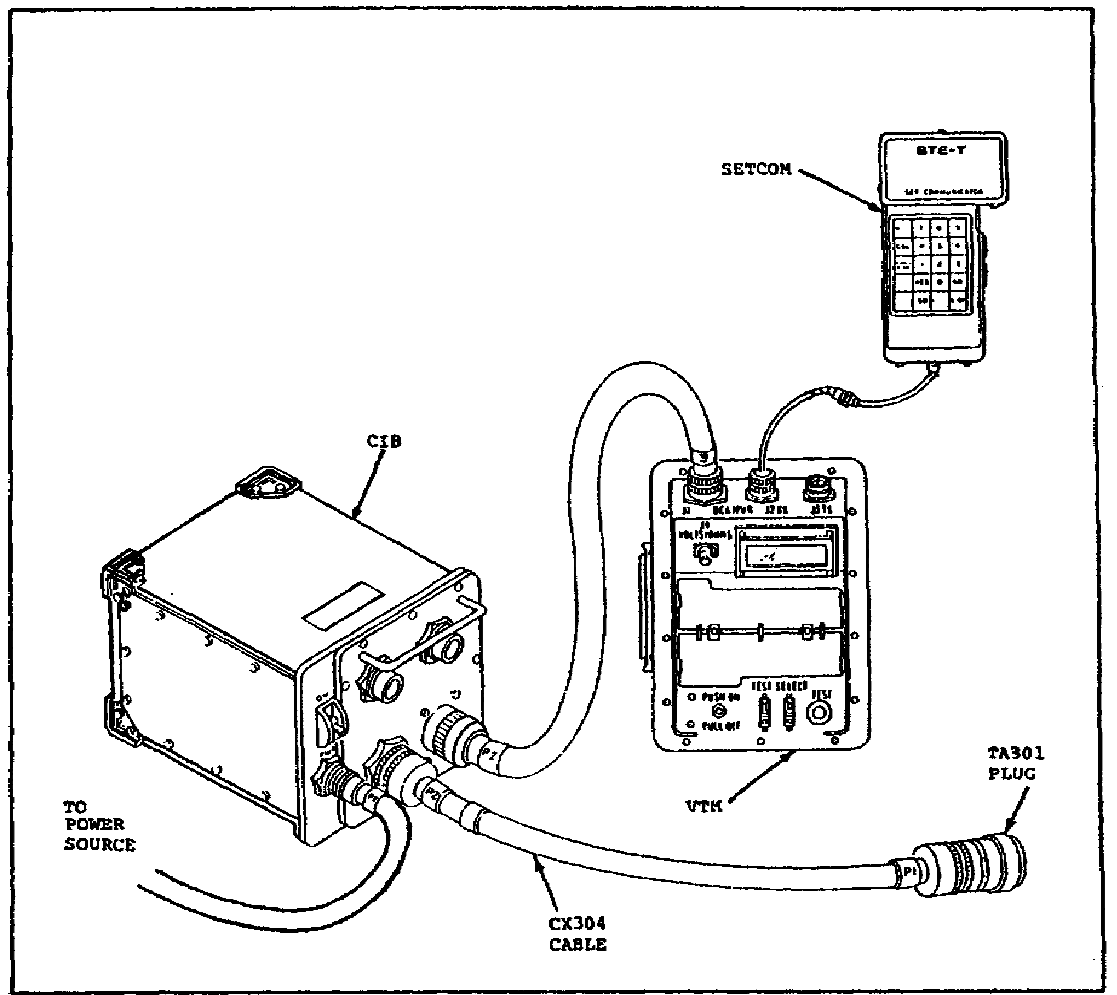

CAUTION

Be careful when connecting CX304 to the CIB. The connector pins are easy to break.

- Press the GO key. The display will read TEST IN PROGRESS PLEASE WAIT.

- Wait for the display to change. When the new message appears, it will say one of two things. If it says FAULTY CIB, press STOP and then CLEAR. Then replace the CIB, in accordance with TM 9-4910-751-14-1, and repeat the self-test. If the message reads REMOVE CX304 AND PLUG TA301, remove plug TA301 from cable CX304. Then remove the CX304-P2 connector from the J2 connector on the CIB.

22

M1 TANK AUTOMOTIVE TEST EQUIP - OD 0460 - LESSON 1/TASK 1

- When plug TA301 and cable CX304 have been removed, press the GO key. The message on the display should read CONNECT CX305 TO CIB J2. Substituting cable CX305 for CX304 in this way will help the test set to determine whether the faulty component is cable CX304 or plug TA301. Plug the CX305-P2 connector into the J2 connector on the CIB. Remember to make the connection carefully because the pins can be bent or broken.

- With cable CX305 connected to J2 on the CIB, press the GO key. CONNECT PLUG TA301 TO CX305 should appear on the display. Connect plug TA301 to connector CX305-P1.

- Press the GO key. The message TEST IN PROGRESS PLEASE WAIT should appear on the display.

- Wait for the display to change. If the message FAULTY TA301 appears on the display, replace TA301 and repeat the self-test. If the message FAULTY CX304 appears on the display, replace cable CX304 and repeat the self-test.

  - When the self-test did not detect any problems with cable CX304, and the message REMOVE PLUG TA301 FROM CX304 appeared on the display, plug TA301 was removed from cable CX304. In this case, the next step is to press the GO key. The message TEST IN PROGRESS PLEASE WAIT should appear on the display.

  - Wait for the display to change. If the display reads CX304 OK, the self-test has detected no problems in cable CX304. In this case, proceed to test cable CX305, as discussed in paragraph 3b(2)(f) below. However, if the message REMOVE CX304 FROM CIB 51 appears on the display, a problem exists. To isolate the problem, follow these steps:

    - Press the GO key. The message REMOVE CX304 FROM CIB J1 should appear. Remove CX304 from connector J1 on the CIB.

    - Press the GO key again. The message TEST IN PROGRESS PLEASE WAIT should appear on the display.

    - Wait for the display to change. If the message that appears on the display reads FAULTY CX304, replace cable CX304 and repeat the self-test. If the message FAULTY CIB appears, replace the CIB, in accordance with TM 9-4910-751-14-1 and repeat the self-test.

23

M1 TANK AUTOMOTIVE TEST EQUIP - OD 0460 - LESSON 1/TASK 1

(f) Checking CIB Cable CX305. Once it has been determined that cable CX304 is okay, a similar test must be performed to check cable CX305 (figure 13). To perform this test, proceed as follows:

FIGURE 13. TESTING CIB CABLE CX305.
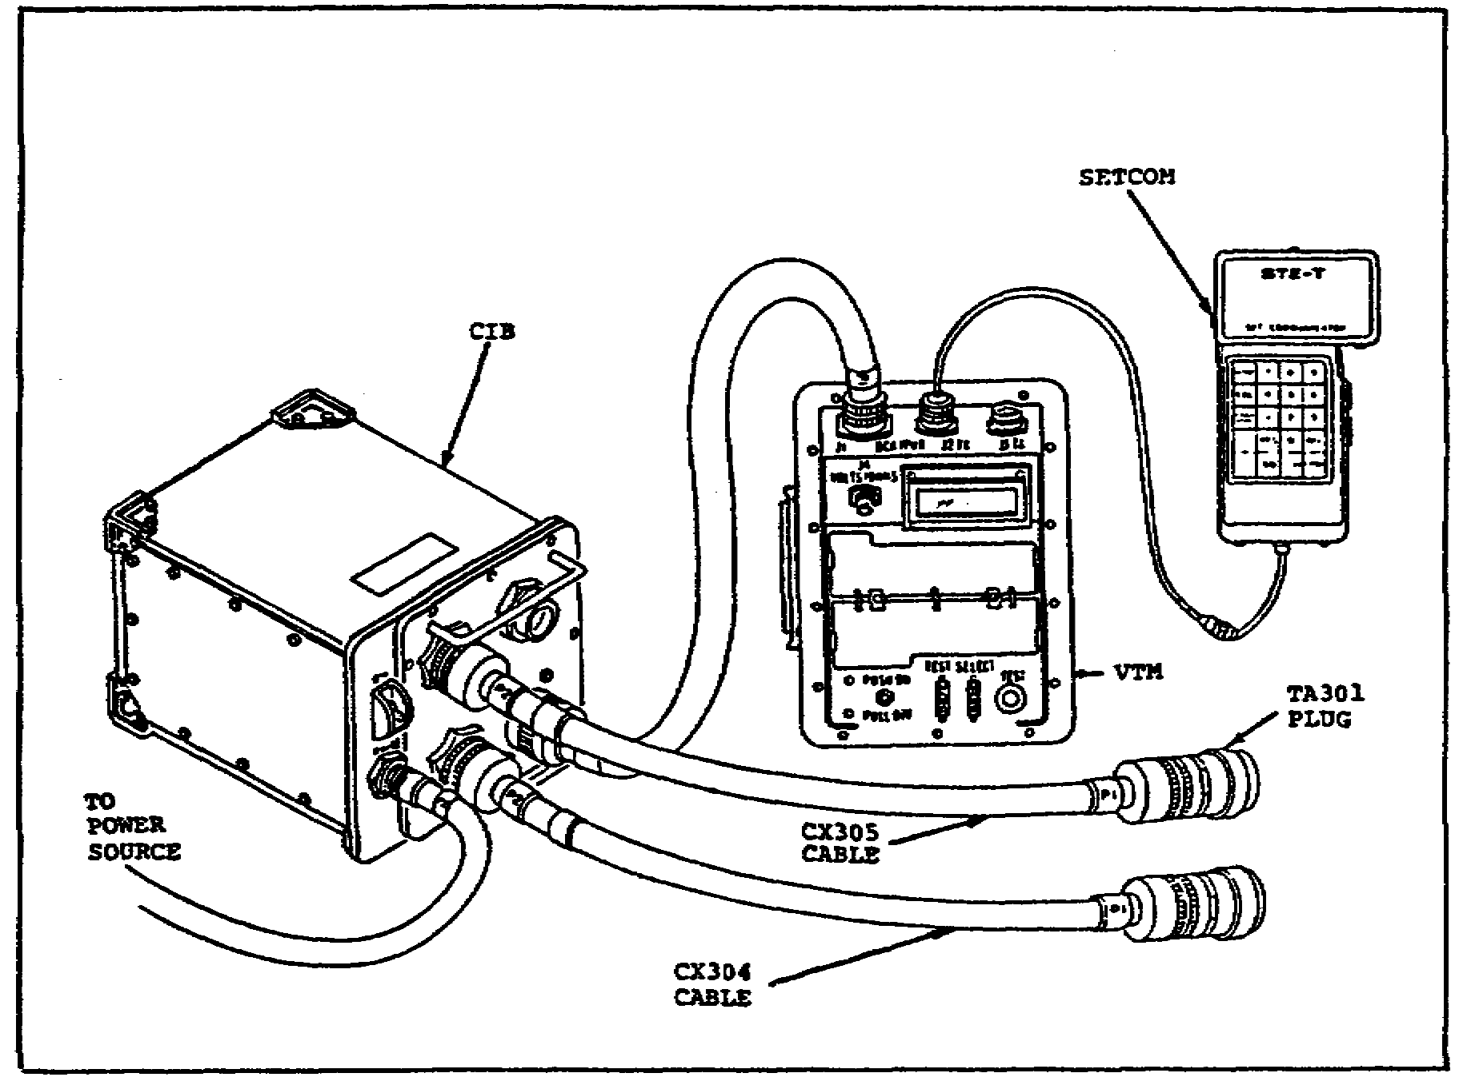

- Press the GO key. CONNECT CX305 TO CIB J2 should appear on the display. Plug the CX305-P2 connector into the J2 connector on the CIB. Remember to be careful when making the connection. The connector pins can be bent or broken.

- Press the GO key. The message CONNECT PLUG TA301 TO CX305 will appear. Plug the TA301 plug into the CX305-P1 connector, being careful not to bend or break any connector pins.

- Press the GO key. The message should be TEST IN PROGRESS PLEASE WAIT.

- Wait for the display to change. One of two messages will appear. If the message displayed is REMOVE PLUG TA301 FROM CX305, no problem has yet

24
M1 TANK AUTOMOTIVE TEST EQUIP - OD 0460 - LESSON 1/TASK 1

been found. When this is the case, continue the self-test of cable CX305. When the message REMOVE CX305 FROM CIB J2 appears, a problem has been detected. When this is the case, proceed as follows:

- When the message REMOVE CX305 FROM CIB J2 appears, remove cable CX305 from connector J2 on the CIB.

- Press the GO key. The message CONNECT CX305 TO CIB J1 will appear. Connect CX305-P2 to connector J1 on the CIB.

- Press the GO key. The message TEST IN PROGRESS PLEASE WAIT will appear on the display.

- Wait for the display to change. When a message appears, it will read one of two things. If the message says FAULTY CX305, replace cable CX305 and then repeat the self-test. If the message reads FAULTY CIB, replace the CIB, in accordance with the instructions found in TM 9-4910-751-14-1. Then repeat the self-test.

  - If no problems were found with cable CX305, the display will read REMOVE PLUG TA301 FROM CX305. When plug TA301 has been removed from cable CX305, press the GO key. The display will read TEST IN PROGRESS PLEASE WAIT.

  - Wait for the display to change. One of two messages will appear. If the display changes to read CIB CABLES OK, proceed to paragraph 3b(2)(g) on page 26 to end the self-test. If the message REMOVE CX305 FROM CIB J2 appears, there is a problem. To isolate the defective component, follow these steps:

- When the message REMOVE CX305 FROM CIB J2 appears, remove cable CX305 from connector J2 on the CIB.

- Press the GO key. TEST IN PROGRESS PLEASE WAIT will appear on the display.

- Wait for the display to change. If the new message on the display reads FAULTY CX305, replace cable CX305 and repeat the self-test. If the new message FAULTY CIB appears, replace the CIB, in accordance with the instructions found in TM 9-4910-751-14-1. Then repeat the self-test.

25

M1 TANK AUTOMOTIVE TEST EQUIP - OD 0460 - LESSON 1/TASK 1

(g) Ending the Self-test. Once it has been determined that all of the STE test set components are operating properly, the self-test is ready to be completed. To finish the self-test, follow these steps:

- Press the GO key. The message TEST FINISHED PUSH STOP AND CLEAR will appear on the display.

- Press the STOP key; then press the CLEAR key. The message ENTER TEST NUMBER will appear on the display. At this point, the test set is ready to perform tests on the vehicle. Specific instructions for using the STE-M1/FVS test set to check out and troubleshoot the M1 Abrams tank will be found in the appropriate -20 technical manuals for that vehicle. A sample task, describing the use of the test set to troubleshoot the M1 tank bilge pump circuits, is the subject of task 2 of this lesson.

4. Shutdown of the Test Set

When the test set is not to be used immediately for checking out or troubleshooting the vehicle, and when troubleshooting procedures are completed, the test set must be properly shut down and stowed.

a. Shutting Off Power and Removing the Cables. To begin the shutdown operation, follow these steps:

- Pull the circuit breaker on the VTM to the OFF position.

- Set the ON/OFF circuit breaker on the CIB to OFF.

- Unplug connector CX306-P1 from the J2 connector of the NATO adapter.

- Unplug the NATO adapter from the slave receptacle. Put the NATO adapter into the VTM/transducer kit/set communicator assembly transit case.

- Install the cover on the slave receptacle.

- Unplug connector CX306-P2 from the J5 connector on the CIB. Put cable CX306 into the test cables and adapter transit case.

26

M1 TANK AUTOMOTIVE TEST EQUIP - OD 0460 - LESSON 1/TASK 1

- Unplug connector CX309-P2 from the set communicator cable.

- Put the set communicator into the VTM/transducer kit/set communicator assembly transit case.

- Unplug connector CX305-P2 from the J2 connector on the CIB.

- Unplug connector CX304-P2 from connector J1 on the CIB.

- Put cables CX304 and CX305 and plug TA301 into the test cables and adapters transit case.

- Unplug connector W1-P2 from connector J4 on the CIB.

- Unplug connector W1-Pl from connector J1 on the VTM.

- Unplug connector CX309-P1 from connector J2 on the VTM.

- Put the VTM and the WI cable into the VTM/transducer kit/set communicator assembly transit case.

- Put the CIB into the controllable interface assembly transit case.

- Put cable CX309 into the test cables and adapters transit case.

5. Conclusion

Knowing how to set up the STE-M1/FVS test set and how to perform the self-test is a big step towards learning how useful the test set can be in troubleshooting and checking out components on the M1 tank. Task 2, of this lesson, will present a sample task illustrating the functional use of the test set during troubleshooting on the vehicle itself.

27

M1 TANK AUTOMOTIVE TEST EQUIP - OD 0460 - LESSON 1/TASK 2

LESSON 1

THE SELF-TEST AND FUNCTIONAL USE OF STE-M1/FVS

TASK 2. Describe the proper procedures for the functional use of the test set on the vehicle.

CONDITIONS

Within a self-study environment and given the subcourse text, without assistance.

STANDARDS

Within one hour

REFERENCES

No supplementary references are needed for this task.

1. Introduction

The simplified test equipment (STE) test set is normally used at the unit maintenance level to check out or troubleshoot the various subsystems on the M1 tank. Because it would be impractical to describe the use of the test set during every troubleshooting or check out procedure, this task will select a representative troubleshooting symptom to demonstrate the STE. First, however, it is necessary to become familiar with some of the STE general operating procedures.

2. Operation in the Automated Test Mode The STE test set can be operated in the automated mode or in the standard simplified test equipment/internal combustion engines (STE/ICE) mode. This task will describe the use of the STE test set in the automated mode only.

a. Test Routines. The STE troubleshooting program consists of a series of test routines identified by digital numbers. The test number for troubleshooting a specific symptom in a subsystem

28

M1 TANK AUTOMOTIVE TEST EQUIP - OD 0460 - LESSON 1/TASK 2

can be found in the Fault Symptom Index of the appropriate technical manual (TM) for the system under test. The test routines and test numbers for the subsystems can also be located in the STE Test Routines Index, also located in the TM. Table 2 shows the STE Hull Test Routines for the M1 tank.

(1) Beginning a Test in the Automated Mode. After successfully performing the STE self-test, the message ENTER TEST NUMBER will appear on the set communicator (SETCOM) display. This indicates that the STE is ready to begin testing on the vehicle in the automated mode.

- Find the number of the test either from the Fault Symptom Index of the system that is to be tested, or from the STE Test Routines Index.

- Enter the test number, using the SETCOM keyboard. The test number will appear on the SETCOM display as it is entered. If the wrong number is entered, press the CLEAR key and enter the correct number. When the complete test number is correctly entered, press the GO key to start the automated test sequence.

(2) The SINGLE STEP Key. The SINGLE STEP key on the SETCOM is used to display a single test measurement. Do not push this key unless specific instructions are given to do so in the test procedure. Pressing the SINGLE STEP key during certain test sequences can cause the wrong information to be displayed on the SETCOM.

NOTE

In table 2, when a number is followed by one *, the test will end with a NO FAULT FOUND message if the tank system is good. If a number is followed by **, the test can end with SEE -20 MANUAL, indicating that the test set measured no out-of tolerance conditions. When a number is followed by ***, the test will end with a fault message if the tank system is good, or if the test is being run for the wrong symptom, or if a fault exists. Do not run this test for serviceability or verification of the tank system.

29

M1 TANK AUTOMOTIVE TEST EQUIP - OD 0460 - LESSON 1/TASK 2

TABLE 2. STE HULL TEST ROUTINES.
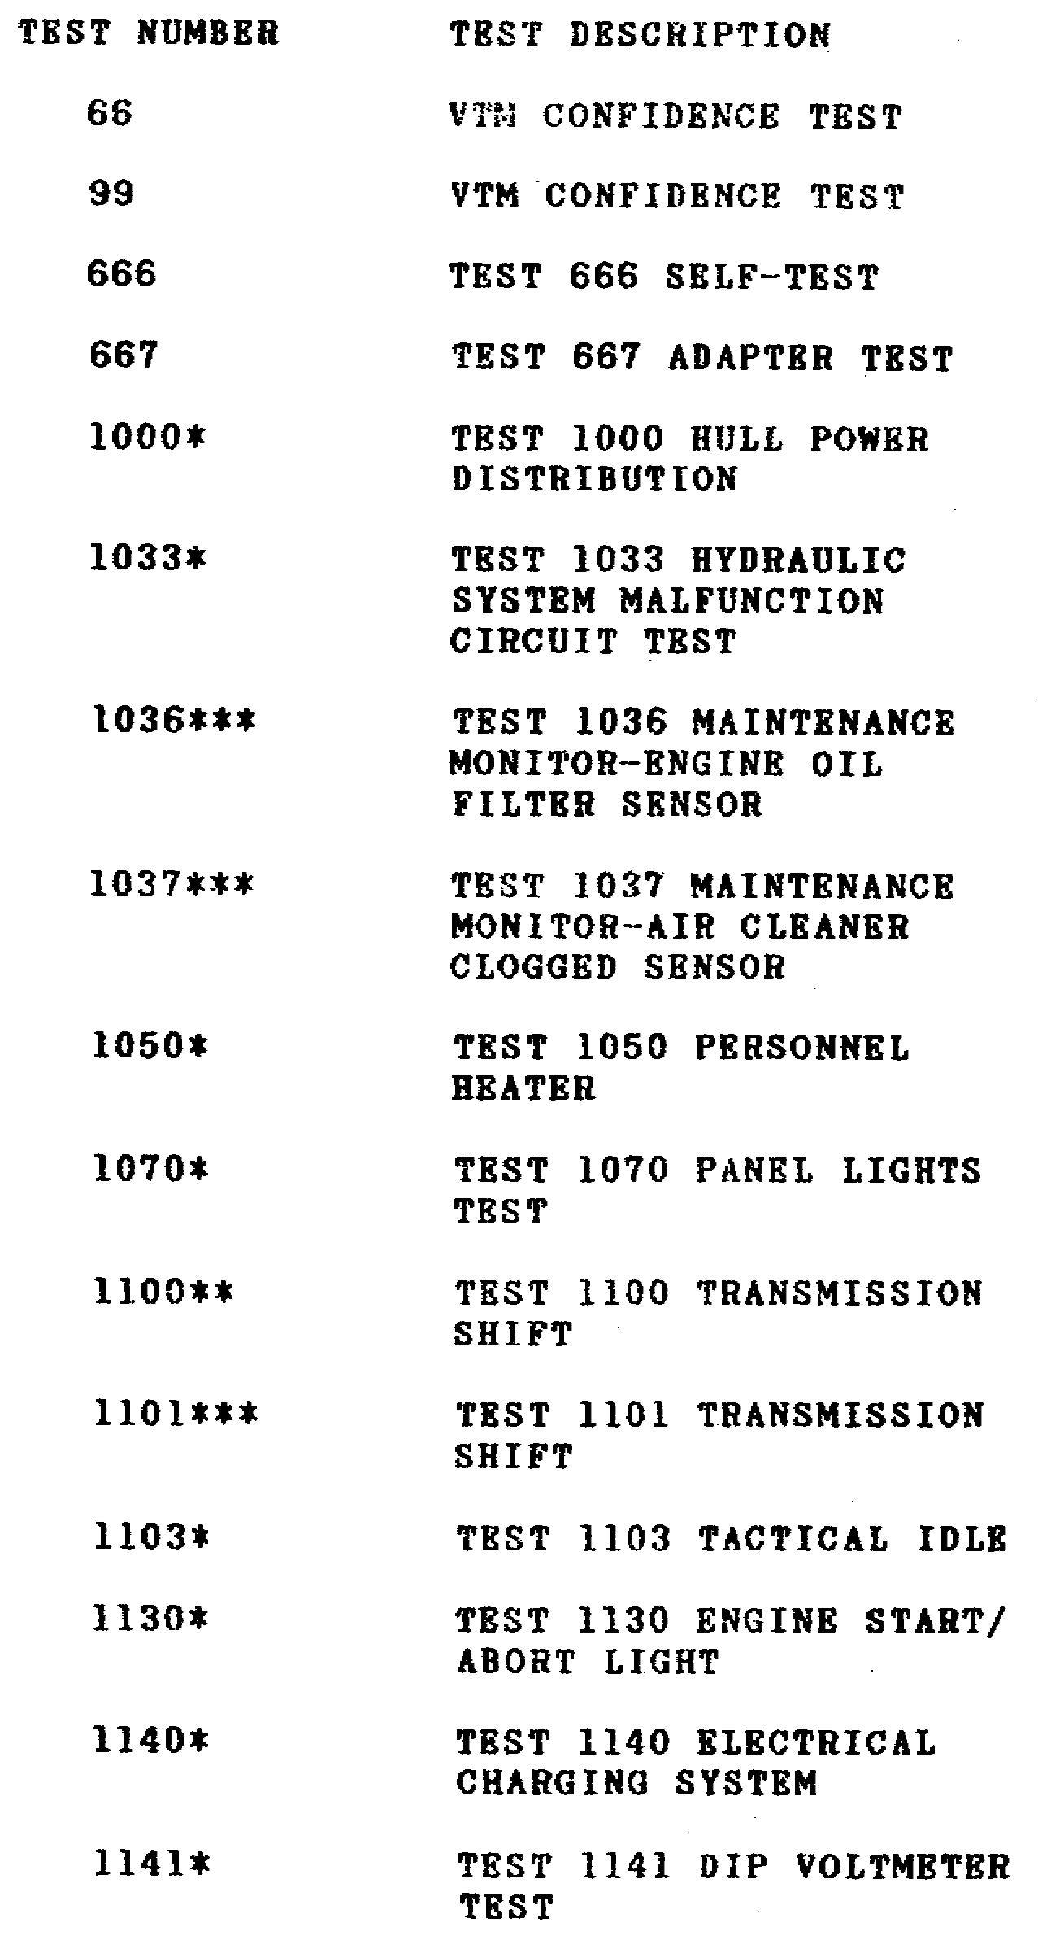

30

M1 TANK AUTOMOTIVE TEST EQUIP - OD 0460 - LESSON 1/TASK 2

TABLE 2. STE HULL TEST ROUTINES.
(CONTINUED)
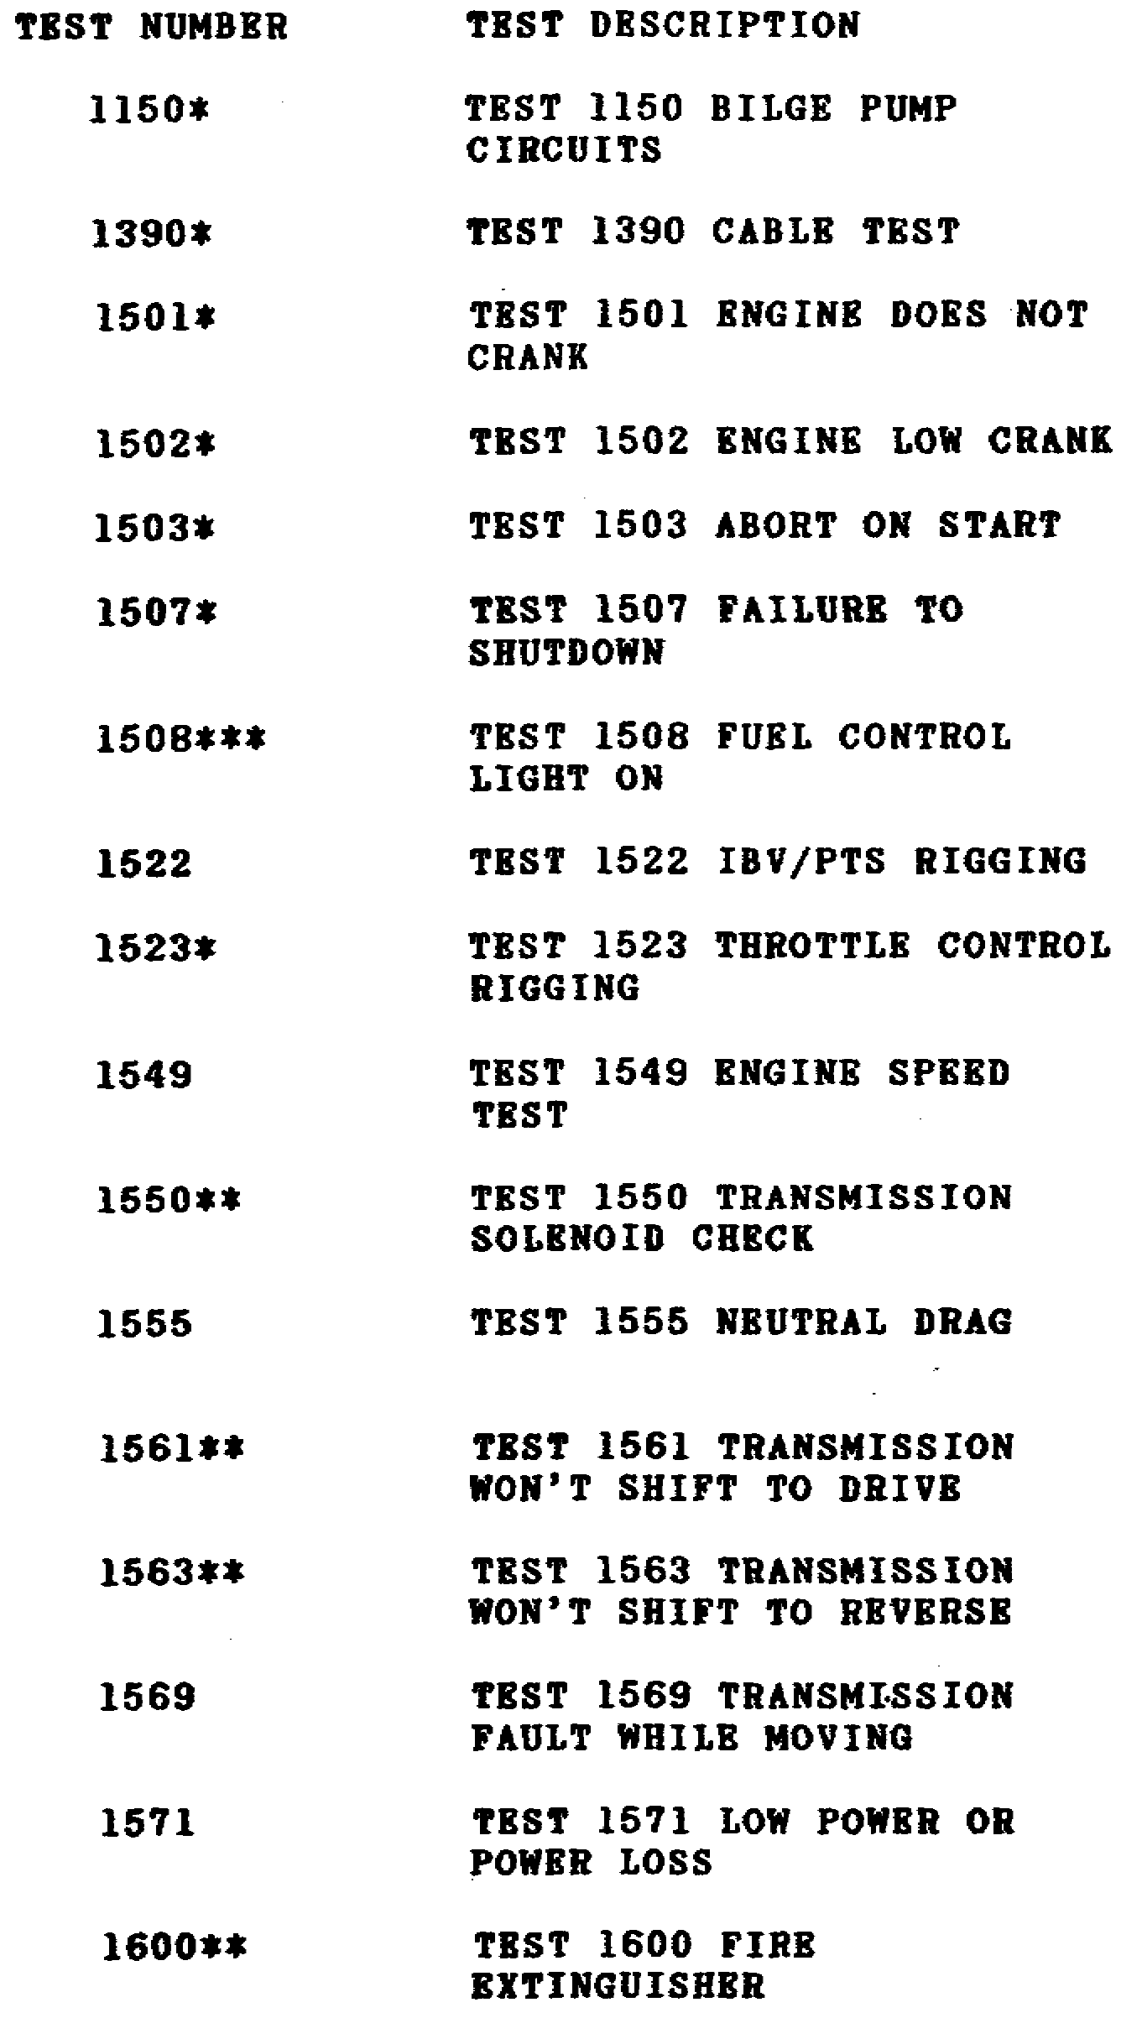

31

M1 TANK AUTOMOTIVE TEST EQUIP - OD 0460 - LESSON 1/TASK 2

b. Messages. Eight types of messages may be displayed on the SETCOM during testing. It is important to understand why the messages appear and what they are trying to communicate.

(1) Test Start Messages. A test start message is displayed every time an automated mode test number is entered on the SETCOM. An example would be: TEST 1150 BILGE PUMP CIRCUITS. Read the message to make sure the correct test number is displayed. If it is correct, push the GO key to start the test.

(2) General Instruction Messages. General instruction messages give information about something that must be done to the tank equipment, or to the test equipment. The messages are simple and do not require special explanation. An example would be: TURN ON MASTER POWER. When a general instruction message is displayed, perform the action as instructed, then press the GO key to continue the test.

(3) Cable Instruction Messages. Cable instruction messages require an action such as connecting, assembling, or disconnecting cables, test adapters, or wiring harnesses. An example would be: CONNECT CX304 P2 TO CIB J2. In this case, the message is straightforward: cable connector CX304-P2 should be connected to connector J2 on the CIB. Some of the cable messages, however, are more complex. For example, what is required by the instruction ASSEMBLE CX304, CX307, AND CA417/18 might be more difficult to determine. When this is the case, the Cable Instruction Message Index, located at the end of each troubleshooting procedure, will explain exactly how to perform the cable hookup, assembly, or disconnect action. After completing the cable instruction, press the GO key to continue testing.

(4) Special Instruction Messages. Special instruction messages usually indicate something that must be done to the equipment to help the test. In many cases the messages are short, and it is difficult to determine exactly what action is required. For example, PULL LINK PIN; REACH PTS-RVDT does not explain exactly what must be done. Therefore, for any troubleshooting procedure in which a special instruction message might be received, a Special Instruction Index is located at the back of the troubleshooting procedure to

32

M1 TANK AUTOMOTIVE TEST EQUIP - OD 0460 - LESSON 1/TASK 2

explain what the message requires. One special instruction message that is frequently shown is SEE -20 MANUAL. The meaning of this message varies from test to test. Always consult the Special Instruction Index when this message is displayed. After completing the action required by the message, press the GO key to continue the test.

(5) Question Messages. Question messages ask the operator about various components in the tank. For example, if the message reads TURRET POWER IS IT ON?, the operator must check to see if the TURRET POWER is ON. The operator must then answer the question by pushing the YES or NO key on the SETCOM to continue the testing.

(6) Information Messages. Information messages provide information about things the operator needs to know about the test. A typical example might be: VTM PROBES WILL BE USED IN VOLTS CHECK. This
message gives the operator information about the method that must be used in an upcoming test. Another example of an information message is: POWER DISTR TEST WILL RUN, PUSH GO. In this case, the operator is being informed of what test will run when the GO key is pressed.

(7) Test Termination Messages. Test termination messages signal the end of a test. There are three kinds of test termination messages.

(a) The first kind of test termination message is displayed when no faults are found by the test. In this case, the display will show the message NO FAULTS FOUND. The STOP key and the CLEAR key must then be pushed in order to repeat a test, or to begin a new test.

(b) The second kind of test termination message is displayed when the test set isolates the problem to a faulty part. This kind of message may be complete, such as FAULTY HNB 116224, indicating a faulty hull networks box. Sometimes however this kind of message may list more than one faulty part, such as the message FAULTY PCU OR 1W105 130014. When this occurs, a follow-on procedure must be performed to find out which of the listed parts is faulty. The follow-on procedures are listed in the Fault Message Index, located at the end of each troubleshooting procedure.

33

M1 TANK AUTOMOTIVE TEST EQUIP - OD 0460 - LESSON 1/TASK 2

(c) The third kind of test termination message, TEST FINISHED PUSH STOP AND CLEAR, ends a test after special information has been given. The information message will be repeated by pushing the GO key. Pushing the STOP and CLEAR keys will begin a new test.

(8) Error Messages. During testing, error messages may appear on the SETCOM display. These messages tell the operator that the test procedures have not been followed correctly, or that there is a possible test set problem. If an error message is repeatedly displayed after everything has been checked, troubleshoot the problem, using TM 9-4910-751-14-2. Also, if a similar type of message not listed below is displayed repeatedly, refer to TM 9-4910-751-14-1 to correct the problem. The common possible error messages are listed below.

- ILLEGAL CAL TEST will be displayed when a calibration test is started on a nonexistent measurement. The test number should be verified and reentered.

- TEST NOT FOUND will be displayed when the operator enters a nonexistent automatic test number. When this message appears, the test number should be verified and reentered.

- INVALID SINGLE-POINT MEASUREMENT will be displayed when the operator enters a nonexistent single-point test number. If this message appears on the display, the test number should be verified and reentered.

- THIS TEST DOES NOT USE CAL will be displayed when a calibration test is started on a measurement that is not necessary. The test number should be verified and reentered if this message appears.

- CAL REQUIRED FOR THIS TEST will be displayed if a test is requested on an uncalibrated measurement, rather than after calibration. To correct this situation, the measurement must be calibrated and the test must then be restarted.

- CHECK FOR PROPER CONNECTIONS will appear if the required connections are not made. If this happens, check for a wrong test connection. If the test connections are okay, perform a self-test on the test set cables, adapters, and test set.

34

M1 TANK AUTOMOTIVE TEST EQUIP - OD 0460 - LESSON 1/TASK 2

3. Using the STE in Troubleshooting

Knowledge of how the STE works, and the messages it displays, makes the use of the test set in troubleshooting an easy task. Since it would be impractical to describe all troubleshooting procedures in one lesson, the specific procedures for troubleshooting for the symptom BILGE PUMP SUBSYSTEM FOUND FAULTY DURING TANK OPERATION will serve as an example here.

The specific instructions for troubleshooting the symptom BILGE PUMP SUBSYSTEM FOUND FAULTY DURING TANK OPERATION are located in TM 9-2350-255-20-1-2-2, Chapter 14. Two indexes are located at the end of this task in the TM. One is the Bilge Pump Subsystem Cable Instruction Message Index. The second is the Bilge Pump Subsystem Fault Message Index. Since the information contained in these indexes is needed when using the STE to troubleshoot the bilge pump subsystem on the M1 tank, these indexes are reproduced here as Tables 3 and 4 respectively. Also, since the emphasis in this lesson is on the use of the STE test set, the troubleshooting pathways which will be more thoroughly explored will be those that involve the use of the test set. Pathways that do not involve the use of the test set will be mentioned but not described in detail.

Table 3 shows the possible cable instruction messages that may be displayed when using the STE to troubleshoot the bilge pump subsystem.

TABLE 3. BILGE PUMP SUBSYSTEM CABLE
INSTRUCTION MESSAGE INDEX.
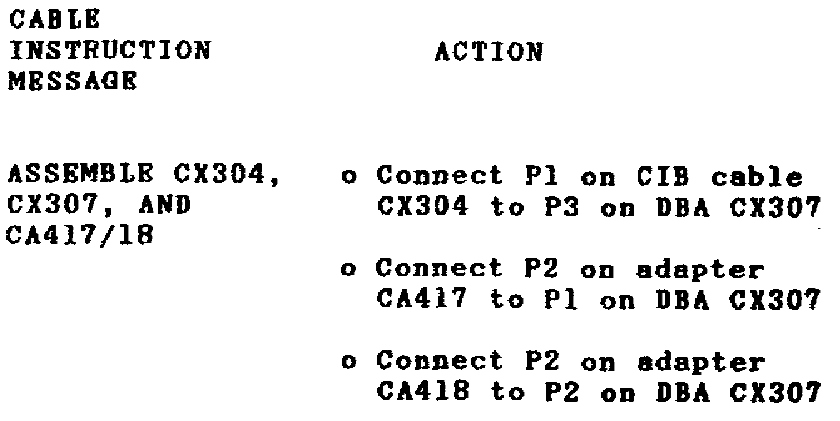

35

M1 TANK AUTOMOTIVE TEST EQUIP - OD 0460 - LESSON 1/TASK 2

TABLE 3. BILGE PUMP SUBSYSTEM CABLE
INSTRUCTION MESSAGE INDEX.
(CONTINUED)
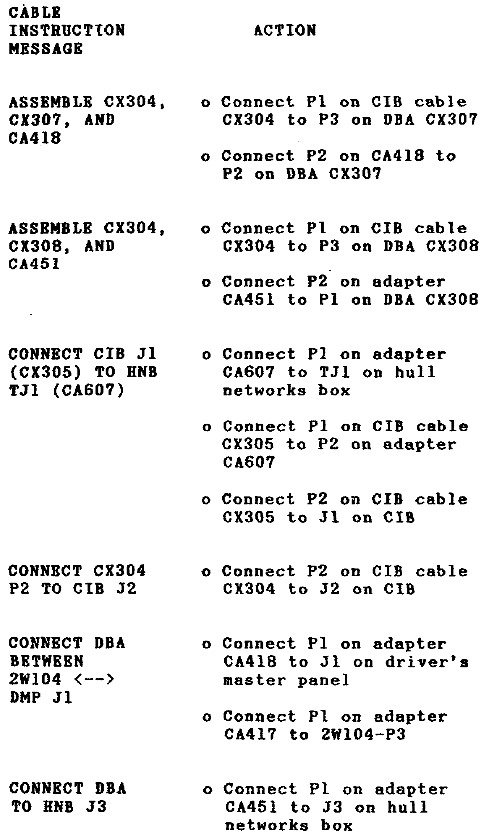

36

M1 TANK AUTOMOTIVE TEST EQUIP - OD 0460 - LESSON 1/TASK 2

TABLE 3. BILGE PUMP SUBSYSTEM CABLE
INSTRUCTION MESSAGE INDEX.
(CONTINUED)
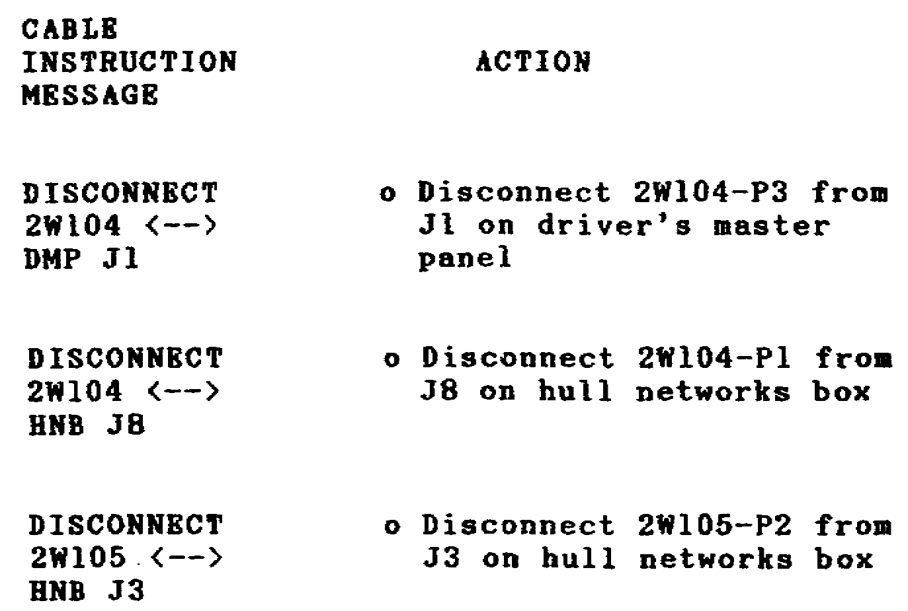

Table 4 shows the fault messages that could be displayed on the SETCOM when troubleshooting the bilge pump subsystem on the M1 tank.

TABLE 4. BILGE PUMP SUBSYSTEM FAULT
MESSAGE INDEX.
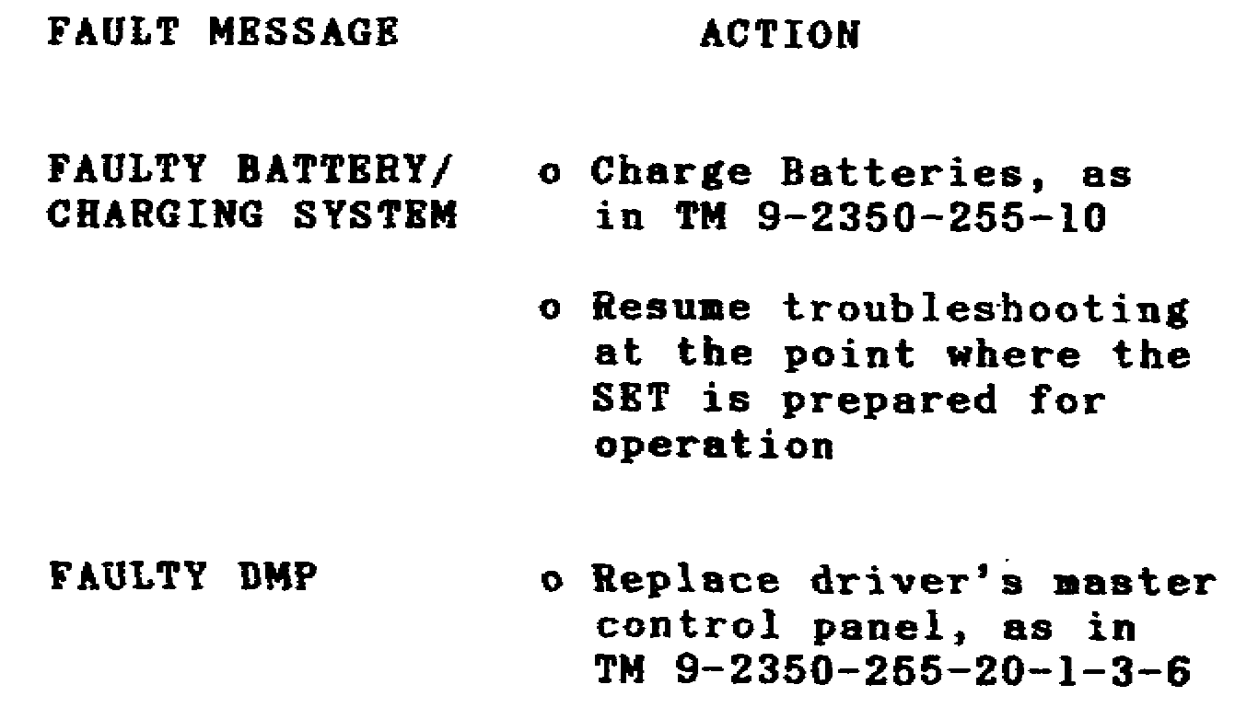

37

M1 TANK AUTOMOTIVE TEST EQUIP - OD 0460 - LESSON 1/TASK 2

TABLE 4. BILGE PUMP SUBSYSTEM FAULT
MESSAGE INDEX.
(CONTINUED)
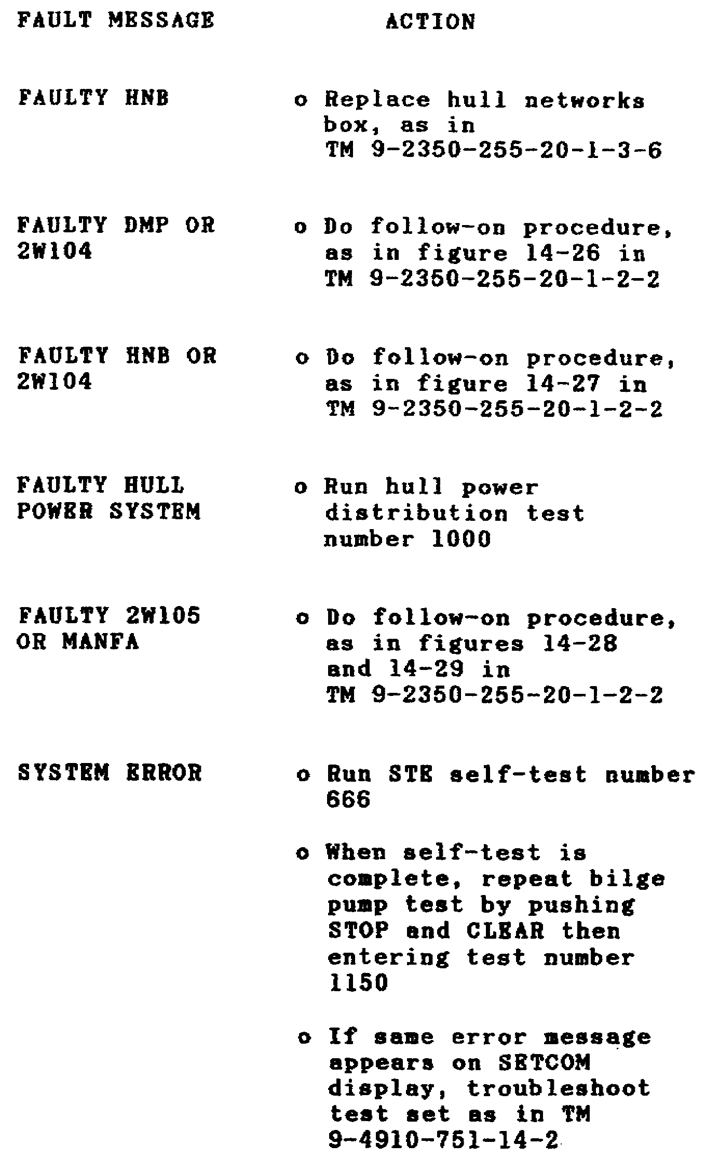

38

M1 TANK AUTOMOTIVE TEST EQUIP - OD 0460 - LESSON 1/TASK 2

a. Preparing to Troubleshoot. A number of conditions are necessary before troubleshooting of the bilge pump subsystem can be started.

(1) Common Tools Needed. The only common tool needed to perform this troubleshooting task is a pair of slip joint pliers, conduit style, with jaw inserts.

(2) Test Equipment/Special Tools. One of the pathways in this troubleshooting task requires the use of the STE-Ml/FVS test set. The TM instructs that the test set should only be procured if that point in the troubleshooting procedure is reached. For the purposes of this lesson, assume that the STE will be necessary for the troubleshooting task.

(3) Equipment Condition. The following conditions should be met before working on the vehicle.

- The tank should be parked.

- The parking brake should be set.

- The engine should be shut down.

- The vehicle master power should be off.

(4) Personnel. Two soldiers will normally be needed to perform the task. The first soldier is responsible for completing the job. The second soldier is the assistant and is directed by the first. The second soldier will only be used to perform turret traversing operations while the first soldier performs an inspection. However, since that step is part of a pathway that does not involve the use of the STE test set, a second soldier will not be needed for the purposes of this lesson.

b. Starting the Troubleshooting Procedure. The initial steps of the troubleshooting procedure for a faulty bilge pump subsystem are as follows:

(1) Set up the tank controls for standard initial test conditions, as described in TM 9-2350-255-20-1-2-2.

(2) Check-to see if an electrical connector is loose. TM 9-2350-255-20-1-2-2 lists five connector

39

M1 TANK AUTOMOTIVE TEST EQUIP - OD 0460 - LESSON 1/TASK 2

checks to be made. If any connectors are loose, a connector inspection procedure must be performed. Since this pathway does not involve use of the STE test set, it will not be followed to completion in this lesson. Assume that no connectors were loose.

(3) The next question in the troubleshooting procedures asks if the troubleshooting is being performed for the symptom BILGE PUMP DOES NOT WORK WHEN THE BILGE PUMP SWITCH IS SET TO ON. Again, since a yes reply to this question leads to a pathway not involving the STE, assume that the answer to the question is no.

(4) At this point in the troubleshooting procedure, the mechanic is instructed to make sure that the VEHICLE MASTER POWER is OFF, then to get the STE test set.

c. Using the STE to Troubleshoot. Whenever an STE test set is available, it should be used in conjunction with the primary troubleshooting procedures as outlined in the TM. If an STE test set is not available, alternate troubleshooting procedures must be performed. Alternate troubleshooting procedures involve the use of the breakout box and multimeter instead of the STE.

These alternate procedures will be discussed in lessons 2 and 3 of this subcourse. For the purpose of this task, assume that an STE test set is available.

(1) Prepare the STE for Operation. Before the STE can be used in troubleshooting, it must be properly prepared for operation as described in task 1 of this lesson.

(2) Using the STE. Once the STE is properly prepared for operation, the troubleshooting procedure can continue.

(a) The display on the SETCOM will show ENTER TEST NUMBER. Looking at Table 2, (STE Hull Test Routines) on page 30, one finds that the test number for the bilge pump circuits is 1150. (This test number can also be found in the Bilge Pump Subsystem Fault Symptom Index at the beginning of the troubleshooting task in TM 9-2350-255-20-1-2-2.)

40

M1 TANK AUTOMOTIVE TEST EQUIP - OD 0460 - LESSON 1/TASK 2

FIGURE 14. USING THE SETCOM UNIT.
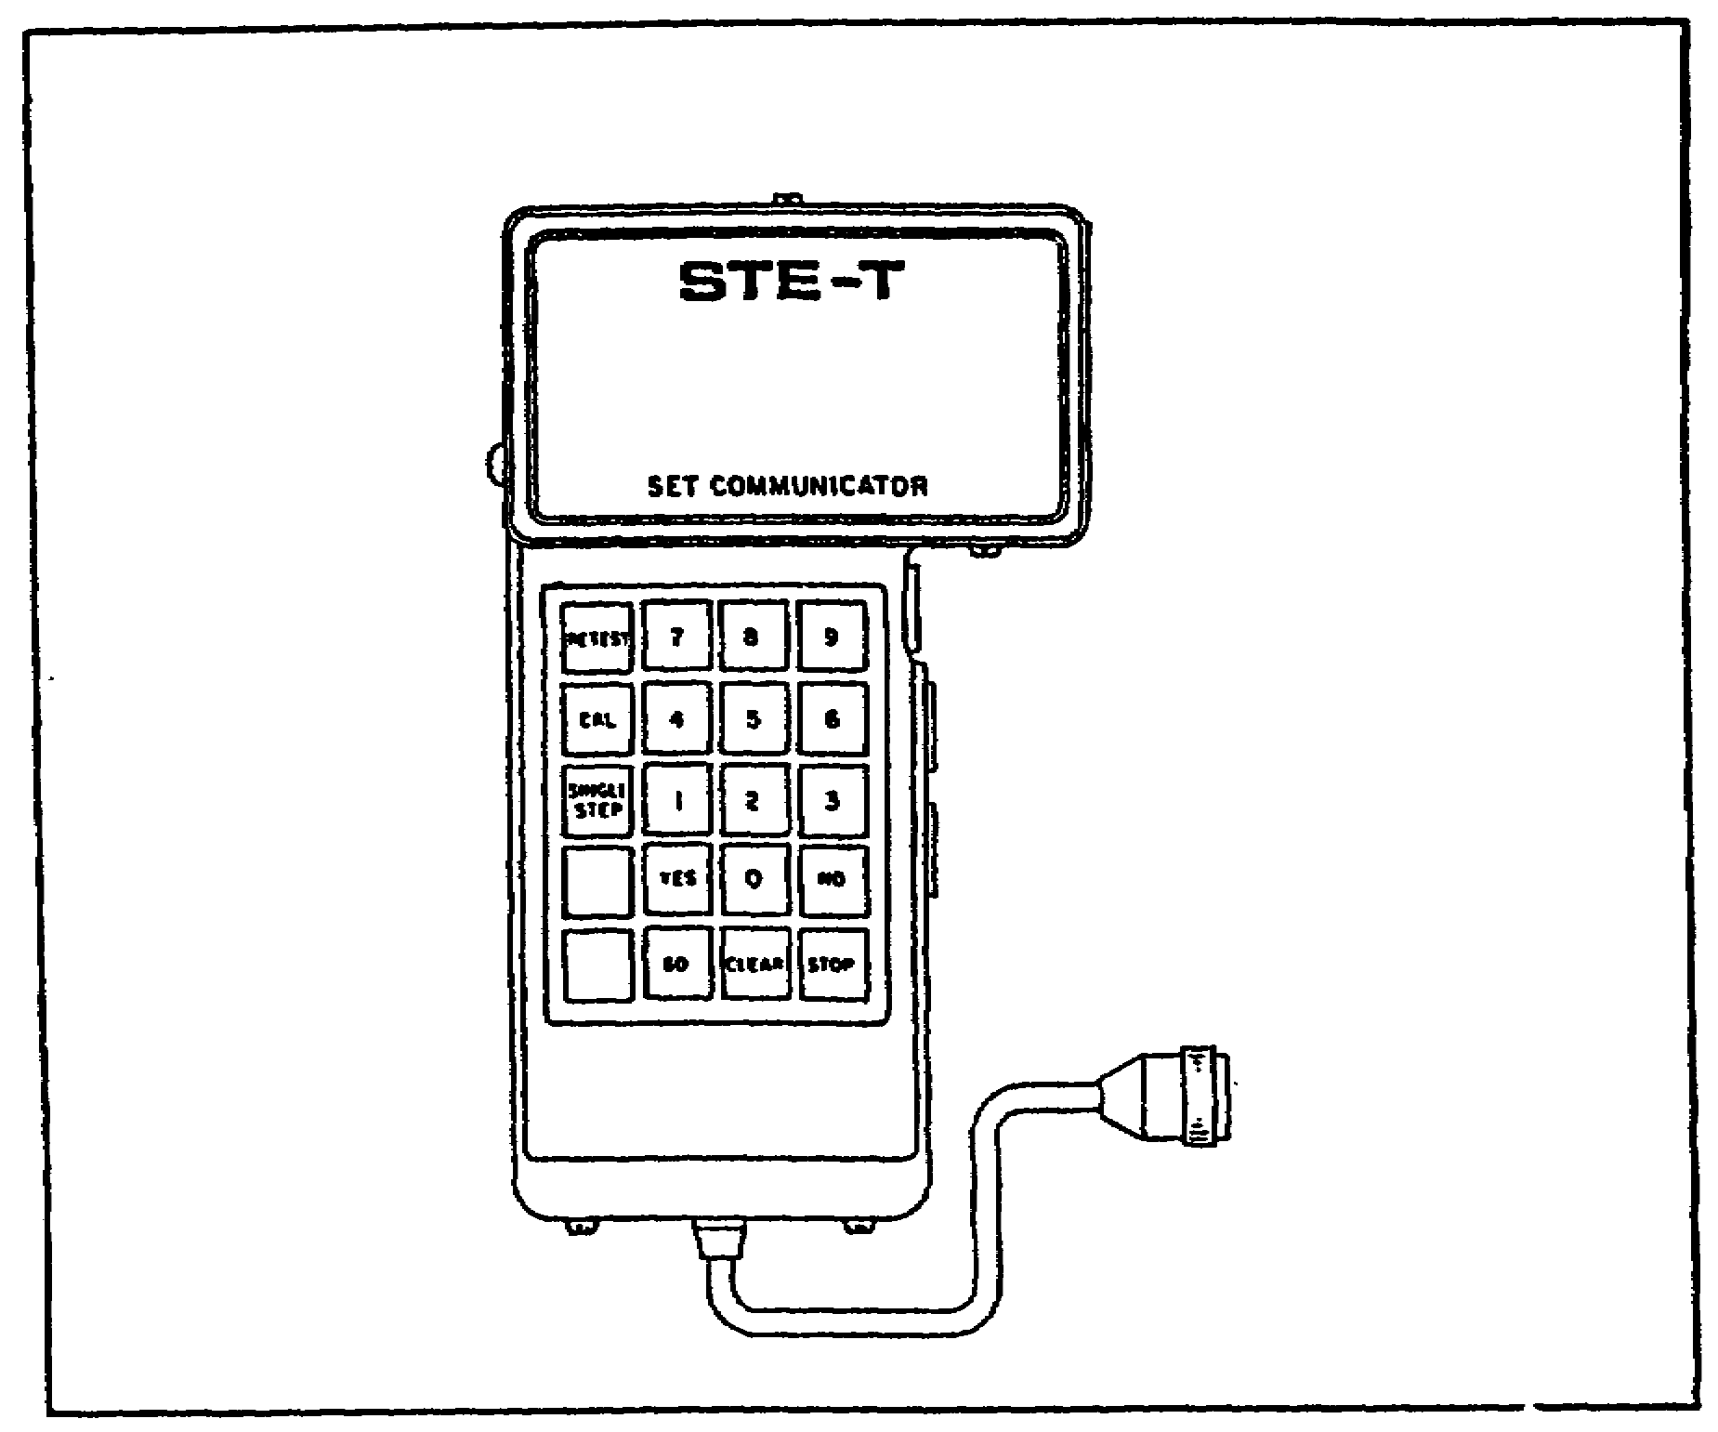

- Enter test number 110 using the SETCOM keys (figure 14).

- Press the GO key. The display should read TEST 1150 BILGE PUMP CIRCUITS.

(b) When the message identifies the proper test number and description, press the GO key again. The display will show a message. All further actions in this troubleshooting task depend on the nature of the messages displayed and the information they are giving.

- If a general information message is displayed, such as TURN ON MASTER POWER, do what the message requires. Then press the GO key and follow the next display message.

- If an assemble, connect, disconnect, or remove message appears, refer to the Bilge Pump Subsystem

41

M1 TANK AUTOMOTIVE TEST EQUIP - OD 0460 - LESSON 1/TASK 2

Cable Instruction Message Index (table 3 on page 35) and perform the action required. Then press the GO key, and read the next displayed message.

- If a fault message appears on the display, refer to the Bilge Pump Subsystem Fault Message Index (table 4 on page 37) and perform the required action. Then verify that the problem is solved.

- If the display shows NO FAULTS FOUND, the test set was not able to locate a faulty component. This message will generally appear during a retest, after the problem has already been located and corrected.

42

M1 TANK AUTOMOTIVE TEST EQUIP - OD 0460 - LESSON 1/PE 1

PRACTICAL EXERCISE 1

1. Instructions

Read the scenario and respond to the requirements that follow the scenario.

2. Scenario

You have just reported back to your unit after graduating from the advanced course. Because of your outstanding performance during the training, the commander has selected you to give instruction to the unit on the hook-up, self-test, and functional use of the simplified test equipment (STE) for the M1 Abrams tank.

First Requirement

To teach the hook-up and self-test of the STE test set, you decide to give a demonstration using the equipment. Below are some statements describing actions you perform during the demonstration. Fill in the blanks to correctly complete each statement.

a. When hooking-up the test set in preparation for the self-test, cable CX306 is connected to connector _ _ _ _ _ _ _ on the controllable interface box (CIB).

b. When all STE connections are complete and power is turned ON at the CIB and the vehicle test meter (VTM), the first message to appear on the VTM display is _ _ _ _ _ _ _ followed by _ _ _ _ _ _ _.

c. The test number entered on the set communicator (SETCOM) to perform the self-test is _ _ _ _ _ _ _.

d. Test number 66 is a confidence test for the _ _ _ _ _ _ _.

e. The _ _ _ _ _ _ _ connects to cable CX306-P1, and also plugs into the slave receptacle on the power distribution box.

Second Requirement

When the self-test demonstration is completed, you continue the demonstration by using the

43

M1 TANK AUTOMOTIVE TEST EQUIP - OD 0460 - LESSON 1/PE 1

troubleshooting malfunction symptom BILGE PUMP SUBSYSTEM FOUND FAULTY DURING TANK OPERATION to illustrate the functional use of the STE test set. Answer these questions about how the STE test set is used to troubleshoot this fault.

a. In which index can the test number for this malfunction be located?

b. What is the test number for this malfunction?

c. During troubleshooting, the SETCOM display shows a general instruction message. After performing the instruction required by the message, which key on the SETCOM should be pressed?

d. During troubleshooting, the message CONNECT DBA TO HNB-J3 appears on the SETCOM. What index contains the information about the appropriate action to be taken?

e. During troubleshooting, the message FAULTY HNB OR 2W104 appears on the SETCOM. What index contains the information about the appropriate action to be taken?

44

M1 TANK AUTOMOTIVE TEST EQUIP - OD 0460 - LESSON 1/PE 1

LESSON 1. PRACTICAL EXERCISE - ANSWERS

First Requirement

a. Connector J5

b. .8.8.8.8 followed by - - - - (four dashes)

c. 666

d. VTM

e. NATO adapter CA1

Second Requirement

a. The Hull Test Routines Index or the Fault Symptom Index

b. 1150

c. GO

d. The Cable Instruction Message Index

e. The Fault Message Index

45

M1 TANK AUTOMOTIVE TEST EQUIP - OD 0460 - LESSON 2/TASK 1

LESSON 2

THE HOOK-UP AND USE OF THE MULTIMETER

TASK 1. Describe the proper procedures for the inspection, hook-up, and use of the TS-352 B/U multimeter.

CONDITIONS

Within a self-study environment and given the subcourse text, without assistance.

STANDARDS

Within one hour

REFERENCES

No supplementary references are needed for this task.

1. Introduction

The TS352 B/U multimeter is the most commonly found multimeter in the automotive unit maintenance number 1 and number 2 common tool sets. It is of military design and is an important and useful piece of test equipment. It can be used to make voltage, resistance, and continuity checks on the M1 tank circuits; and, when the STE-M1/FVS test set is not available, the TS352 B/U multimeter is used in conjunction with the breakout box to troubleshoot malfunctions in the various M1 tank subsystems. It is, therefore, important to know how to care for and use the multimeter. This task describes the inspection procedures for the TS352 B/U multimeter and describes the proper procedures for the hook-up and use of the multimeter.

2. Inspecting the TS352 B/U Multimeter Before using the multimeter, it is important to perform a brief inspection to make sure that the multimeter is in good shape, so that it will make accurate measurements.

46

M1 TANK AUTOMOTIVE TEST EQUIP - OD 0460 - LESSON 2/TASK 1

a. Inspection Points. There are a number of points on the multimeter which should be inspected before the multimeter is used (figure 15). Simple problems, such as a jack plug that needs to be tightened, can be fixed on the spot. When an item is found to be damaged however, such as a broken meter or a badly frayed cable, repair instructions can be found in TM 11-6625-366-15.

(1) Cables. The first items to be inspected are the multimeter cables.

FIGURE 15. THE TS352 B/U MULTIMETER.
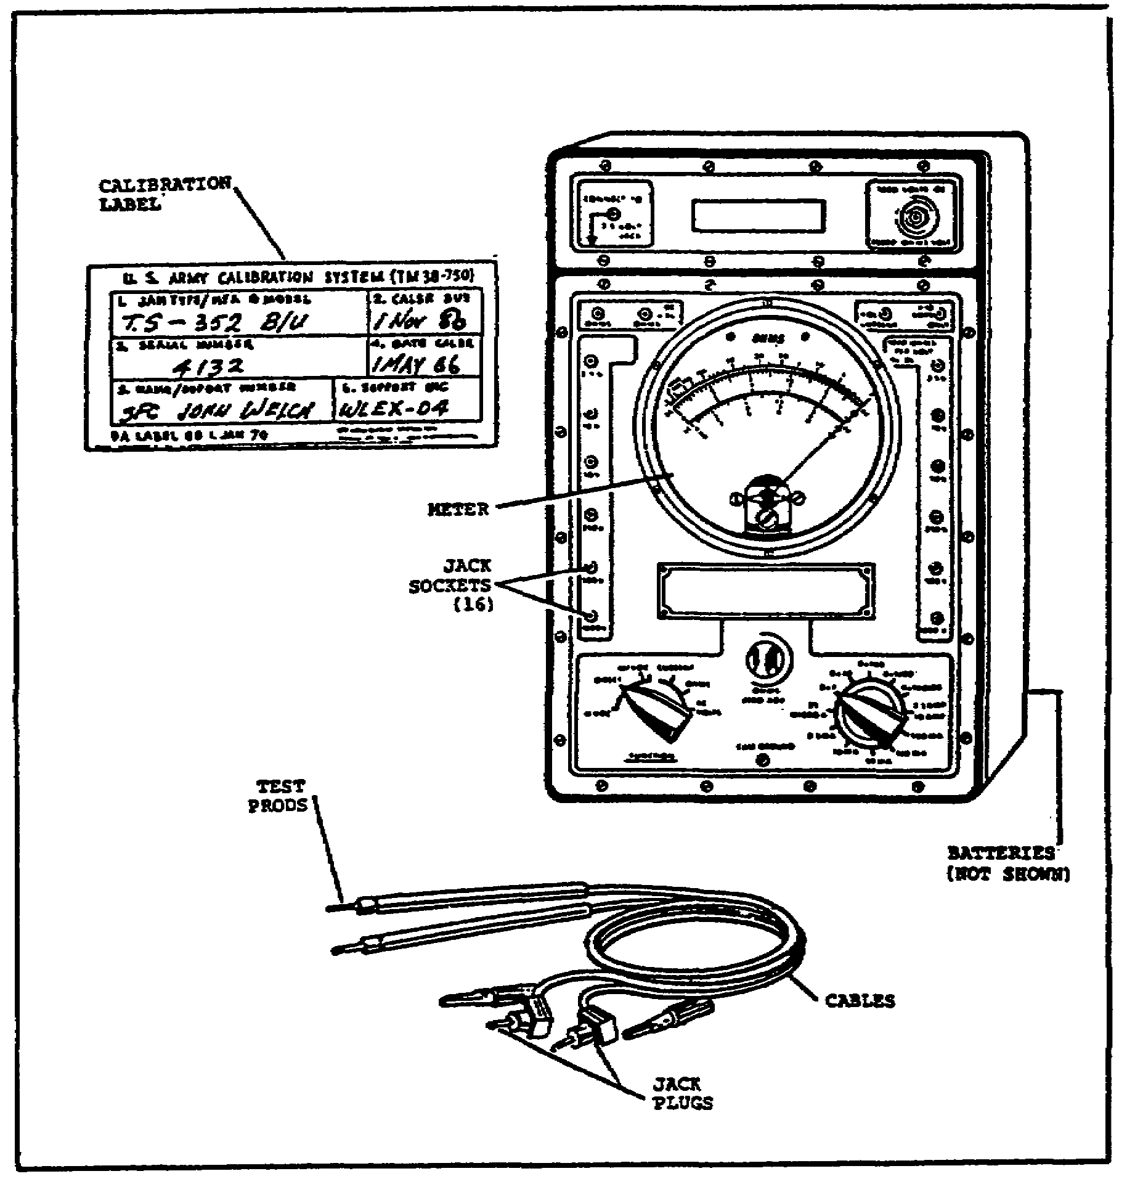

47

M1 TANK AUTOMOTIVE TEST EQUIP - OD 0460 - LESSON 2/TASK 1

- Inspect the cables for cuts, sharp nicks, and fraying.

- Inspect the cable jack plugs; they should be tight on the cables and the prods should be clean.

- Inspect the cable test prods; they should be tight on the cable, and the tips should be free of paint or any other substance that may act as an insulator.

(2) Calibration Label. Check the dates on the calibration label. The TS352 B/U multimeter must be recalibrated every six months; therefore, be sure that the multimeter has been calibrated within that period.

(3) Meter. Inspect the meter to be sure that the glass and/or the pointer are not broken. The pointer should be resting over the zero marks at the left side of the scales.

(4) Jack Sockets. Make sure that the jack sockets are open and free of dirt.

(5) Batteries. Make sure that the batteries are not corroded or leaking. Check to be sure that the batteries are installed correctly.

(6) Switches. Move the switches to make sure that they work freely without binding or scraping.

3. Performing a Zero Adjust

Since the multimeter should be zero adjusted before it is used in a test and whenever the RANGE switch is moved during a test, the zero adjust procedure will be described first. Use the steps below to zero adjust the TS352 B/U multimeter (figure 16 on the following page).

- Set the range switch to the desired range of ohms position.

- Plug the black lead into the ohms -DC +AC jack. Put the red lead into the left ohms jack.

- Place the FUNCTION switch on OHMS.

- Now zero adjust the meter. Touch the two probes together and turn the OHMS ZERO ADJ knob until the needle settles exactly over the "0"

48
M1 TANK AUTOMOTIVE TEST EQUIP - OD 0460 - LESSON 2/TASK 1

(zero) that is on the right side of the very top meter scale.

FIGURE 16. ZERO ADJUSTING THE MULTIMETER.
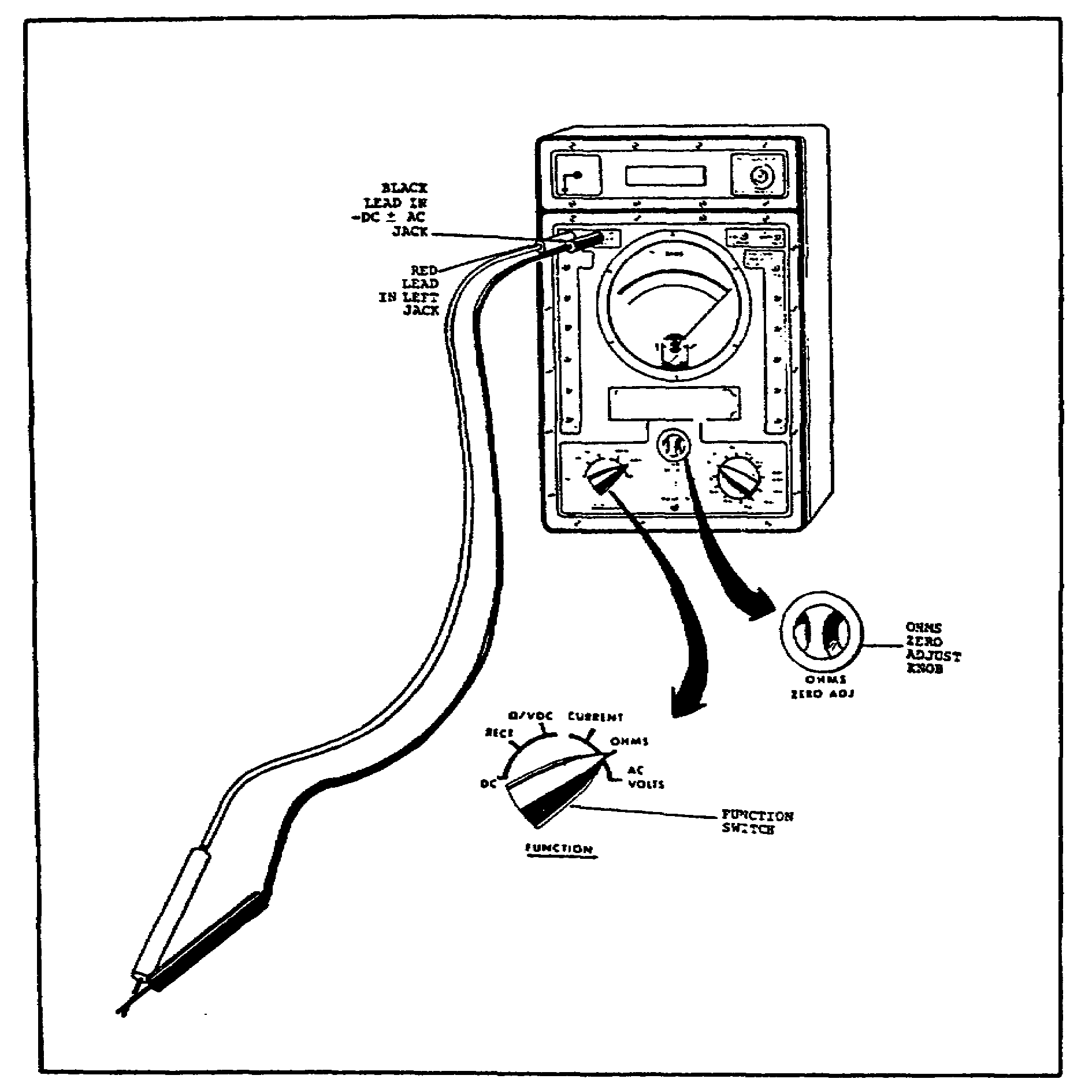

4. Performing DC (Direct Current) Voltage Tests One of the important uses for the TS352 B/U multimeter is to make direct current (dc) voltage tests. These tests are used to measure battery voltage, charging system output voltage, and voltage drops at various test points. Bad connections, poor wiring, and dirty switch contact points will cause errors in voltage readings. To

49

M1 TANK AUTOMOTIVE TEST EQUIP - OD 0460 – LESSON 2/TASK 1

get accurate readings, measure at the exact circuit points given in the electrical circuit troubleshooting diagrams in the M1 tank TMs. Follow the steps below to make dc voltage tests (figure 17).

FIGURE 17. DC VOLT, GE TESTS.
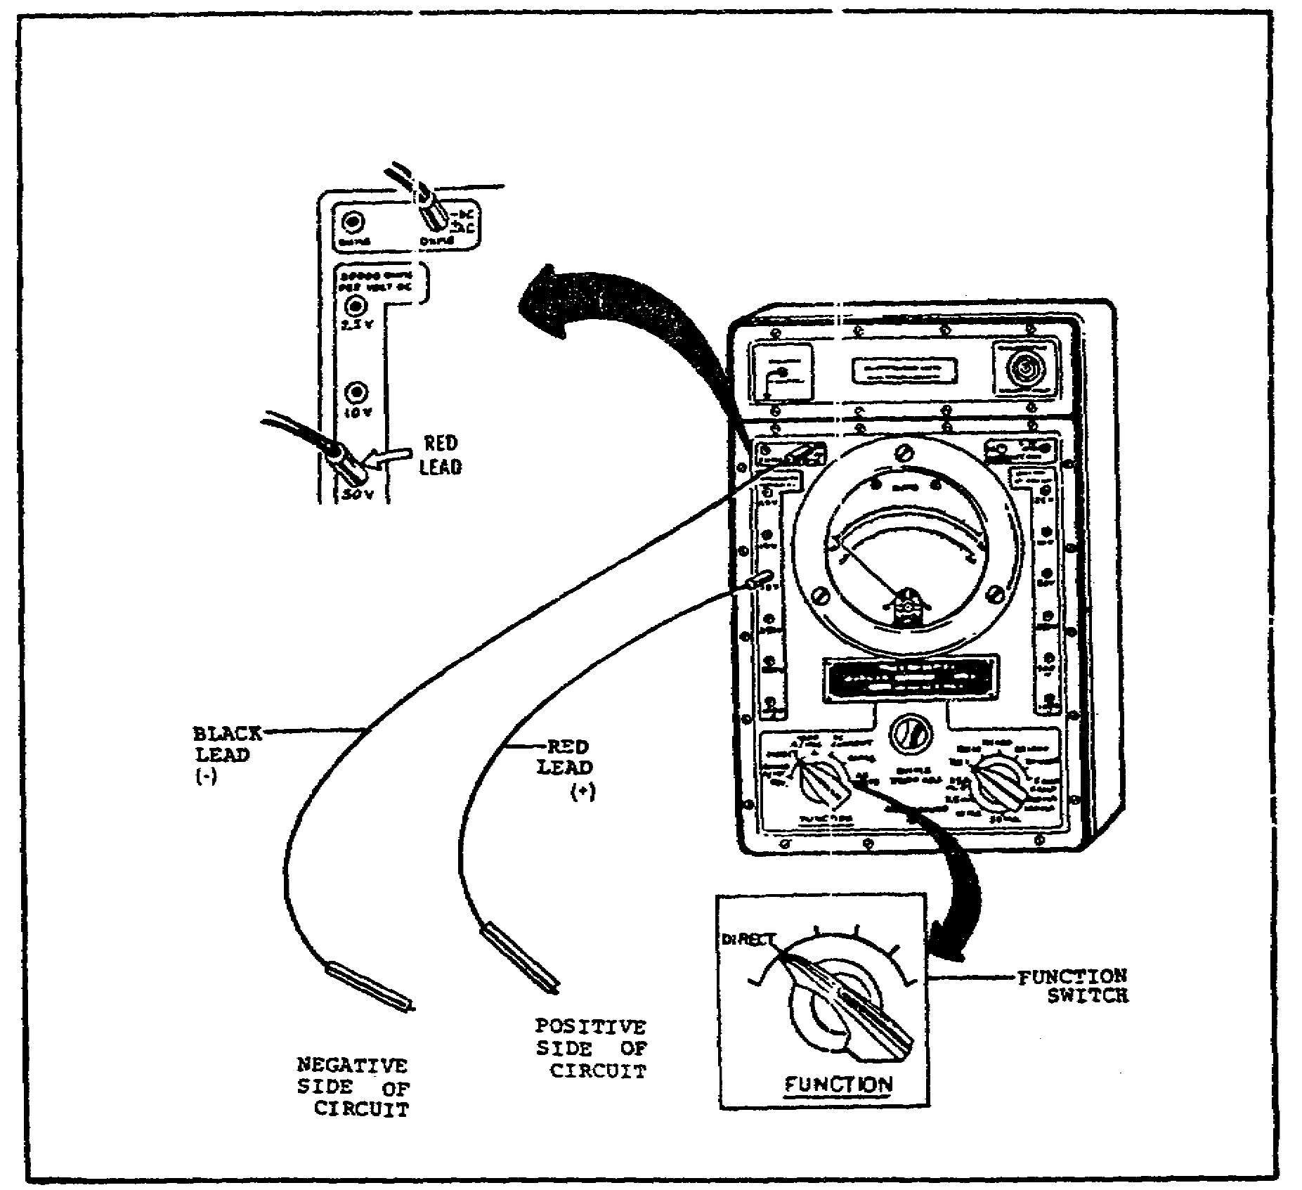

- Set the FUNCTION switch to DIRECT.

- Plug the black test lead into the OHMS -DC +AC jack. Plug the red lead into the 50V jack that is in the 20000 OHMS per volt dc column on the left side of the multimeter.

50

M1 TANK AUTOMOTIVE TEST EQUIP - OD 0460 - LESSON 2/TASK 1

NOTE

The red lead is plugged into the 50V jack because this lesson assumes that the circuit being tested will be a part of the M1 tank 28 volt system. When testing circuits in other voltage ranges, plug the red lead into the jack that is suitable for the range of voltage being tested.

- Make the dc voltage test by connecting the black probe to the negative (ground) side of the circuit being tested. Connect the red probe to the positive side of the circuit at the point where the voltage is being measured. All contact points, especially the ground (vehicle chassis), must be bare metal and clean.

- Take the dc voltage reading, using the dc scale for the range of the jack to which the red lead is connected. Since the red lead is, in this case, connected to the 50V jack, make the readings on the dc scale using the figures in the middle row (the one that ends with a 5). Read the figures on that scale by multiplying each number on the scale by 10. Thus, the scale readings will be 10, 20, 30, 40, and 50.

- If the meter pointer moves in the opposite direction (tries to move off the scale to the left), reverse the test leads at the point of contact to correct the polarity; or, if preferred, set the FUNCTION switch to 20000/VDC REV to reverse the polarity.

5. Measuring for High Resistance or a Drop in Voltage

The TS352 B/U multimeter is useful for performing tests for high resistance and for drops in voltage. These tests are used to find any voltage loss caused by a bad part or a faulty connection. Use the steps listed below to perform a test for high resistance or a drop in voltage.

- Leave the red (positive) test lead plugged into the 50V jack and the black lead plugged into the -DC tAC jack. The FUNCTION switch should remain on DIRECT, just as in the dc voltage test.

51

M1 TANK AUTOMOTIVE TEST EQUIP - OD 0460 - LESSON 2/TASK 1

- Place the test leads across the suspected connection or part, with the red lead on the plus side and the black lead on the ground side.

- What is done next depends on the circuit being tested. Generally, the circuit is loaded down by turning on something like the headlights.

- Make the voltage reading on the dc scale ending in 5, just as in the dc voltage test. If only a flicker of the needle is seen on the 50V scale, move the red lead to the 10V jack and try again. If there is still only a flicker of movement, try the 2.5V jack. A no voltage reading on the DC 25 (2.5) scale means that the connection or part is good. Any high resistance reading over 1 volt usually means that the part or connection is bad. However, in all tests, abide by the values and methods cited in the M1 tank TM being used during the test.

6. Continuity and Resistance Tests

The TS352 B/U multimeter can also be used to make continuity and resistance tests.

a. Continuity Tests. Continuity tests are used to test for broken or loose wires, closed or short circuits and burned-out lamps.

- Set the RANGE switch to RX 1, unless there is a transistor in the circuit. If a transistor is in the circuit, use the RX100 setting.

- Plug the black lead into the -DC +AC jack and the red lead into the upper left OHMS jack (figure 18 on the following page).

- Set the FUNCTION switch on OHMS.

- Touch the black lead to one end of the circuit and the red lead to the other end.

- If the needle swings to the extreme right, the circuit could be either closed but good or closed but shorted depending on the reason for the test.

- When testing solid state circuits, if the needle doesn't move, try switching the probes at the point of contact. If the needle still doesn't move, the circuit is open.

- A flickering needle means a loose connection.

52

M1 TANK AUTOMOTIVE TEST EQUIP - OD 0460 - LESSON 2/TASK 1

FIGURE 18. CABLE POSITIONS FOR CONTINUITY
AND RESISTANCE TESTS.
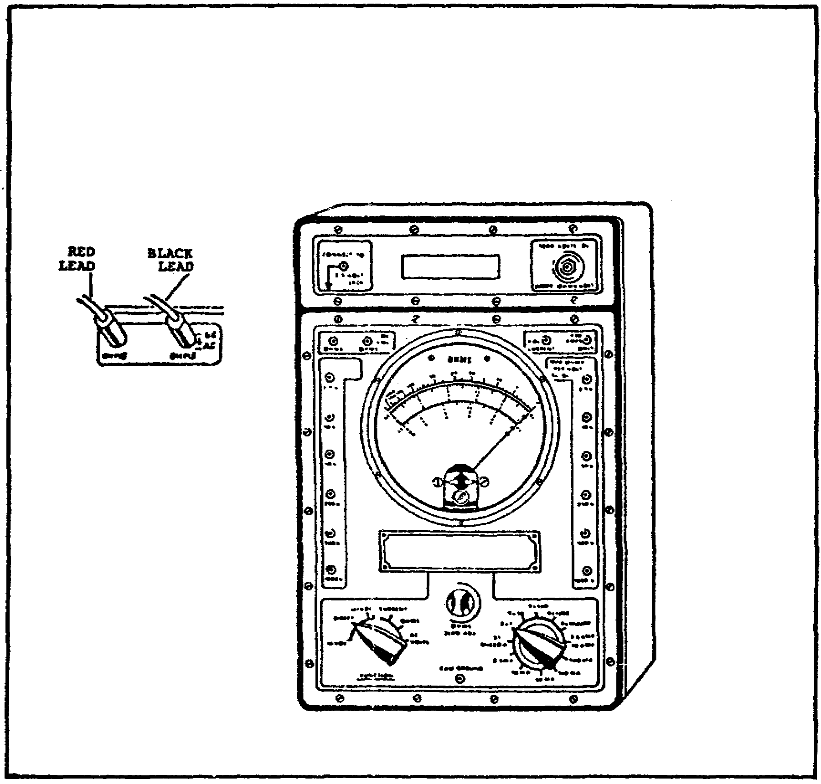

b. Resistance Tests. Resistance tests are used to measure the resistance of coils and resistors.

NOTE

Before beginning a resistance test, make sure no battery voltage is connected to the circuit to be tested. Use the meter to see if any voltage is present, or disconnect the battery ground cable. This will prevent possible burnout of the meter.

53

M1 TANK AUTOMOTIVE TEST EQUIP - OD 0460 - LESSON 2/TASK 1

- Plug the black lead into the -DC +AC jack and the red lead into the upper left OHMS jack.

- Set the FUNCTION switch in the OHMS position.

- If the approximate ohms rating of the circuit to be tested is known, set the RANGE switch to that RX value. If the rating is not known, set the RANGE switch to RX10000. When testing the resistance of transistor circuits, use the RX100 range setting only. This limits the meter's power source to only 1.5 volts. A higher RX setting may destroy the transistors or electrolytic capacitors.

- Connect the test probes across the item to be checked.

- If the needle is not on the meter scale, turn the RANGE switch slowly counterclockwise one range step at a time until the needle is on the meter.

- Then, zero adjust the meter.

7. Conclusion

When putting the multimeter away, stow all the test leads neatly in their proper compartment. Set the FUNCTION switch in the DC CURRENT position and set the RANGE switch to any MA setting. This will prevent battery drain and keep the meter needle from being jolted while being carried.

54

M1 TANK AUTOMOTIVE TEST EQUIP - OD 0460 - LESSON 2/PE 2

PRACTICAL EXERCISE 2

1. Instructions

Read the scenario and respond to the requirements that follow the scenario.

2. Scenario

You have been placed in charge of a maintenance unit in which most of the mechanics have just come out of school. When performing maintenance tasks, many of the mechanics are running into trouble because they are getting multimeter readings that are way out of line with the specifications in the TMs. You decide that the failure is probably not with the multimeters, but with the way they are being used. When you ask a few questions, you find that most of the mechanics are being exposed to the TS352 B/U multimeter for the first time. Therefore, you decide to spend some time instructing them on the use of this particular multimeter.

First Requirement

As a first step, you review with the mechanics the inspection procedures for the TS352 B/U multimeter. Provide the answers for the questions listed below.

a. Name three things that should be checked when inspecting the multimeter cables.

b. How often must the multimeter be calibrated?

c. What is being checked for when the batteries are inspected?

Second Requirement

After reviewing the procedures for making various tests using the multimeter, you give the mechanics the brief written quiz shown below. Provide the correct answers to the questions.

a. In what position must the FUNCTION switch be set to perform a dc voltage test?

b. In what position must the FUNCTION switch be set to perform a continuity check?

55

M1 TANK AUTOMOTIVE TEST EQUIP - OD 0460 - LESSON 2/PE 2

c. In what position must the FUNCTION switch be set to perform a resistance test?

d. When performing a resistance test on a transistor circuit, in what position must the RANGE switch be set?

e. For all tests mentioned above, which cable should be plugged into the -DC +AC jack?

56

M1 TANK AUTOMOTIVE TEST EQUIP - OD 0460 - LESSON 2/PE 2

LESSON 2. PRACTICAL EXERCISE - ANSWERS

First Requirement

a.(1) Check the cables for cuts, sharp kinks or fraying.

(2) Make sure the test prods are on tightly and their tips are free of paint or any substance that might act as an insulator.

(3) Make sure the jack plugs are on tightly and that the prods are clean.

b. Every 6 months.

c. The batteries should be checked for corrosion or leaking and to be sure they are installed correctly.

Second Requirement.

a. DIRECT.

b. OHMS.

c. OHMS.

d. RX 100.

e. The black (-) cable.

57

M1 TANK AUTOMOTIVE TEST EQUIP - OD 0460 - LESSON 3/TASK 1

LESSON 3

THE HOOK-UP OF THE BREAKOUT BOX AND MULTIMETER

TASK 1. Describe the proper procedures for setting up the breakout box.

CONDITIONS

Within a self-study environment and given the subcourse text, without assistance.

STANDARDS

Within one hour

REFERENCES

No supplementary references are needed for this task.

1. Introduction

Another piece of test equipment used on the M1 tank is the breakout box. The breakout box, with its adapters and test accessories, provides access to electrical connector contacts that would otherwise be inaccessible for test measurements. When used with the multimeter, the breakout box is an important tool for performing alternate troubleshooting procedures, when the simplified test equipment (STE) is malfunctioning or not available. This task describes the procedures for setting up the breakout box to troubleshoot components on the M1 tank.

2. Setting-up the Breakout Box

The breakout box, associated adapters, and test accessories provide access to electrical connector contacts and aid in troubleshooting. It is used when measurements are required at connectors on the tank components, cable harness connectors, or at component test jacks.

58

M1 TANK AUTOMOTIVE TEST EQUIP - OD 0460 - LESSON 3/TASK 1

a. Test Accessories. Test accessories include pin/socket adapters, jumpers, and other items required to make test set-ups.

b. Setting-up when Simplified Test Equipment is Available. When the simplified test equipment (STE) is available, the breakout box can be used with the STE adapters and diagnostic breakout assemblies (DBA's). STE cables CX304 and CX305 can also be used in the breakout box set-up. When this equipment is available, the breakout box can be connected to any electrical connector on the tank. Figure 19 shows typical set-ups of the breakout box in conjunction with the STE cables, adapters, and DBA's.

FIGURE 19. BREAKOUT BOX STE CONFIGURATIONS.
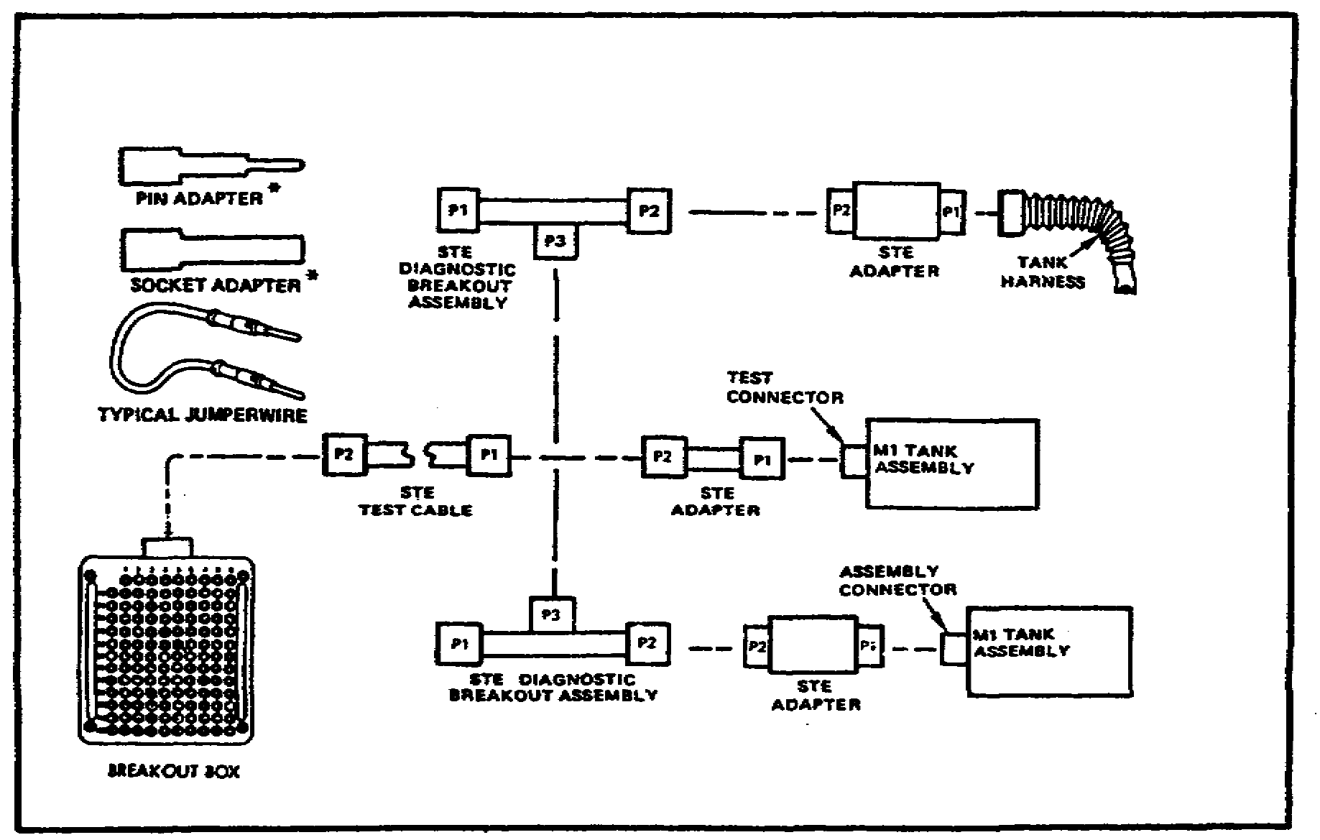

c. Setting-up when the STE is Not Available. When the STE is not available, the breakout box can be connected to assembly test connectors only by using the cable and adapters of the breakout box tool kit. Figure 20 (on the following page) shows the common configurations for the set-up of the breakout box, using the breakout box tool kit components.

59

M1 TANK AUTOMOTIVE TEST EQUIP - OD 0460 - LESSON 3/TASK 1

FIGURE 20. BREAKOUT BOX TOOL KIT
CONFIGURATIONS.
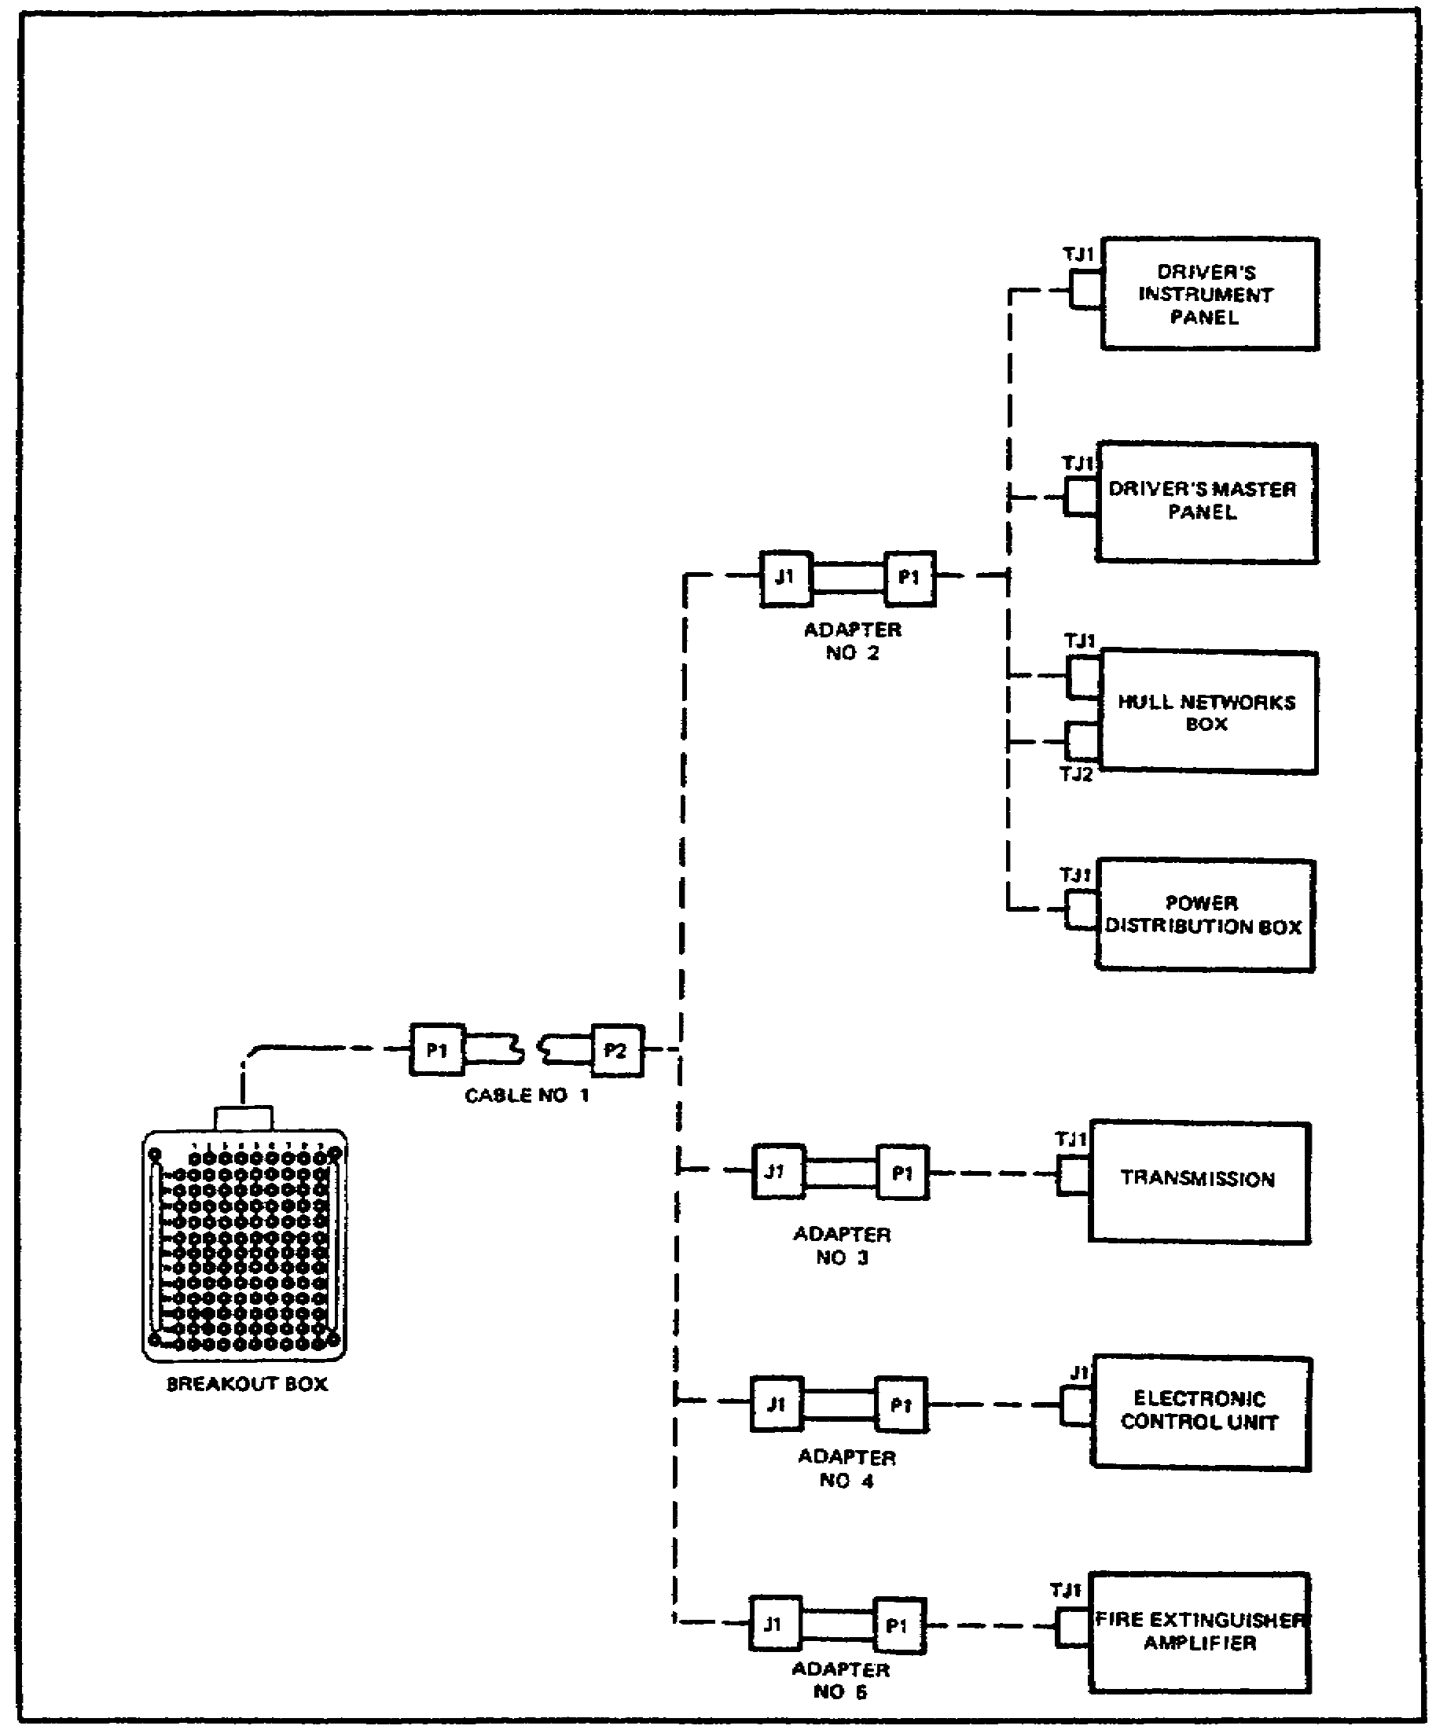

d. Connecting the Breakout Box to the Hull Networks Box. It is evident from figure 19 (on the previous page) and figure 20 that there are several configurations for setting up the breakout box to test the various systems of the M1 tank. As in lesson 1, the bilge pump system will be used as an

60

M1 TANK AUTOMOTIVE TEST EQUIP - OD 0460 - LESSON 3/TASK 1

example troubleshooting task to demonstrate typical set-up of the breakout box. This time, the symptom BILGE PUMP WORKS BUT BILGE PULP LIGHT DOES NOT COME ON will serve as the example troubleshooting task. To set-up the breakout box for troubleshooting this symptom, refer to figure 21 and follow the steps listed below:

FIGURE 21. CONNECTING THE BREAKOUT BOX
TO THE HULL NETWORKS BOX.
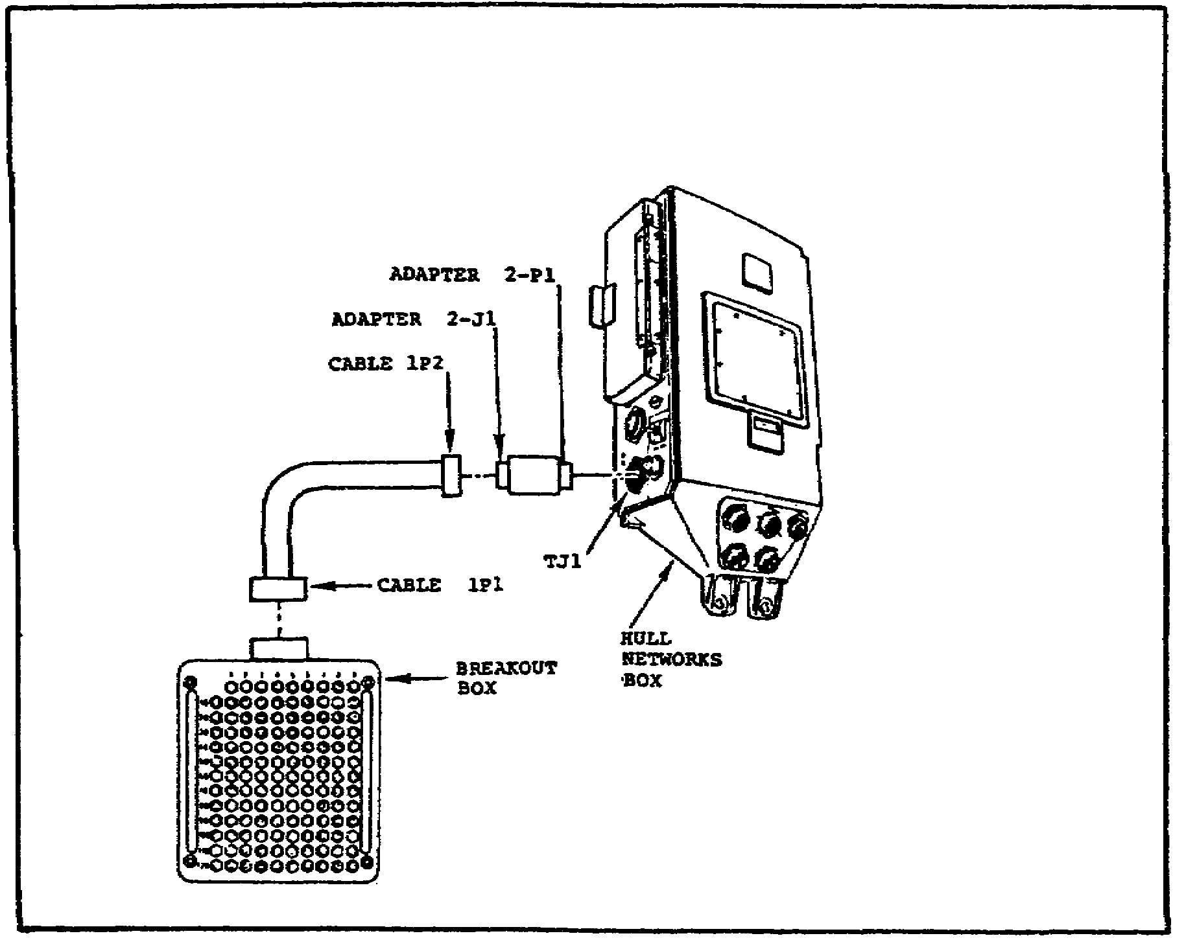

- Make sure that the VEHICLE MASTER POWER is OFF and that all circuit breakers are ON.

- Connect the breakout box to connector TJ1 on the hull networks box, using these steps:

  - Connect P1 of cable I to the breakout box.

  - Connect P1 of adapter number 2 to connector TJ1 on the hull networks box.

61

M1 TANK AUTOMOTIVE TEST EQUIP - OD 0460 - LESSON 3/TASK 1

  - Connect P2 of cable 1 to J1 of adapter number 2.

- When the breakout box is connected, set the VEHICLE MASTER POWER to ON.

FIGURE 22. CONNECTING THE BREAKOUT BOX
TO THE DRIVER'S MASTER PANEL.
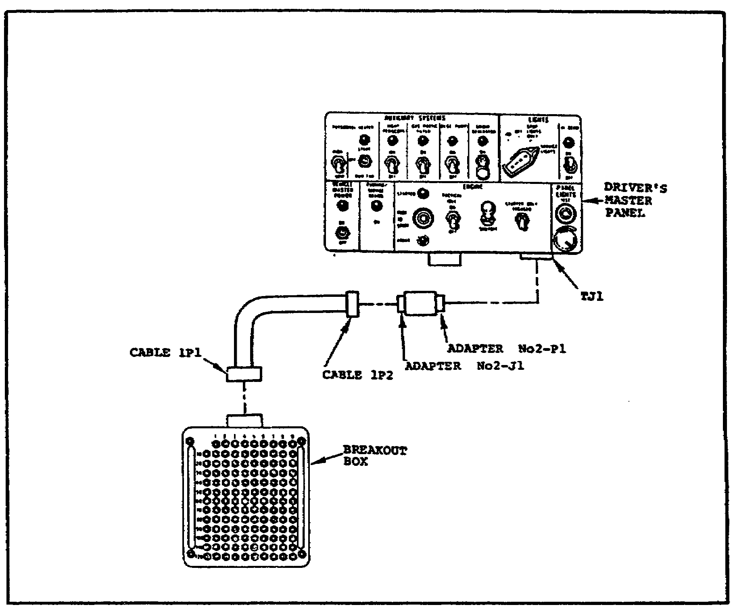

e. Connecting the Breakout Box to the Driver's Master Panel. The sample task, troubleshooting for the malfunction BILGE PUMP WORKS, BUT BILGE PUMP LIGHT DOES NOT COME ON, requires the breakout box to be initially connected to the hull networks box, as described in paragraph 2d. on page 60. However, during the task, the breakout box must be disconnected from the hull networks box and connected to the driver's master panel. Refer to figure 22 and use the steps listed below to connect the breakout box to the driver's master panel:

62

M1 TANK AUTOMOTIVE TEST EQUIP - OD 0460 - LESSON 3/TASK 1

- Make sure the VEHICLE MASTER POWER is OFF.

- Connect the breakout box to TJ1 on the driver's master panel using these steps:

  - Connect P1 of cable 1 to the breakout box.

  - Connect P1 of adapter number 2 to connector TJ1 on the driver's master panel.

  - Connect P2 of cable 1 to JI of adapter number 2.

3. Conclusion

The correct procedure for connecting the breakout box in these two configurations is all the set-up information that is required to troubleshoot for the malfunction symptom BILGE PUMP WORKS BUT BILGE PUMP LIGHT DOES NOT COME ON. Task 2 will describe the specific procedures for the functional use of the breakout box, in conjunction with the multimeter, for this troubleshooting task.

63

M1 TANK AUTOMOTIVE TEST EQUIP - OD 0460 - LESSON 3/TASK 2

LESSON 3

THE HOOK-UP OF THE BREAKOUT BOX AND MULTIMETER

TASK 2. Describe the proper procedures for the functional use of the breakout box and multimeter.

CONDITIONS

Within a self-study environment and given the subcourse text, without assistance.

STANDARDS

Within one hour

REFERENCES

No supplementary references are needed for this task.

1. Introduction

Task 1 of this lesson described the procedures for hooking-up the breakout box for use in troubleshooting the malfunction symptom BILGE PUMP WORKS BUT BILGE PUMP LIGHT DOES NOT COME ON. To illustrate how the breakout box is actually used in conjunction with the multimeter to perform troubleshooting procedures, this task will describe the step-by-step procedures for troubleshooting this symptom.

2. The Functional Use of the Breakout Box and Multimeter

The breakout box and the multimeter are used together when performing alternate troubleshooting procedures. The breakout box allows the mechanic to gain access to circuits and/or components that would otherwise be inaccessible for testing. The multimeter makes the test readings on the circuits and components that the breakout box has made accessible. Used together in this way, the two items of test equipment are a valuable aid in troubleshooting procedures.

64

M1 TANK AUTOMOTIVE TEST EQUIP - OD 0460 - LESSON 3/TASK 2

As in lesson 1, the bilge pump system will be used as an example for troubleshooting procedures. In this task, the procedure for the use of the breakout box and multimeter, while troubleshooting for the symptom BILGE PUMP WORKS BUT BILGE PUMP LIGHT DOES NOT COME ON, will be described. Since the primary purpose of this task is to describe the use of the breakout box and multimeter, only the steps involving these two test equipment items will be explored in depth.

a. Supplies and Equipment Needed. To perform the necessary steps for troubleshooting the malfunction symptom BILGE PUMP WORKS, BUT BILGE PUMP LIGHT DOES NOT COME ON, it will be necessary to have on hand some connector pins/socket adapters, electrical jumpers, the breakout box tool kit, and a multimeter.

b. Hooking up the Breakout Box. As a first step in troubleshooting for this symptom, connect the breakout box to the hull networks box connector TJ1, using cable number 1 and adapter number 2 as described in paragraph 2d. on page 60.

c. Using the Breakout Box and Multimeter to Troubleshoot the Symptom. When the breakout box is properly connected to the hull networks box, and the VEHICLE MASTER POWER switch is set to ON, the troubleshooting procedure can begin.

(l) Checking for Proper Direct Current (dc) Voltage. Follow these steps to check for the proper dc voltage:

- Set the PANEL LIGHTS brightness control on the driver's master panel to the fully clockwise position.

- Set the BILGE PUMP switch to ON.

- Set up the multimeter for a dc voltage test, as described paragraph 4 on page 49.

- Using the multimeter, check for 18 to 30 vdc between point 9 (negative, black probe) and point 48 (positive, red probe) on the breakout box (figure 23 on the following page).

- If 18 to 30 vdc is present, replace the hull networks distribution box, in accordance with the procedures outlined in TM 9-2350-255-20-1-3-6.

65

M1 TANK AUTOMOTIVE TEST EQUIP – OD 0460 - LESSON 3/TASK 2

When the replacement is complete, verify that the problem has been solved.

FIGURE 23. USING THE BREAKOUT BOX
AND MULTIMETER FOR A
DC VOLTAGE CHECK.
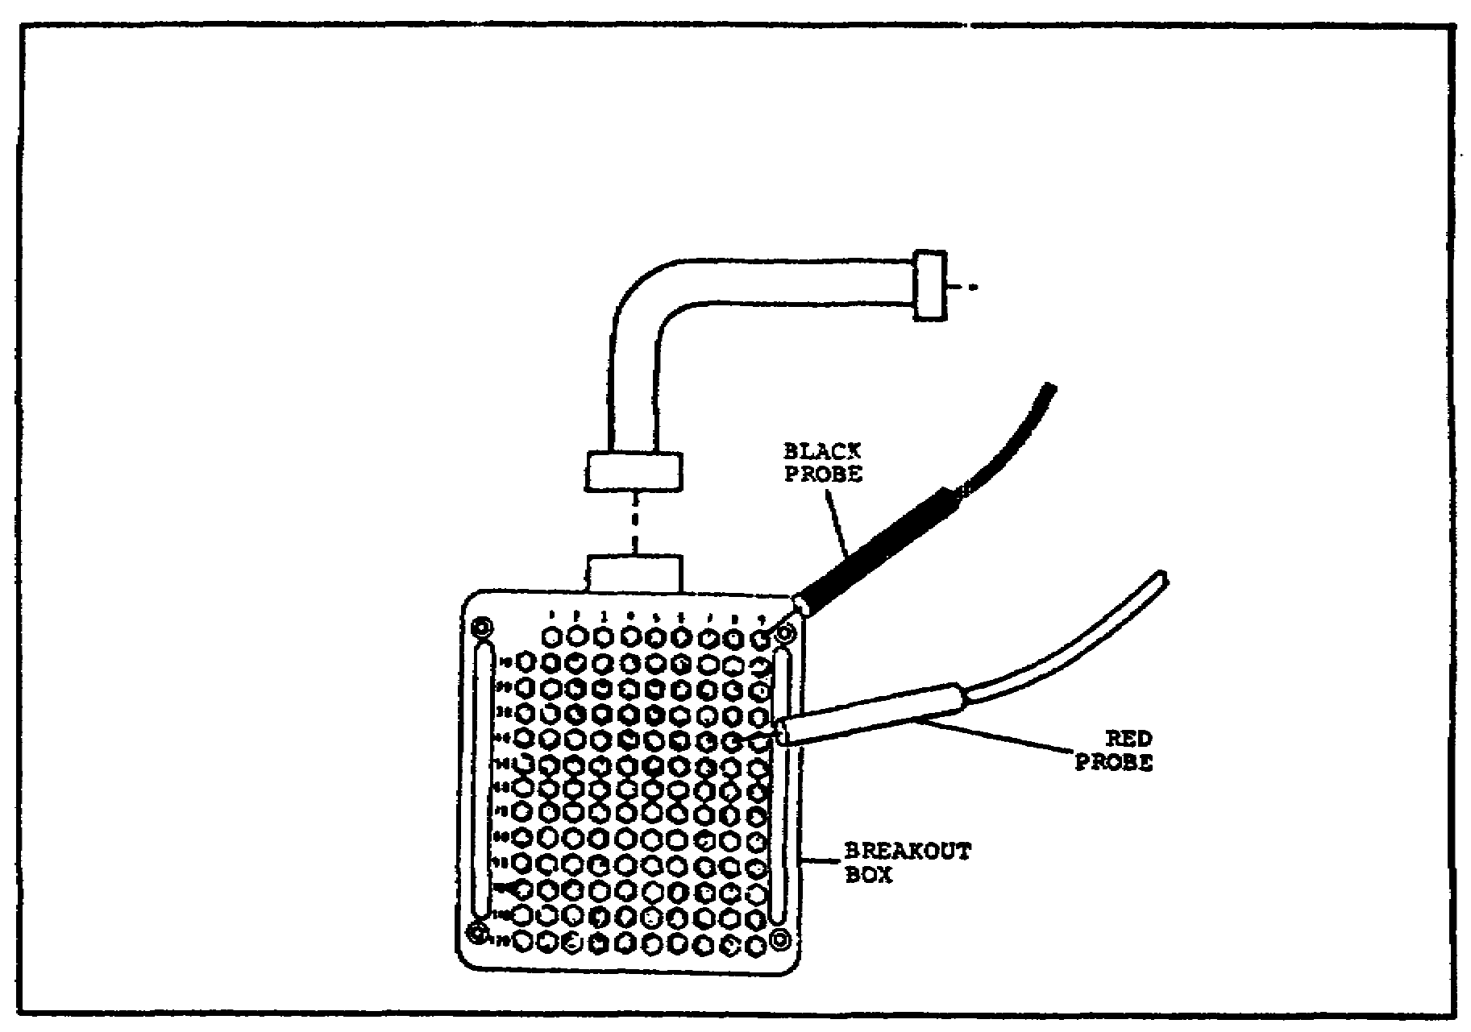

(2) Continuity Check Number One. If 18 to 30 volts was not present between points 9 and 48 on the breakout box, proceed as follows:

- Set the VEHICLE MASTER POWER switch to OFF.

- Disconnect the breakout box from the hull networks box.

- Connect the breakout box to the driver's master panel connector TJ1, using cable number 1 and adapter number 2 as described in paragraph 2e. on page 62.

- Disconnect 2W104-Pl from the hull networks box connector J8.

- Connect a jumper between contacts s and t on 2W104-PI (figure 24 on the following page).

66
M1 TANK AUTOMOTIVE TEST EQUIP - OD 0460 - LESSON 3/TASK 2

FIGURE 24. 2W104-P1 WITH JUMPER WIRE.
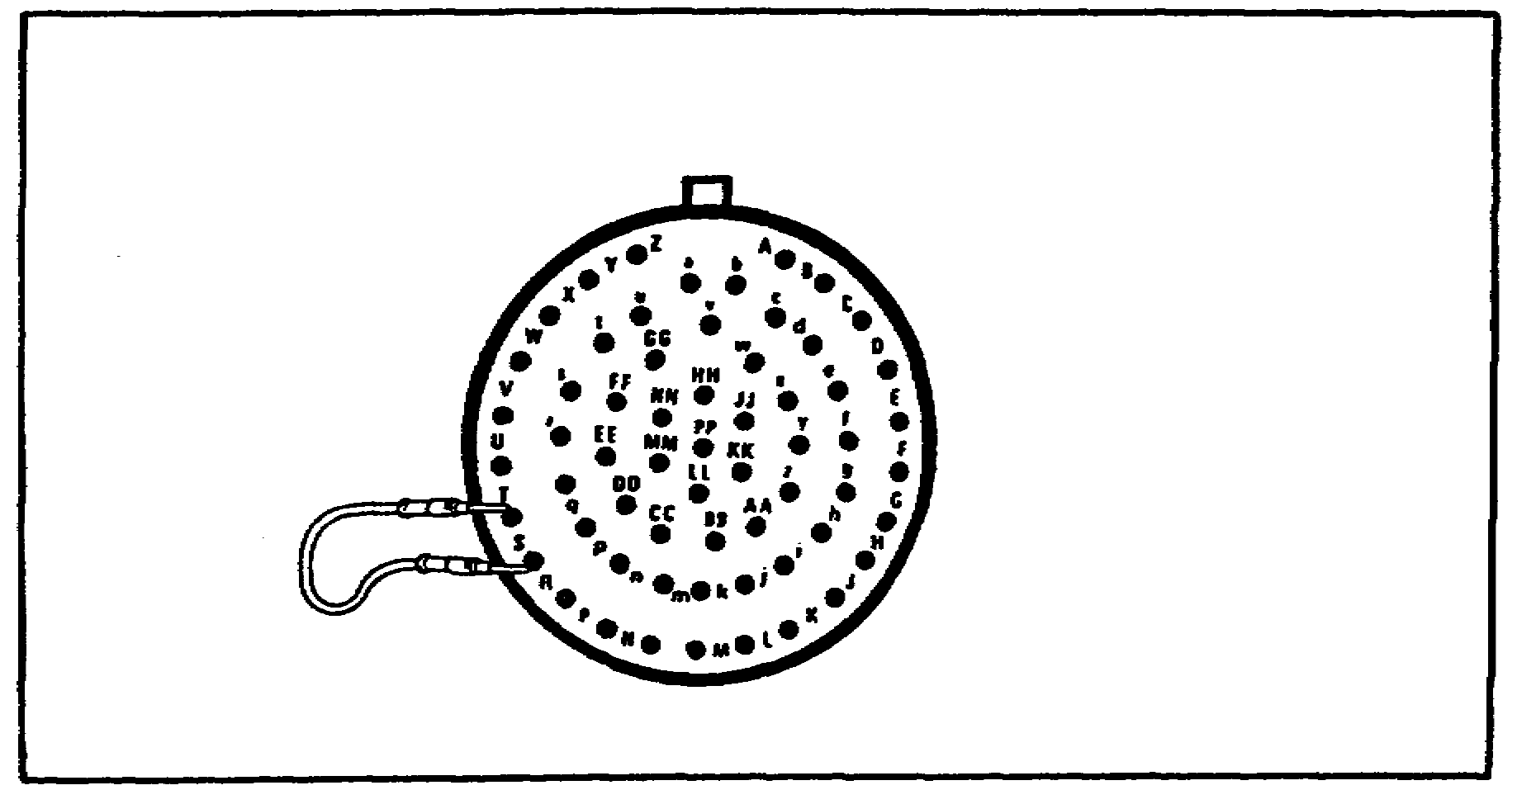

- Make sure that the BILGE PUMP switch is ON.

- Set up the multimeter for a continuity check as described in paragraph 6a. on page 52.

- Using the multimeter, check for continuity between points 39 and 40 on the breakout box (figure 25 on the following page).

- If continuity exists, the hull networks distribution box must be replaced, using the procedures outlined in TM 9-2350-255-20-1-3-6. When the replacement is complete, verify that the problem has been solved.

(3) Continuity Check Number Two. If continuity did not exist between points 39 and 40 on the breakout box, a second continuity check must be performed.

- Disconnect 2W104-P3 from the driver's master panel connector J1.

- Be sure the jumper wire is still connected between contacts s and t on 2W104-P1.

- Using the multimeter, check for continuity between contacts z and AA on 2W104-P3 (figure 26 on the following page).

67

M1 TANK AUTOMOTIVE TEST EQUIP - OD 0460 - LESSON 3/TASK 2

FIGURE 25. USING THE BREAKOUT BOX
AND MULTIMETER FOR A
CONTINUITY CHECK.
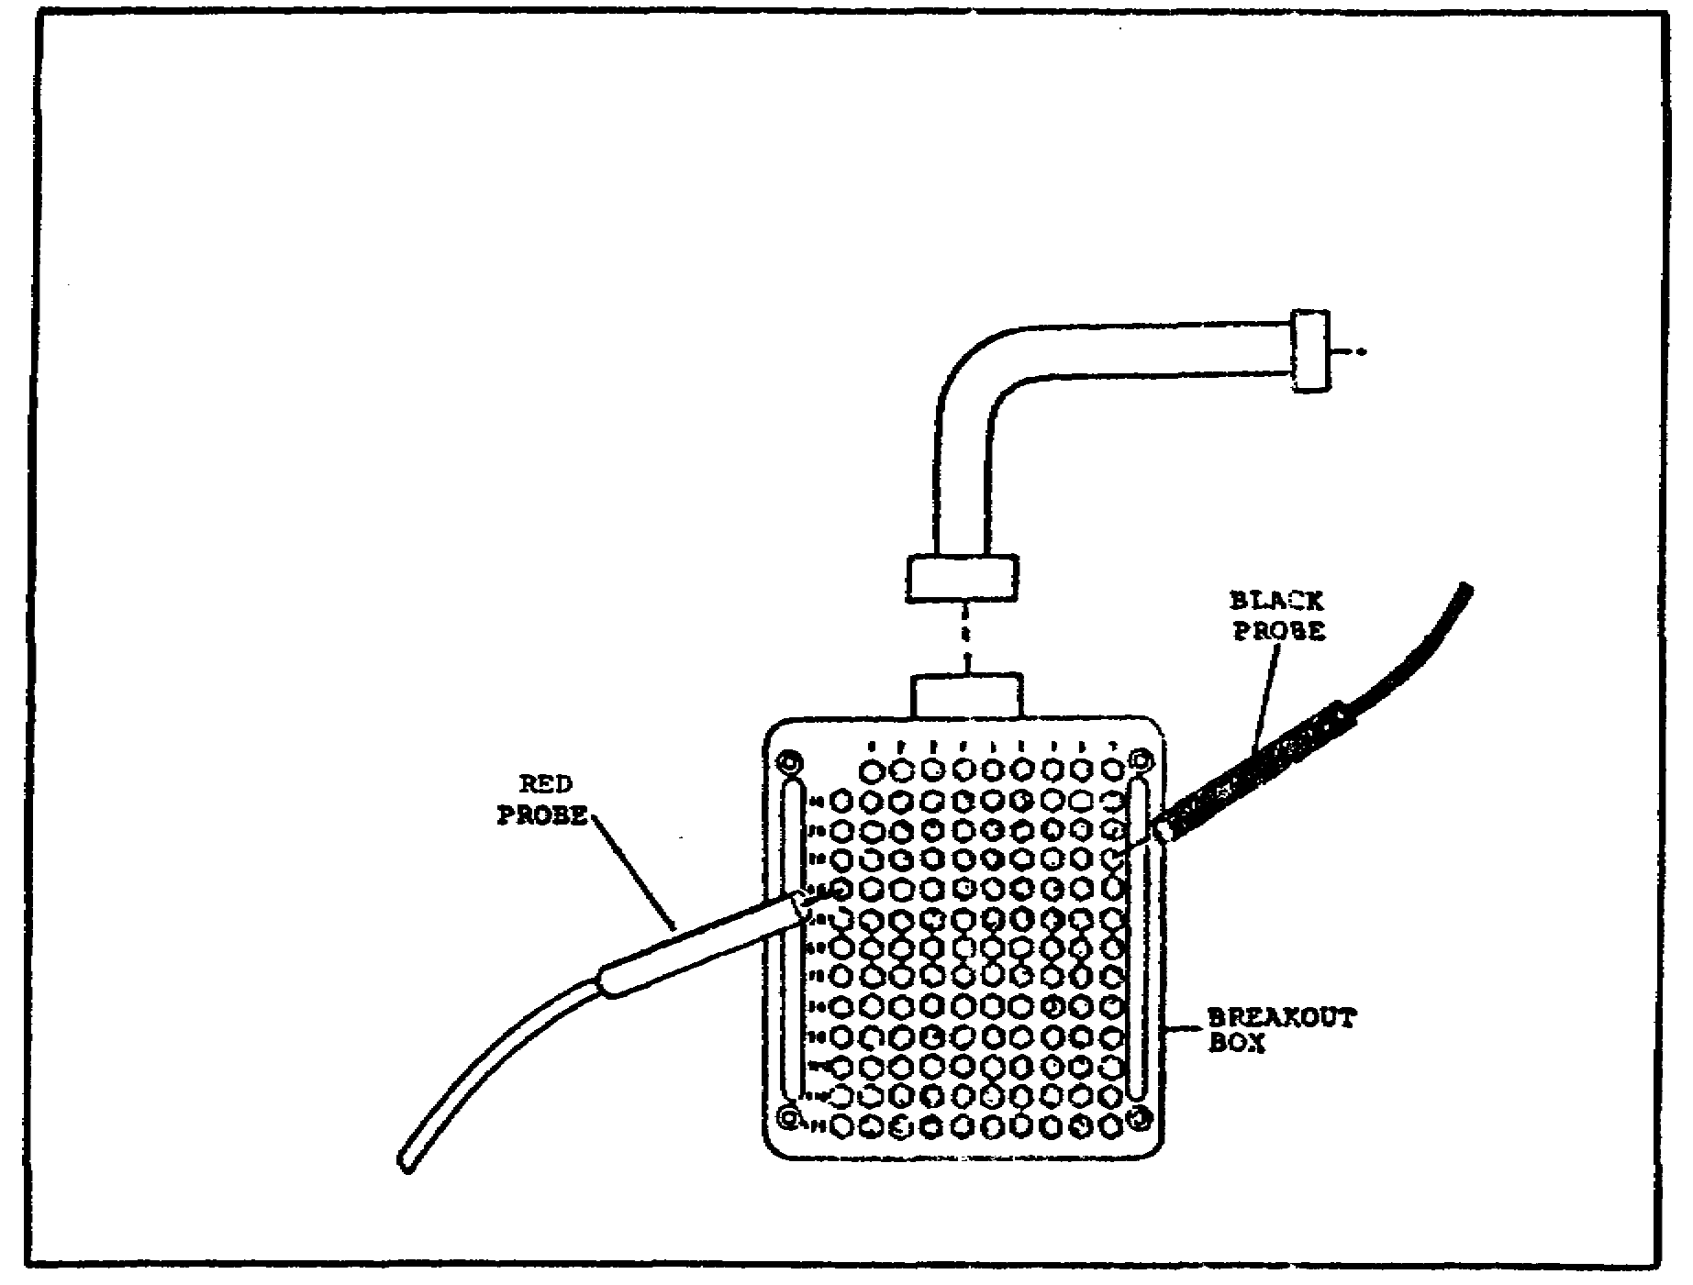

FIGURE 26. A CONTINUITY CHECK
ON 2W104-P3.
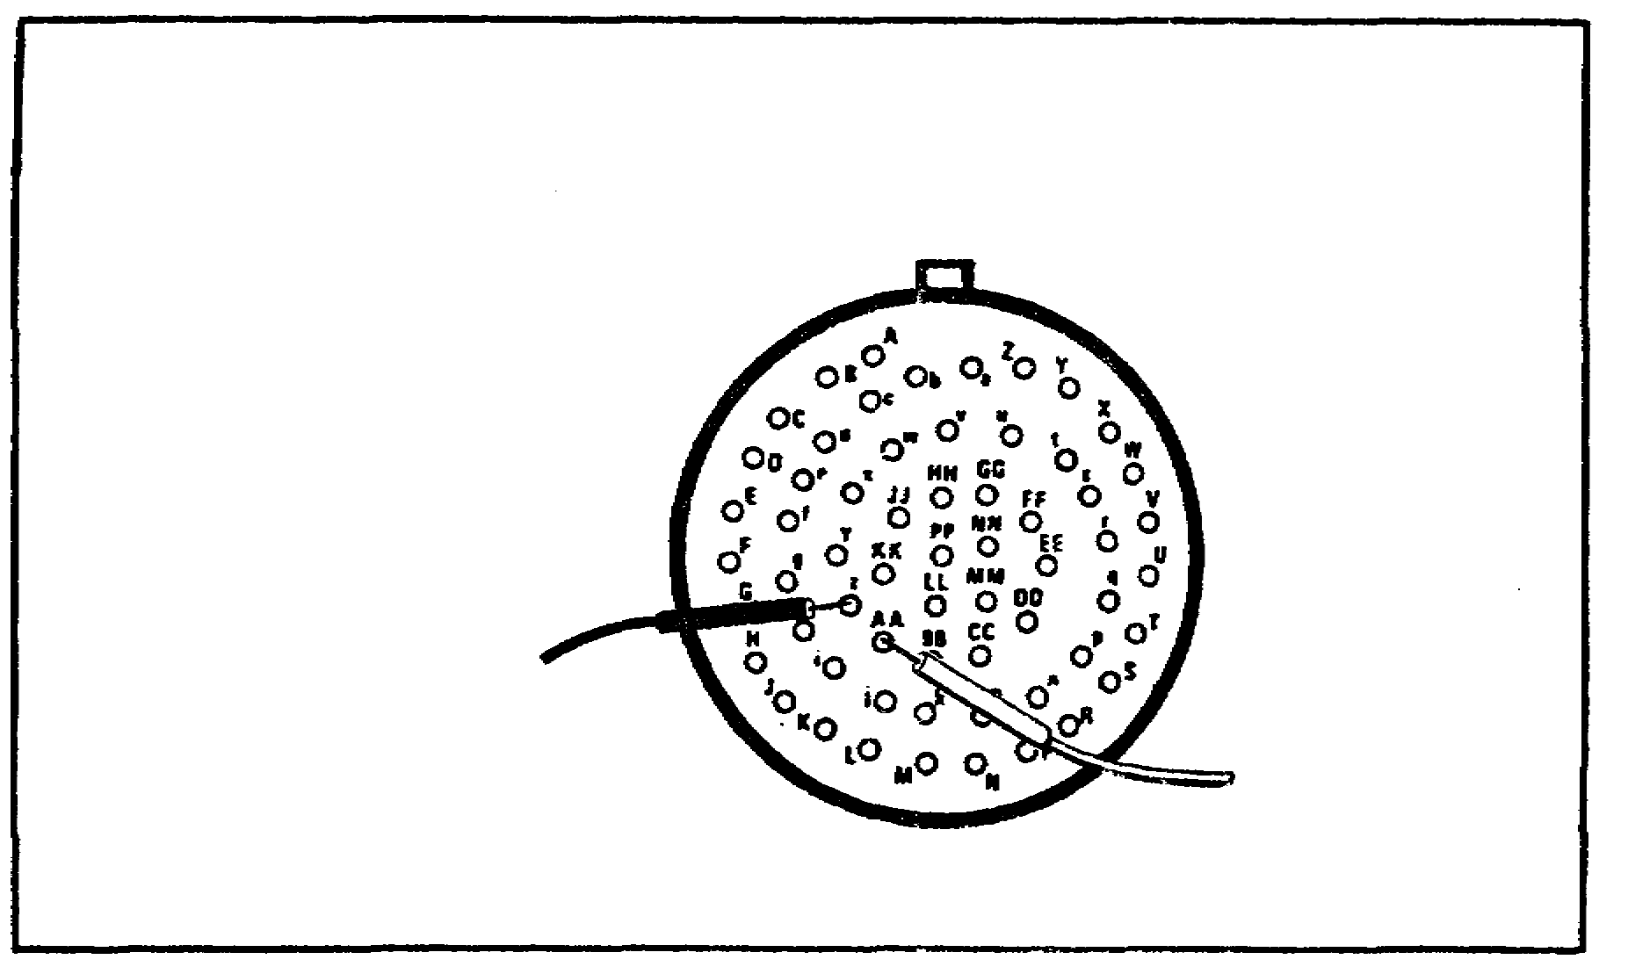

68
M1 TANK AUTOMOTIVE TEST EQUIP - OD 0460 - LESSON 3/TASK 2

- If continuity exists, connect 2W104-PI to the hull networks box connector J8. Then replace the driver's master control panel, in accordance with TM 9-2350-255-20-1-3-6. After the replacement is completed, verify that the problem has been solved.

- If continuity does not exist between contacts z and AA on 2W104-P1, replace the branched wiring harness 2W104, in accordance with the procedures outlined in TM 9-2350-255-20-1-3-6. Then, verify that the problem is solved.

3. Conclusion

In the absence of a functional STE test set, the breakout box and multimeter are essential items for the tests that must be performed in troubleshooting. Proper use of these test equipment items will ensure success in performing alternate troubleshooting procedures.

69

M1 TANK AUTOMOTIVE TEST EQUIP - OD 0460 - LESSON 3/PE 3

PRACTICAL EXERCISE 3

1. Instructions

Respond to the requirement.

Requirement

Answer these questions about the use of the breakout box and multimeter when performing alternate troubleshooting procedures on the M1 tank for the symptom BILGE PUMP WORKS, BUT BILGE PUMP LIGHT DOES NOT COME ON.

a. In setting up to troubleshoot, to what junction on the hull networks box should the breakout box be connected?

b. If 18 to 30 volts dc was not present at the hull networks box, to what junction of the driver's master panel should the breakout box be connected?

c. With the breakout box connected to the hull networks box, the multimeter is used to take a dc voltage reading. Identify the two points on the breakout box to which the red (positive) lead and the black (negative) lead of the multimeter are touched in order to take this reading.

d. With the breakout box connected to the driver's master panel, what type of test is taken with the multimeter between contacts z and AA on 2W104-P3?

e. What adapter is used in connecting the breakout box to the hull networks box?

70

M1 TANK AUTOMOTIVE TEST EQUIP - OD 0460 - LESSON 3/PE 3

LESSON 3. PRACTICAL EXERCISE - ANSWERS

Requirement

a. TJ1.

b. TJ1.

c. The red (+) lead is touched to point 48 and the black (-) lead is touched to point 9.

d. A continuity check.

e. Adapter number 2.

71

M1 TANK AUTOMOTIVE TEST EQUIP - OD 0460 - REFERENCES

REFERENCES

72

M1 TANK AUTOMOTIVE TEST EQUIP - OD 0460 - REFERENCES

REFERENCES

The following documents were used as resource materials in developing this subcourse:

TM 9-2350-255-20-1-2-2
TM 9-2350-255-20-1-2-3
TM 9-4910-751-14-1
TM 9-4910-751-14-2
TM 9-4910-751-14-P
TM 11-6625-366-15
DA PAM 750-22

73

